Chap. 1 Attention

Please read the attention carefully before operating the machine.
- No magnetic devices should be placed in the vicinity of the plotter, specifically the carriage.
- Prevent from dropping foreign matters into cracks such as pins, little screws, etc.
- Please pull out the power plug if not using during a long time.
- Don’t plug or unplug serial/parallel/usb cables on plotter while the power is on
- Don’t leave pinch rollers pressed down while machine is not in use.
- Always connect the power cord to a grounded outlet.
- Don’t move the carriage manually.
- Don’t touch carriage, metal roller, cutter and all moving devices when the machine is working.
- Place machine in a stable area that is free of strong vibrations, electromagnetic field, dust, moisture and /or direct sunlight.
- Don’t press top beam or lift up black rail.

Chap. 2 Installation
2-1 Packing-box
Please carefully check up the goods after opening the packing box, and in every box there should be as following:
- A main machine.
- A packet of accessories.
- A set of parts of machine stand.

2-2 Accessories
NO. | Item | Quantity
1 | Power cord | 1
2 | Operation manual | 1
3 | Cutter holder | 1
4 | Cutter | 3
5 | Plotter holder | 1
6 | Allen wrench | 1
7 | Fuse | 1
8 | Serial cable | 1
9 | Parallel cable | 1
10 | USB cable (optional) | 1
11 | Ground cable | 1
12 | Plotter protective cover | 1
13 | Driver disk for CorelDraw and USB port | 1
14 | Artcut 2005 CD (optional) | 1

2-3 Parts of stand
NO. | Item | Quantity | NO. | Item | Quantity
1 | Left column | 1 | 6 | Paper roller | 2
2 | Right column | 1 | 7 | Paper hanger | 2
3 | Crossbeam | 1 | 8 | Connection board | 2
4 | Pillar-bars | 2 | 9 | Screw M4×20 | 12
5 | Pillars/wheels | 4 | 10 | Screw M4×8 | 8
2-4 Assembly of machine stand
Referring to the following drawing:
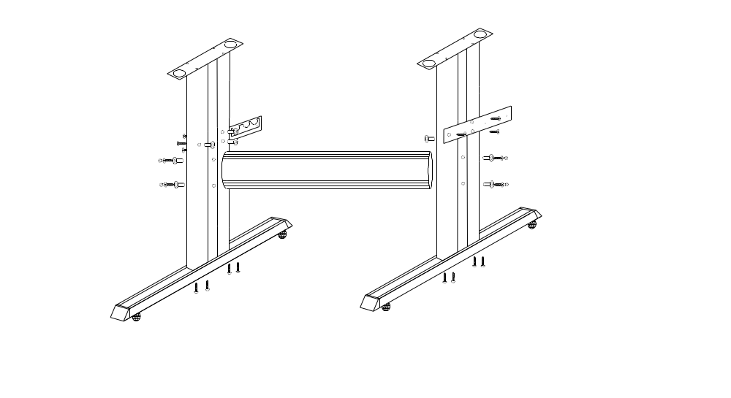

Step 1: Connect the pillar bars to left and right columns with screws respectively.
Step 2: Connect the crossbeam to left and right columns with screws.
Step 3: Join the paper hanger to the inside of the left and right columns with screws.
Step 4: Join the connection board to the top of the left and right columns with screws.
Step 5: Lay down the four pillars of main machine, place the machine on the connection board, and then insert the pillars into the connection board to connect to the main machine.
Step 6: Place the paper-roller on the roller of paper hanger.

Chap. 3 Items of Components

3-1. _0 Types
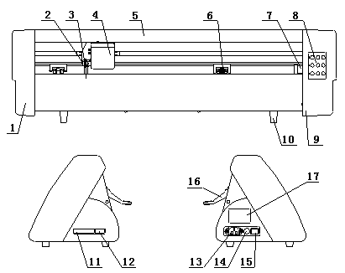
1. Left cover 9. Right cover
2. Cutter bracket 10. Pillar
3. Cutter holder 11. Socket of parallel port
4. Carriage of cutter-bracket 12. Socket of serial port
5. Cover of guide 13. Power socket
6. Pinch roller 14. Fuse socket
15. Power switch
8. Controlling panel 16. Pinch roller handle

3-2. _1 Types
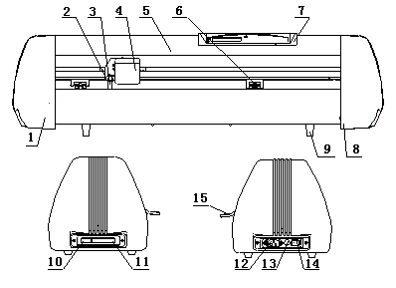

1. Left cover 9. Pillar
2. Cutter bracket 10. Socket of parallel port
3. Cutter holder 11. Socket of serial port
4. Carriage of cutter-bracket 12. Power socket
5. Cover of guide 13. Fuse socket
6. Pinch roller 14. Power switch
7. Controlling panel 15. Pinch roller handle
8. Right cover

Chap. 4 Loading Paper
4-1 Adjust the place of pinch rollers according to paper width
Cutting plotter has 2 to 4 pinch rollers and they can be moved along the guide rail. The handles of pinch rollers must be lifted before moving pinch rollers, hold the back of the roller and push it to the left or the right. Please don’t pull the roller bars in the front, otherwise the machine precision will be affected.
The place of the rollers must ensure:
- Pinch rollers should be in the place out of the scope of the pattern.
- Pinch rollers should be 10 to 50mm away from the edges of the paper.
- Pinch rollers shouldn’t be let down on the conjunction of two connecting metal rollers.
4-2 Loading the paper
1. Lift the pinch-roller handles and let it away from the metal rollers.
2. Insert the vinyl between metal rollers and pinch rollers of the machine from behind to front.
3. Align the front of the vinyl basically with the board-crack of the machine, then press down pinch rollers.
4. Carefully check the vinyl before cutting, since if vinyl is not well placed, serious deviation will occur. If the vinyl is uneven lift the pinch rollers on one side to adjust and then press down pinch rollers. It is necessary to trial-run the vinyl several times to attain minimum deviation before cutting work.

Chap. 5 Installing Cutter / Plotter
5-1 Structure of cutter holder and items of components
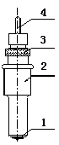Rotate the cutter holder to adjust the out-stretching length of the cutter as to ensure that it doesn’t cut off the bottom layer of stickiness.
- Cutter (diameter is 2mm)
- Cutter holder shell
- Cutter holder body
- Cutter-exiting staff
  - Installation and adjustment of blade
  - Before installing the cutter, you must carefully clean the cutter holder body, the cutter and your hands. Even very slight dirt can affect the performance of the cutter. Use a flexible plastic or rubber grip to hold the cutter in your hand. Carefully insert the cutter into the cutter holder body and it should magnetically attach.
  - Rotate the shell of the cutter holder and make the out-stretching length of the blade tip not longer than the thickness of the stickiness.
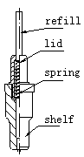5-3 Structure of Plotter holder and items of components
You can use a ballpoint pen to plot with the given plotter holder.
- Rotate the lid.
- Insert a ballpoint pen and let the refill tip out of proper length.
- Cover the refill with the lid then rotate them into the shelf.
5-4 Installation
1. Turn off the power
2. Loosen the locking screw of the cutter-bracket, then put the cutter holder or plotter holder in the V breach and ensure the blade tip or refill to reach to the plastic pressing strip. Fasten the locking screw clockwise at last.
3. After turning on the machine, the tip should be raised about 1.5 - 2 mm away from pressing strip.

Chap. 6 Testing Machine

- Place the machine in a stable area(such as machine stand or a table) that is free of electromagnetic interference, clutter, dust and vibration. Ample space is necessary in the working environment.
- To ensure the machine work safely and reliably, please connect to the ground effectively.
- Be sure the power is off and then connect the machine to a computer via the parallel/serial/USB cable.
- Then turn on the switch, and the red light lights up. The carriage should move to the right side and the metal roller will rotate automatically, thus complete the automatic reset. If it fails to reset, press the RESET key please.
- At the same time of turning on the switch, cutter bracket will be raised about 2 mm. And pressing ORIGIN key will make it fall downward. Release the key the bracket will raise again. This shows the carriage and bracket are functioning properly.
- If the machine is required to cut from an appointed location, press the OFFLINE key. The yellow light will turn on. Press ←or → to move the carriage left or right. Press ↑or ↓ to move the vinyl forward or backward. Now press the ORIGIN and the machine will work from the point at which the blade is located.
- Press the TEST key so the plotter can start its self test and cut a test pattern.

Caution:

- Be sure the computer and machine power are off before connecting any cables
- Be sure the settings in the software such as port, baud rate, commands set and device, etc. are all set correctly to function with this model machine

Chap. 7 Operating Instruction
  - _0 Type
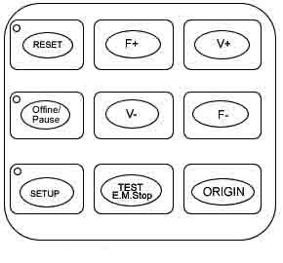

7-2 _1 Type
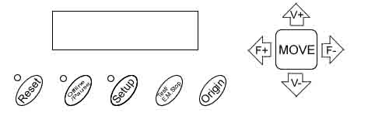

7-3 The machine has six modes: Reset, Online, Offline/Pause, Setup,
Offline + Setup
- Reset Status:
When the power is turned on, the machine can automatically reset. When it is working, if the RESET key is pressed, the machine will return to reset mode---clear up all information, and get ready for new work. ”WELCOME” will appear on the LCD that means the machine is ready to receive the data from the computer. At this point the default settings in the LCD are as following:
·Baud rate: 9600
·Cutting speed: 350mm/s
·Cutting force: 100g
·Cutting origin is according to the default of the machine
·Cleaning the buffer
The above information may be changed during operation.
- Online Status:
After the machine is reset, the red light (reset indicator) should be on. When the machine receives date from the computer, the yellow light will flash and it means the machine is in online mode. From the ONLINE mode the following changes can be made:
·Change the cutting speed by pressing V+ or V-
·Adjust the cutting force by pressing F+ or F-
·To change the origin: Press OFFLINE and the F+, F-, V+, V- keys to move the cutting blade to the appropriate position. Then press ORIGIN to confirm this position as the new work origin. After you press the RESET key the machine will keep this position as the new origin default.
- Offline / Pause Status:
Under online status, press the OFFLINE key to enter offline mode. The yellow light is on. Meanwhile, “Motion, X= xxx, Y= yyy” will appear on LCD, which shows the coordinates location of the blade at the moment. If cutting plotter is at work, it will stop working, and the blade will be lifted up. Then the cutting plotter can not receive data transmitted from the computer, but you may operate as follows:
· Press the key V+ or V- the carriage can be moved left or right.
· Press the key F+ or F- the vinyl can be moved forward or backward.
· Press the key Origin, the current location of the blade will be defaulted as a new work point.
- Setup status
In ONLINE status, when you press the SETUP key, the green light is on, and the baud rate of serial port can be changed. If you press SETUP key again, it will restore to online status.
ATTENTION: unless professional technicians, you’re not suggested to change this setting.
- Copy Status:
Press the OFFLINE, SETUP and ORIGIN keys the machine will re-cut all the data output of the last setting. The machine won’t re-cut if the green RESET light is flashing, it means the output data is more than the buffer capacity. In this case press RESET to restart the cutting work.

Chap. 8 Test Cut and Force Adjustment
8-1. Test Cut
Once the blade/plotter is installed and the vinyl is inserted, preliminary test-cut should be carried out to check the force of the blade/plotter if it is acceptable. To do so, press the TEST key.
8-2. Force Adjustment
By pressing F+ or F- the force of the blade will be increased or decreased by one level. If the force is too low the cut will not be deep enough or the pattern will be difficult to discern. If the force is too high the pattern may be deformed or incomplete, additionally the blade and pressing strip could be damaged. The protruding portion of the blade tip should be about 0.5mm or less in length normally which is 2/3 of the thickness of vinyl. While drawing patterns by the plotter you should first try adjusting the force to be conservatively low.
Caution:
Always test cut every time you use a new type of vinyl to check the cutting force

Chap. 9 After Work Over
After work is over…
  - Remove the paper.
  - Remove the cutter holder or plotter holder, then wipe it clean with a soft-cloth and keep it properly.
  - Turn off the power, and pull the power cord out if not using during a long time.
  - Cover the machine with a cloth or a cover.
Chap. 10 Using life of the cutter
Cutter’s using life is limited, but you can use it as long as possible.
Note:
      - More longer the out-stretching length of the cutter, more shorter the using life. Please avoid cutting off the bottom layer during the process of cutting.
      - The more cutting force, the shorter the using life.
      - As for different materials, the requirement to the cutter sharpness is different.
      - Set the cutting force as little as possible; only increase it when the cutter feels blunt.
      - As for the cutters from different factories, the using life is also very different.
      - Renew the cutter timely when it is blunt in case of affecting the machine performance. As an urgent method, a piece of leather can be used to sharpen the blade tip just like sharpening a razor.
Chap. 11 Parameters Table
Technical Specifications ( _0 Type )
Model | 360 | 720 | 870 | 1100 | 1350
Max. paper width | 365mm | 720mm | 870mm | 1100mm | 1350mm
Max. cutting width | 275mm | 630mm | 780mm | 1010mm | 1260mm
Cutting speed | 50-800mm/s | 50-800mm/s | 50-800mm/s | 50-800mm/s | 50-800mm/s
Cutting force | 50-500g | 50-500g | 50-500g | 50-500g | 50-500g
Buffer capacity | 1M | 1M | 1M | 1M | 1M
LCD | Optional | Optional | Optional | Optional | Optional
CPU | 8-bit CPU
Strip of plotter | Plastic sheet
DRIVE | Stepping
Min. character matrix | Approx 5 mm [0.2''] high
Blade type | Super steel [1.2mm and 2.0mm]
Film type | Self -adhesive vinyl film, fluorescent film, reflective film, paper
Display panel | 8digits X 2 line LCD
Interfaces | parallel & serial
Power requirements | 90-260V
Repeatability | 0.127mm
Mechanical resolution | 0.0254mm/step
Commands set | DMPL / HPGL
Environmental temperature | 0-35℃
Environmental humidity | 5%-65%（without condensation）

Technical Specifications ( _1 Type )
Model | 361 | 721 | 871 | 1101 | 1351
Max. paper width | 365mm | 720mm | 870mm | 1100mm | 1350mm
Max. cutting width | 275mm | 630mm | 780mm | 1010mm | 1260mm
Cutting speed | 50-800mm/s
Cutting force | 50-500g
Buffer capacity | 1-4M
LCD | YES
CPU | 8-bit CPU
Special setting | Dual cutter position, dual strips
Strip of plotter | Double sheet(soft sheet and plastic sheet)
DRIVE | Stepping
Min. character matrix | Approx. 5 mm [0.2''] high
Blade type | Super steel [1.2mm and 2.0mm]
Film type | Self -adhesive vinyl film, fluorescent film, reflective film, paper
Display panel | 8digits X 2 line LCD
Interfaces | Parallel & serial, USB
Power requirements | 90-260V
Repeatability | 0.127mm
Mechanical resolution | 0.0254mm/step
Commands set | DMPL / HPGL
Environmental temperature | 0-35℃
Environmental humidity | 5%-65%（without condensation）

Chap. 12 Questions and Answers
Why is the pattern deformed or incomplete?
- More pressure or too long blade tip or too dirty platen or too soft stickiness, all of these factors can cause more resistance to the two faces of paper and make it fall behind the roller rotating, thus result in deformed pattern.
- The software setting isn’t proper. (The tool compensation value is too big)
- The carriage belt is too loose, or the metal roller can’t exactly follow the motor running.
- The motor doesn’t run all the steps.
- The pattern is normal but not complete, this may be resulted from too small tool compensation value.
Why does the machine plot abnormally?
- Software setting is not matched to the machine, so you must adopt proper commands set or set proper tool compensation value.
- The plotting software is suddenly broken up.
- Plotting software has been damaged or there is virus in computer.
Why does the paper run deviation?
- The stickiness isn’t placed right.
- The platen is too dirty so that the resistance from two sides can’t be balanced when the paper is moving.
- The pinch rollers have been deformed or don’t match to each other.
- The pressure of the pinch roller is a little smaller and the paper is very sensitive to the external force.
- The balance of the stickiness weight isn’t very good.
Why some parts of letters are missing?
- The vinyl is too heavy or too tightly wrapped. Metal roller might be soiled by some foreign substance or by vinyl chips.
- Cutting speed is too fast, cutting force is too great, or cutter tip is too long.
- Synchromesh belt is too tight, or pinch roller is under too much pressure.
- Metal roller is faulty. Contact local distributor for repairs and replacement.
Why different letters on the same line are cut to different depths?
- Cutter holder is not tightly attached. It should be tightened.
- Cutter blade is not tightly set in the holder.
Why letters appear to have ripples?
- Cutting speed is too fast. Except for cutting large letters, speed should not exceed 480mm/s.
- Cutting blade is of poor quality, or it has been damaged. Replace it.
- Cutter holder is not tightly installed. Tighten screw.
Cutting small letters
When cutting small letters, cutting speed and force should be adjusted to the lowest setting. Similarly cutter tip should be adjusted to as short as possible.
Cutting large letters
Cutting speed and force may be increased to higher settings. When cutting large letters Sharp Angle in Artcut software may be ignored.

Chap. 13 Appendix: USB Port Setting

1. Install USB port:
Connect USB cable with USB port of your computer and insert Driver CD into your CD ROM of computer. You will find the following installation guide. Press “Next” and enter USB installation.
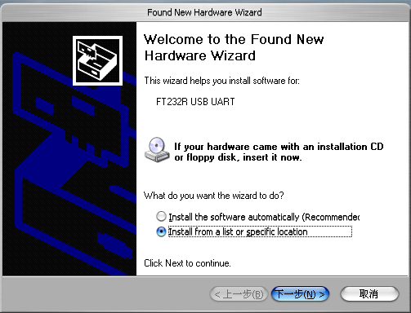

Click “ Browse” and select “Driver” file from Disk: F
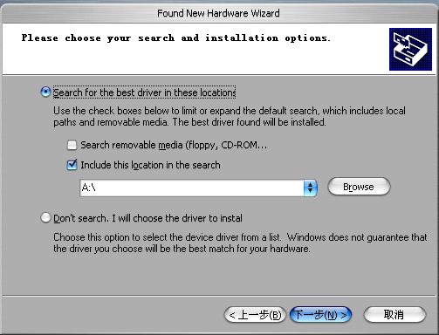

Make sure to select “ XP 232R ” under “ USB2 Driver “ file and press “ OK ”
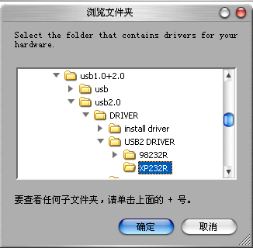
Press “ Next ” to install
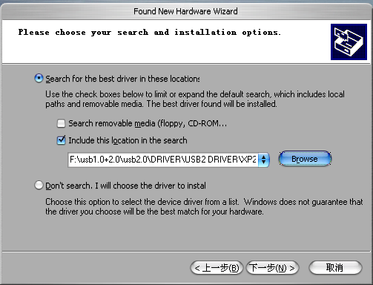
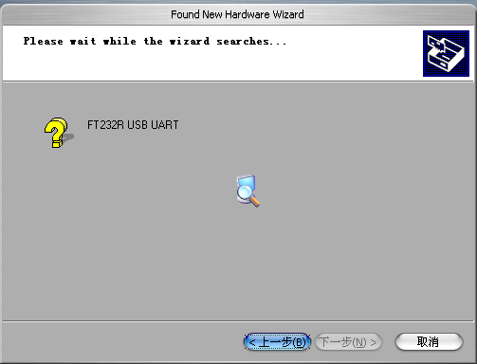
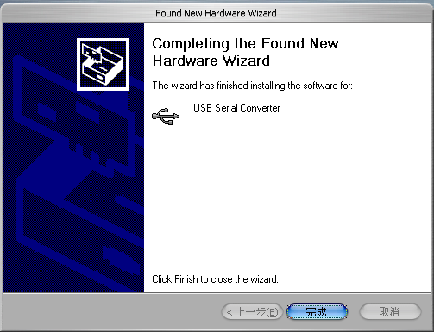

2. Port Setting:
The USB device will be found as ”COM4 ” from “ Device Manager ”.
To ensure stable work, please change the port to “COM3”.
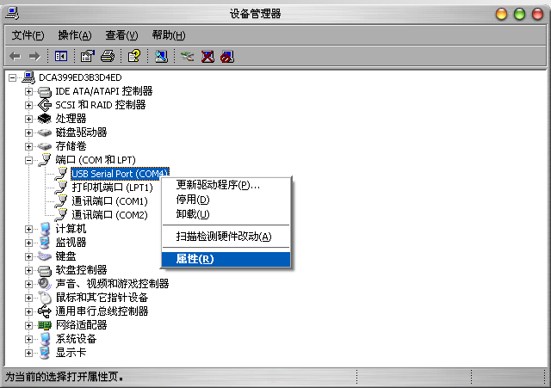
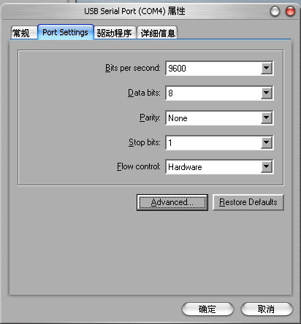
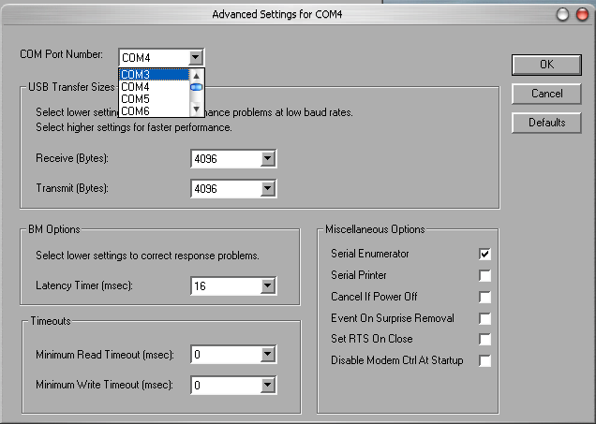

Set port in Artcut software
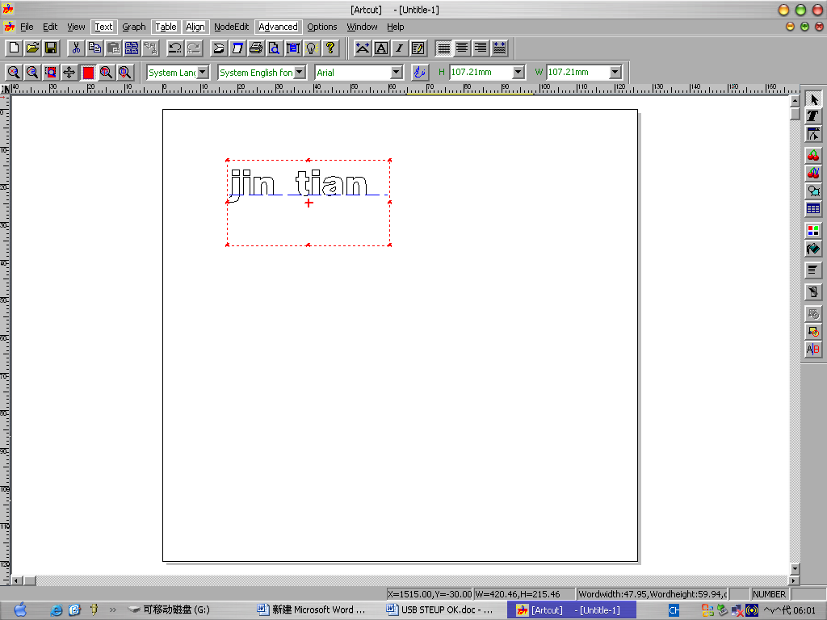
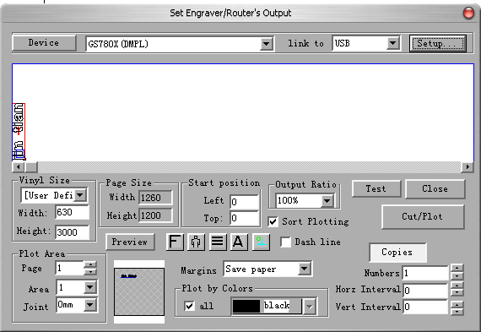

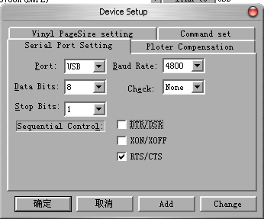

3. Turn on the power of cutter and press “Setup” on control panel. Adjust Baud Rate to “4800” by pressing “←” key on panel of cutter, and then press “Setup”. That means you have successfully change Baud Rate to 4800 on the cutter.
Please note that the default Baud Rate of cutter is 9600, so you’ll need to adjust the baud Rate every time you work through USB port.
Of course, you need to change Baud Rate back to “9600” both in Artcut software and the cutter when you work the cutter through Serial or Parallel port.

Caution:
USB Port Setting & CorelDraw Port Setting Seen in “DRIVER” CD.

