Package List of Flash Dryer
(It includes 1 package; please check the followings before installing.)
Drying Box | Knighthead | Chromium-plated Tube
pc | Set | set
1 | 1 | 1
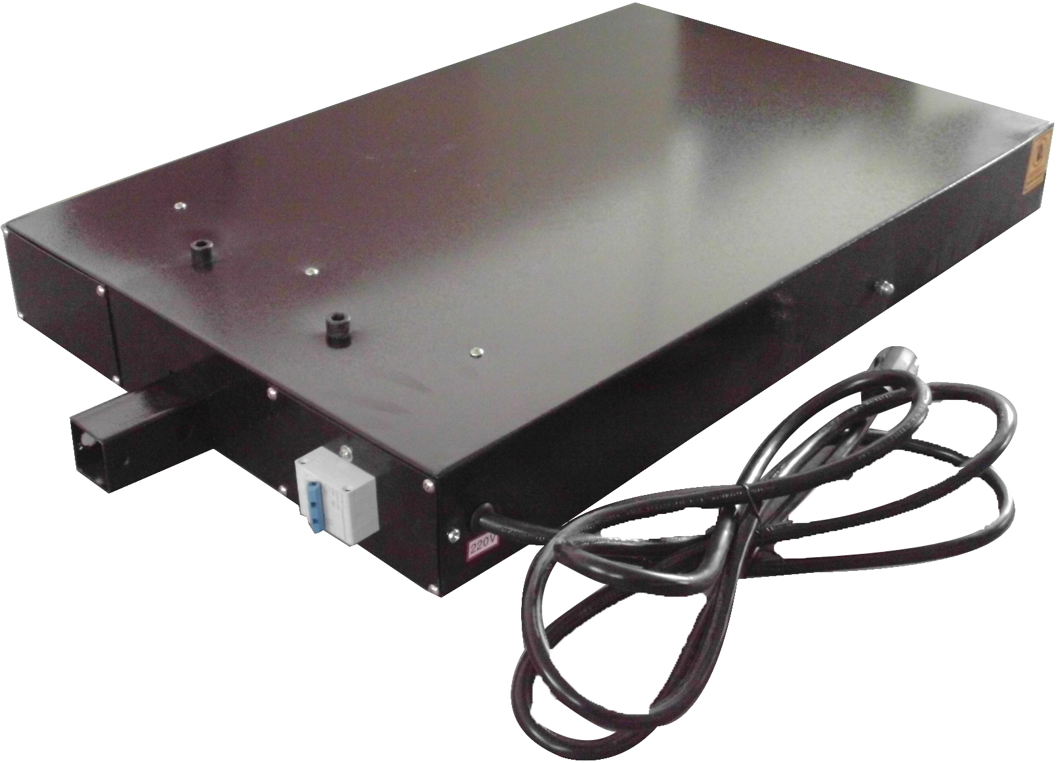 | 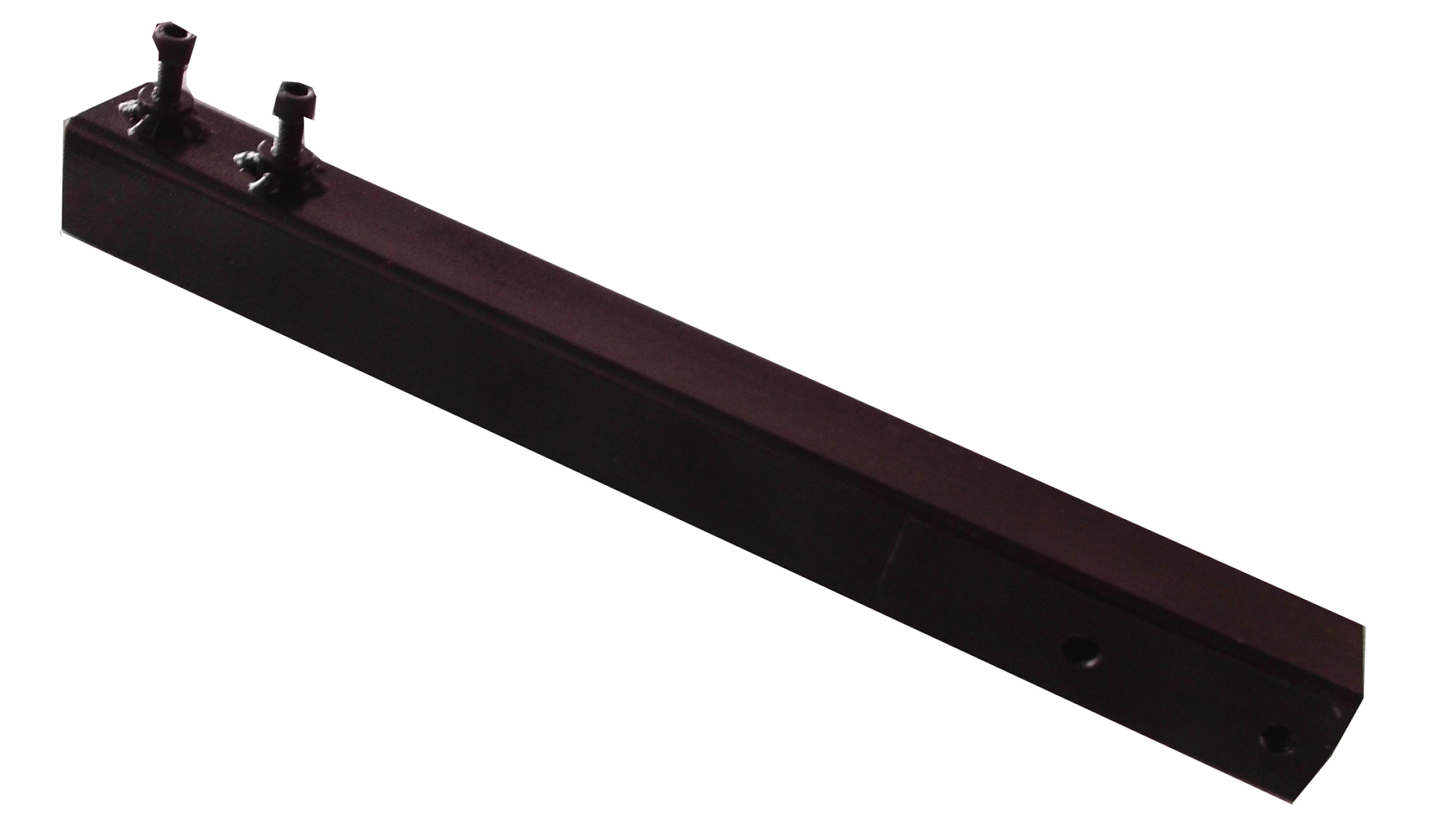 | 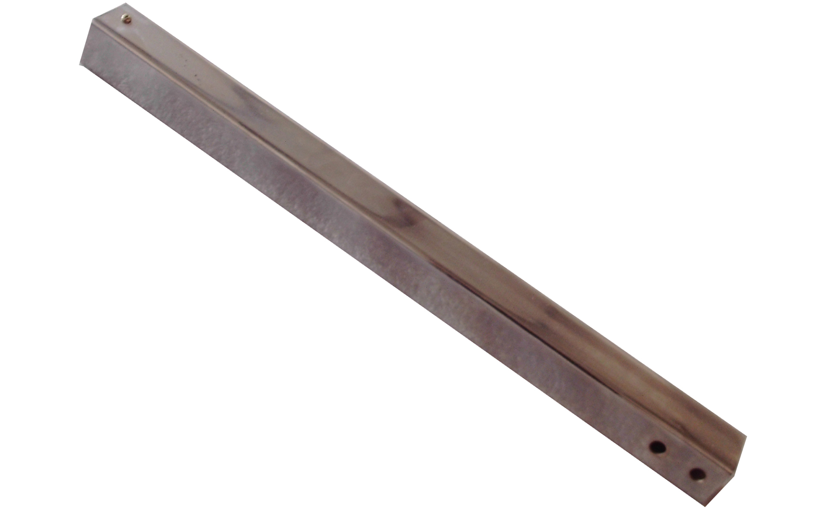
Junction Block A  （Connecting dying box and knighthead） | Junction Block B  （Connecting knighthead and base） | Base
Set | Set | pc
1 | 1 | 1
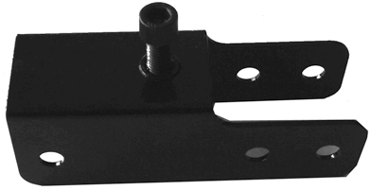 | 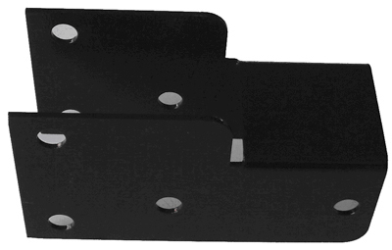 | 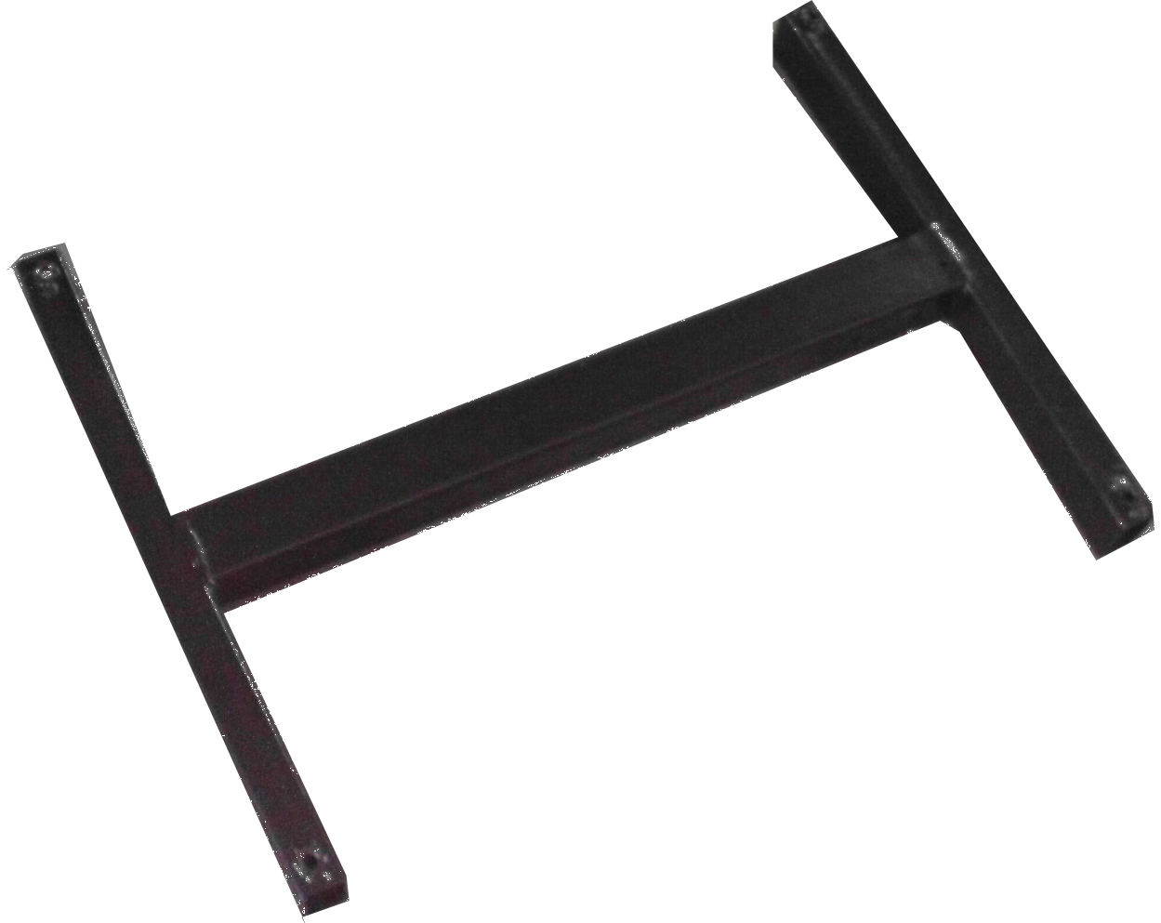
Truckle | Screws and Bolts | Installation Tools
pc | set | pc
4 | 7 | 4
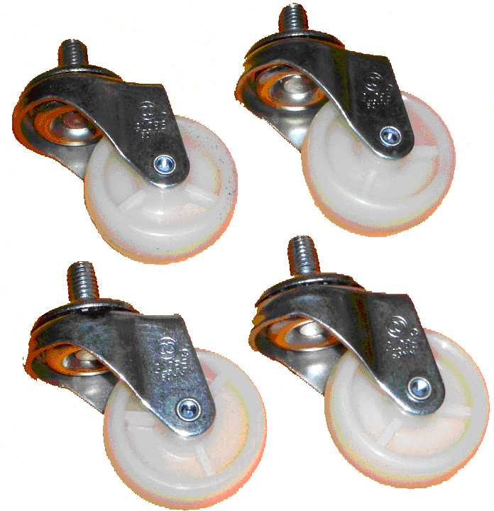 | 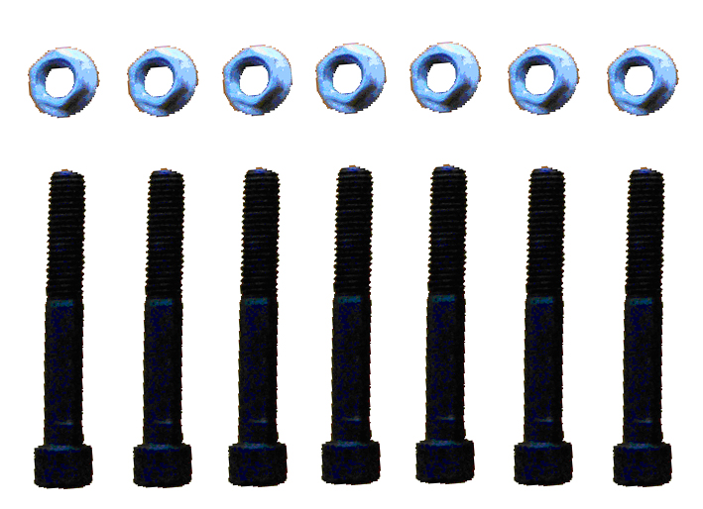 | 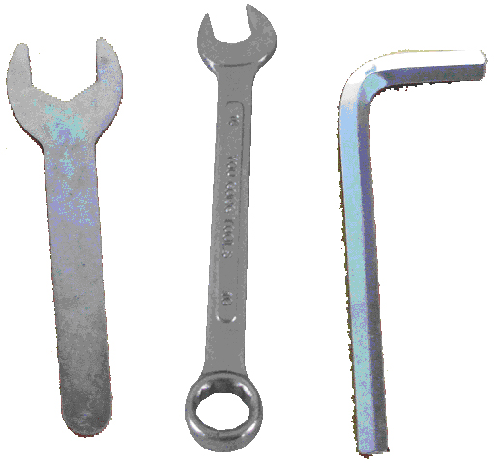
Thermometer
set
1
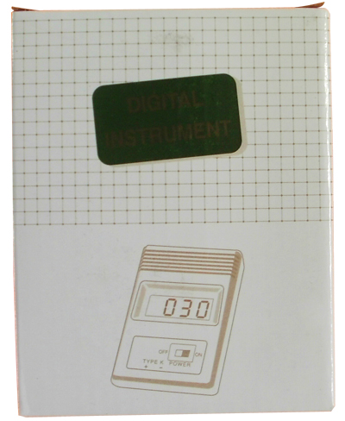

ASC365 International Ltd
http://asc365.com

