Dear Users:
Welcome to select our product, the feature of our product is to make a hole directly on the spectacle gasket.use the gasket perforated as template, and the precision is absolutely correct if only by the demand. Operating method is as follows:

[Safety Precautions］
1. Don’t use this machine for other purposes than drilling the lens;
2. While the machine is working ,don’t touch the turning drill to avoid getting injured;
3. Don’t use this machine when the power requirements (voltage and frequency) are not met, you should be clear about the actual working power supply;
4. Don’t install other parts at will except the original parts of this machine;
5. Don’t press hardly while you are drilling.
6. You should check the carbon brush of the motor sometime,because it is easy to worn, it is necessary to exchange on time

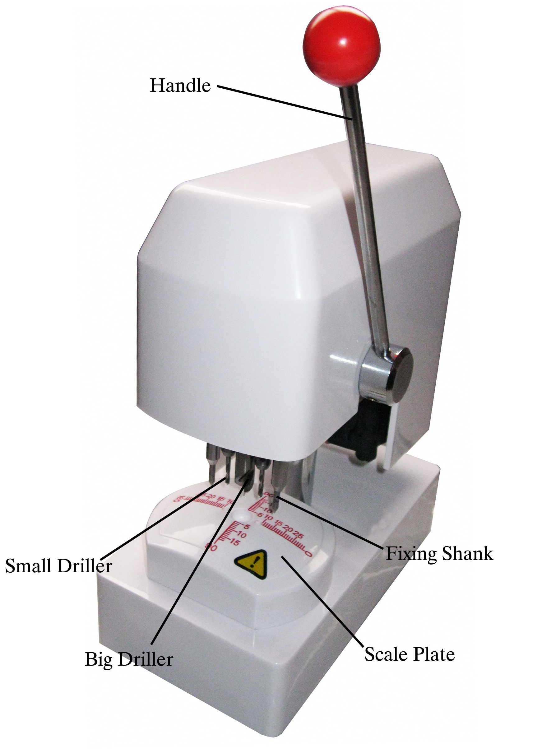

［Operation Procedure］
1.First set center position of pupil distance on the spectacles holder, take down the gasket and perforate on the perforator, aim to align the center of pupil distance and coordinate center of perforator.
2.Press the handle and drill on the gasket, but please do not drill quickly one time.
3.Take the drilled gasket to edge on the lens edger( some frames are very thin, please use the spare steel disc to avoid deformation.)
4.While drilling, you should drill on the lens slowly, otherwise the flotsam of the lens will be sticked around the driller. Please clean the driller before using next time.
5.You must replace the driller if the plastic flotsam stuck on the driller which can not be cleaned.

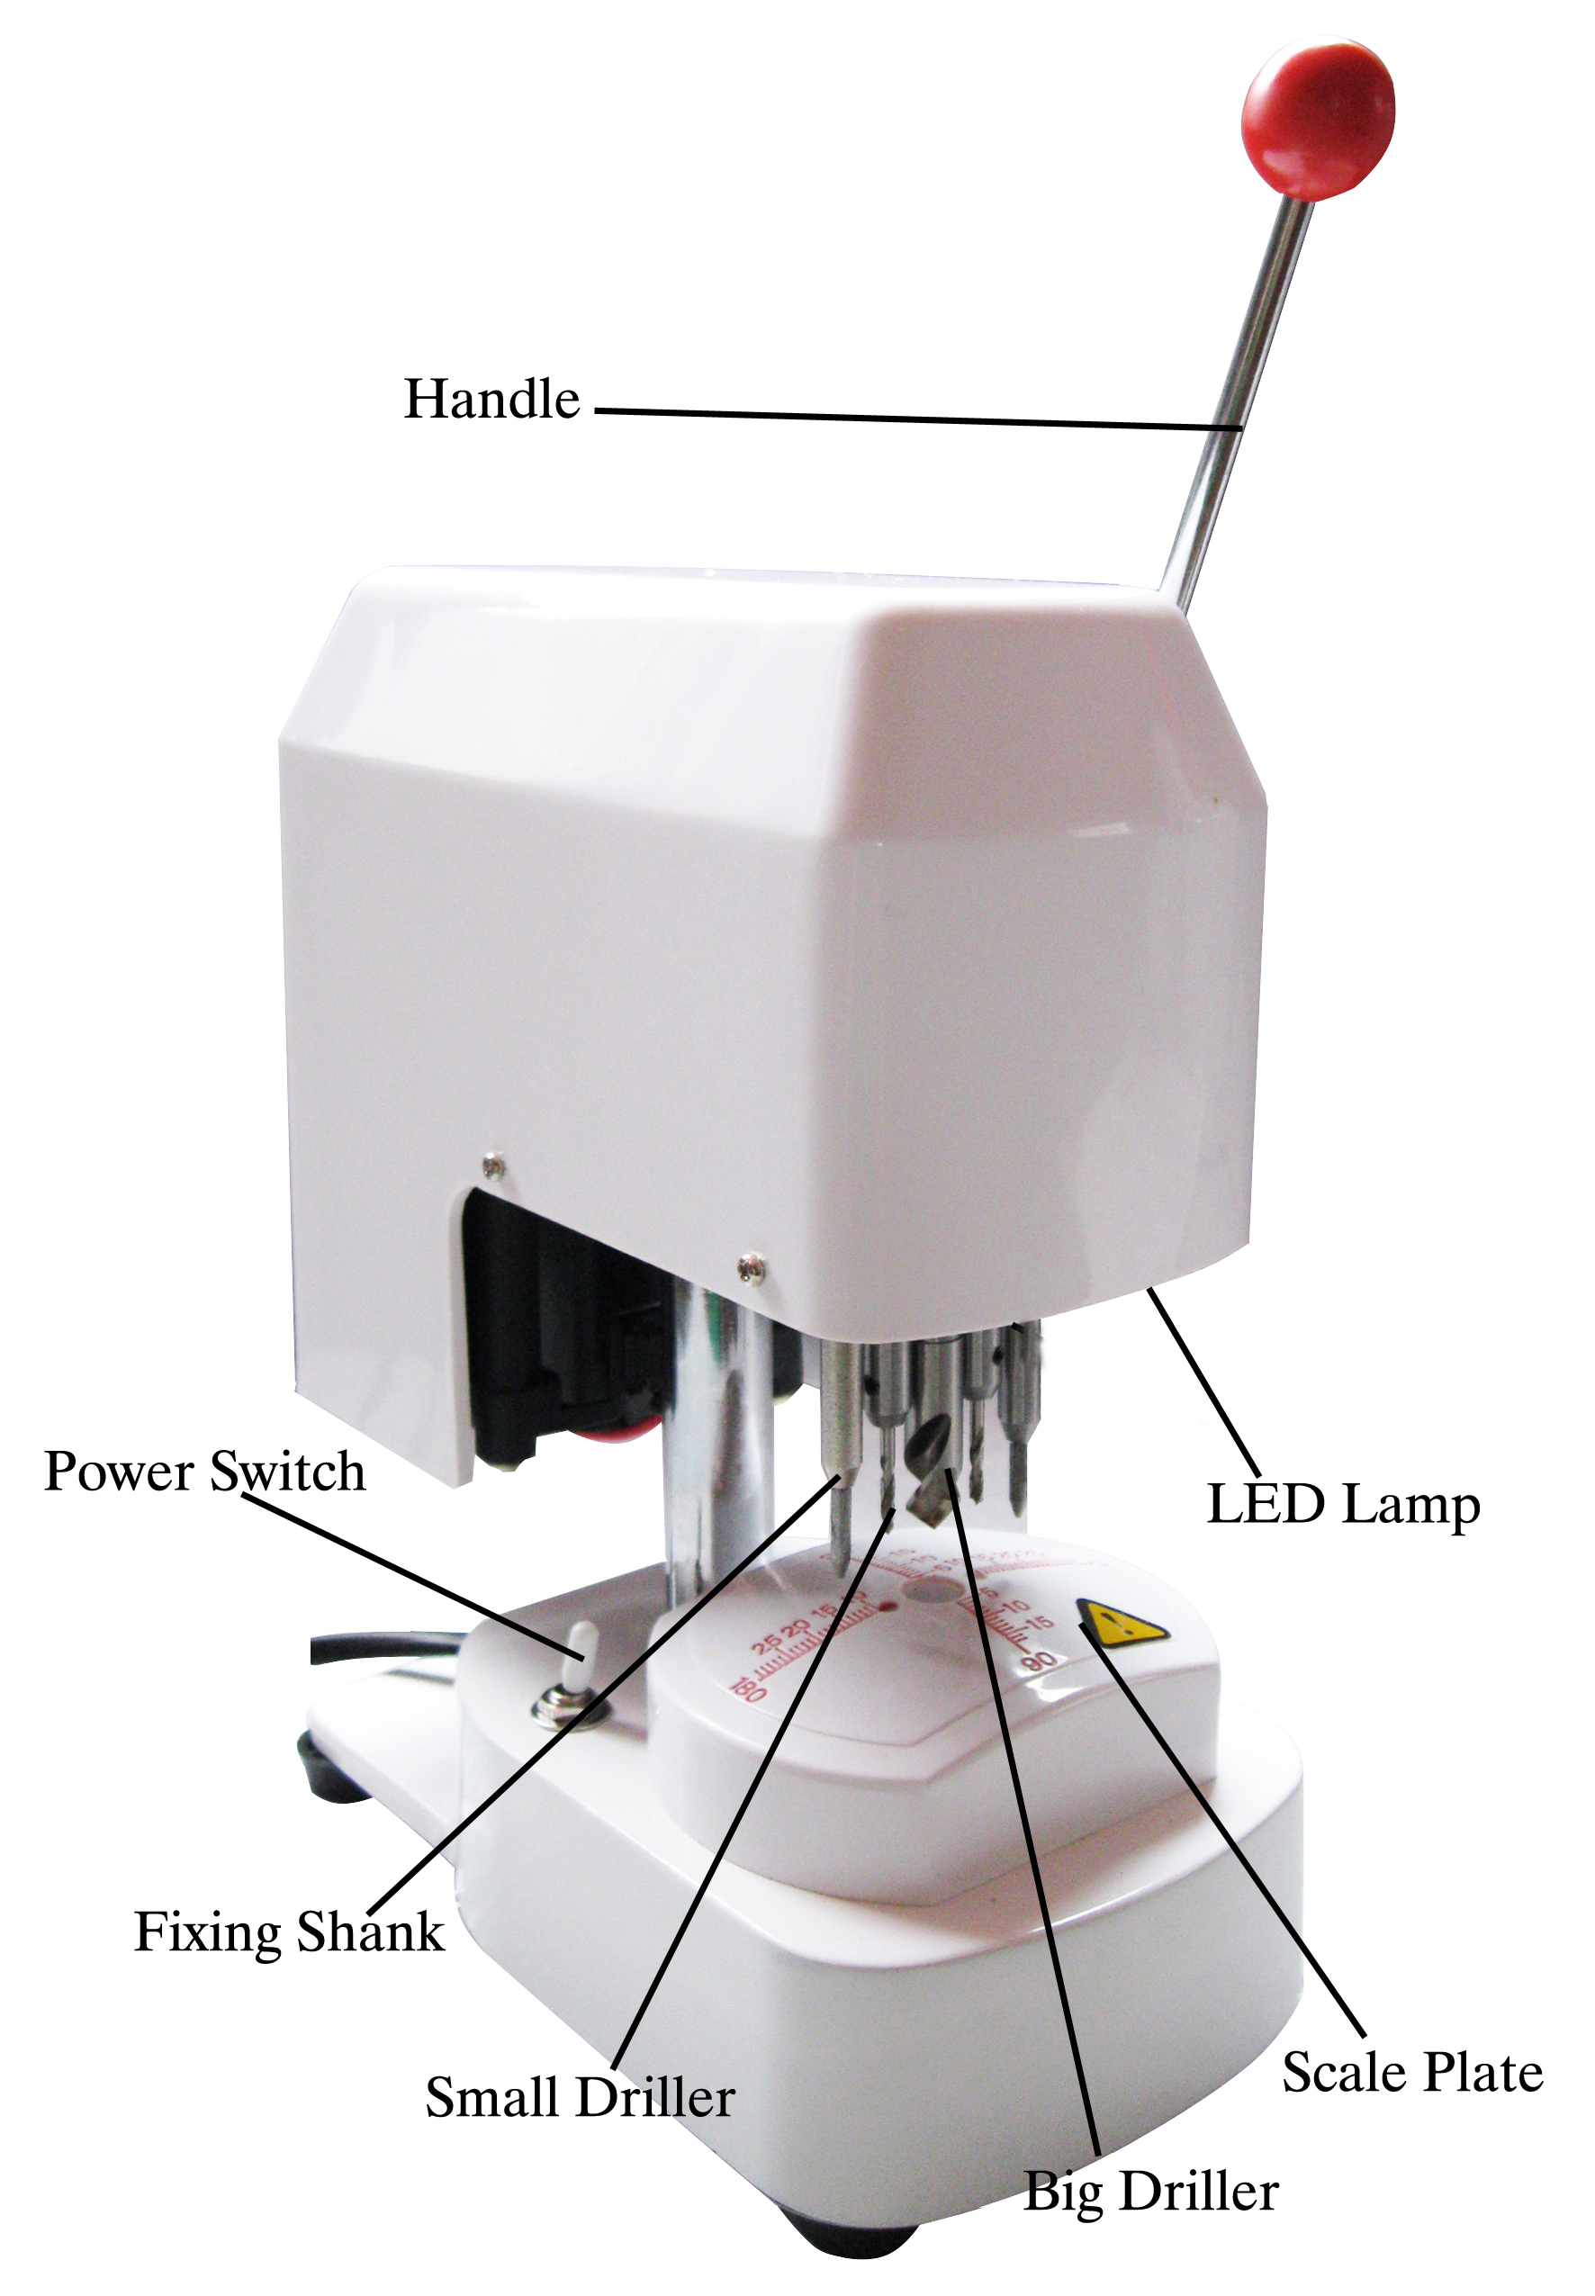
Name of Parts

