Saw Blade Grinder Sharpen Machine

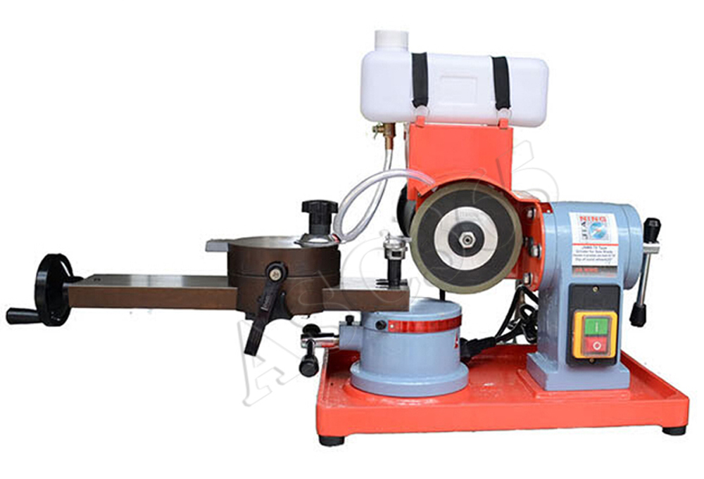

Instruction
- The machine is specially designed for hard alloy grinding blade , which is fit for grinding all kinds of hard alloy saw blades.
- Its fascia can support the teeth of saw blades and other parts in order to prevent jumping and improve grinding quality.
- The positioning pin can be adjusted to the best position in order to ensure the conformability of grinding blade .
- Slip board can rotate horizontally , which can ensure the primary grinding angle or change blade.
- The rotation table on the fascia can adjust the process angle of grinding blade.
- If the center axle is far away from the direction of grinding blade , and when the diameter of grinding saw blade and saw teeth are bigger ,the angle of saw blade is smaller ,the grinding blade and saw blade can be reversed 180°and adjust the table to a proper angle.
- Slip block, center axle, limited screw is installed on the rotation table , which is fit for operation and ensure the diameter from grinding blade to the center.
- ±20 rotation structure is installed on the grinding head, which can meet grinding for bevel saw teeth
- The diamond wheel can be dry﹣grinded.
Figure of Installation
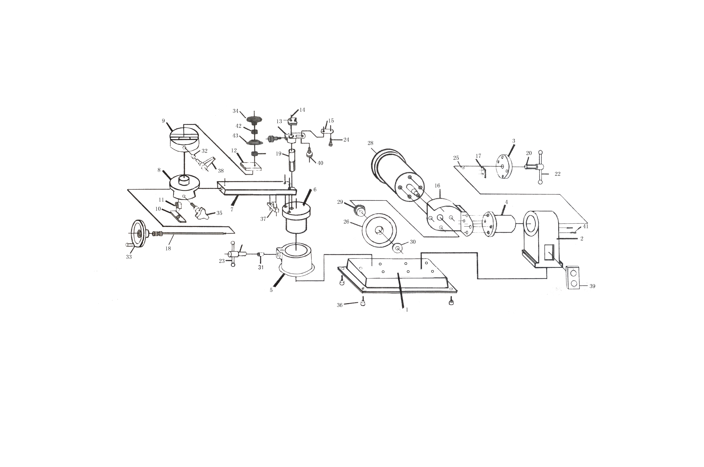
1.base | 7.slide base | 13.frame | 19.upright post | 25.mat cover | 31.big pin | 37.adjusting bolt base | 43.cover
2.box body | 8.slide disc | 14.board | 20.long bolt | 26.diamond wheel | 32.small pin | 38.fastening handle
3.end cover | 9.table | 15.positioning board | 21.short bolt | 27.cover | 33.hand wheel | 39.switch
4.rotatary base | 10.guide nut table | 16.safe cover | 22.long bolt | 28.motor | 34.round handle | 40.screw
5.rotary table base | 11.guide screw | 17.press board | 23.short bolt | 29.rear stuck disc | 35.turret handle | 41.lirnit pin
6.rotary table | 12.slide block | 18.adjusting bolt | 24.positioning pin | 30.fore stuck disc | 36.earth foot | 42.washe

Technical Parameters
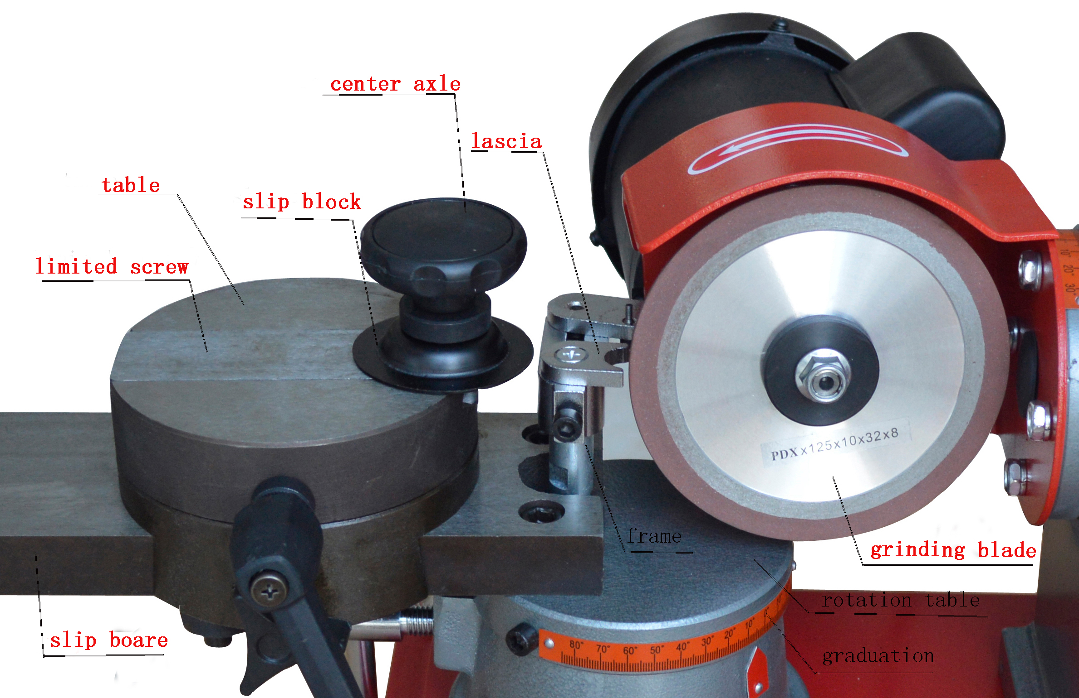
Stipulation | 125*10*32*8mm
Angle of grinding blade | ±20°
Angle of rotation frame | Left 30°; right 45°
Diameter of grindable saw | 3”-27.5” (80—700 mm)
Power | 250w
Voltage | 110v
Revolution | 2850rpm
Package | 770*430*300mm
Weight | 42kg
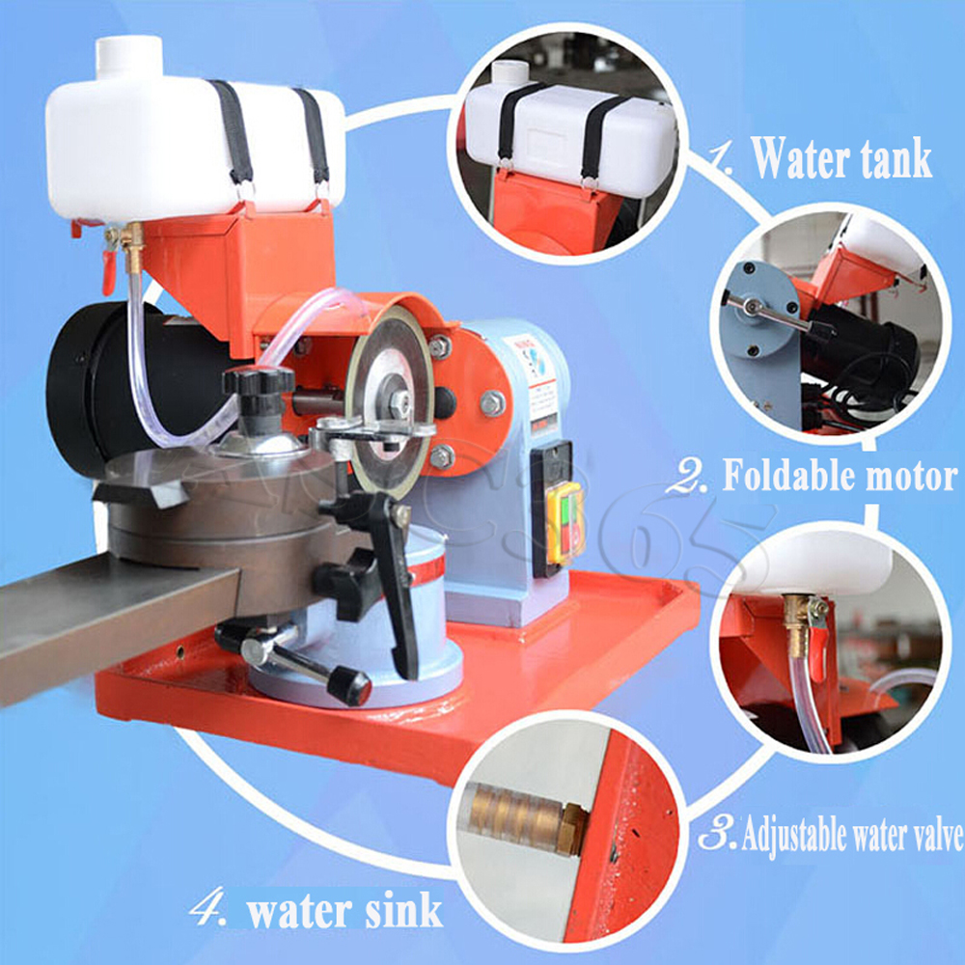
Method of operation
- First loose the fascia, then adjust the angle of grinding blade and fasten. Rotate the center axle to the grinding blade when grinding small saw ; otherwise away the grinding blade .
    - Push the center axle to the right
    - Install the saw blade, rotate the wheel and decide the position of grinding surface of saw teeth
    - Rotate the rotation table to ensure the angle if grinding face of saw teeth
    - Rotate the rotation table in order to ensure process angle of grinding blade. The cross angle between the grinding surface and work surface is about 5°
- Adjustment of center axle.
- Adjusting of positioning assembly.
Adjust the saw blade to the best grinding condition, rotate the positioning frame and fascia, adjust positioning pin to the more proper base of saw teeth and leave gap of grinding quantity, the fasten the fixed screw.
- Adjust the center axle to the same gap of grinding quantity to the right.
- After all the parts are fastened, the saw blade supported with hand will be grinded.

ASC365 International Ltd
http://asc365.com

