Operation of Pneumatic Heat Press Machine
6*6 inch(15*15 cm) 110V

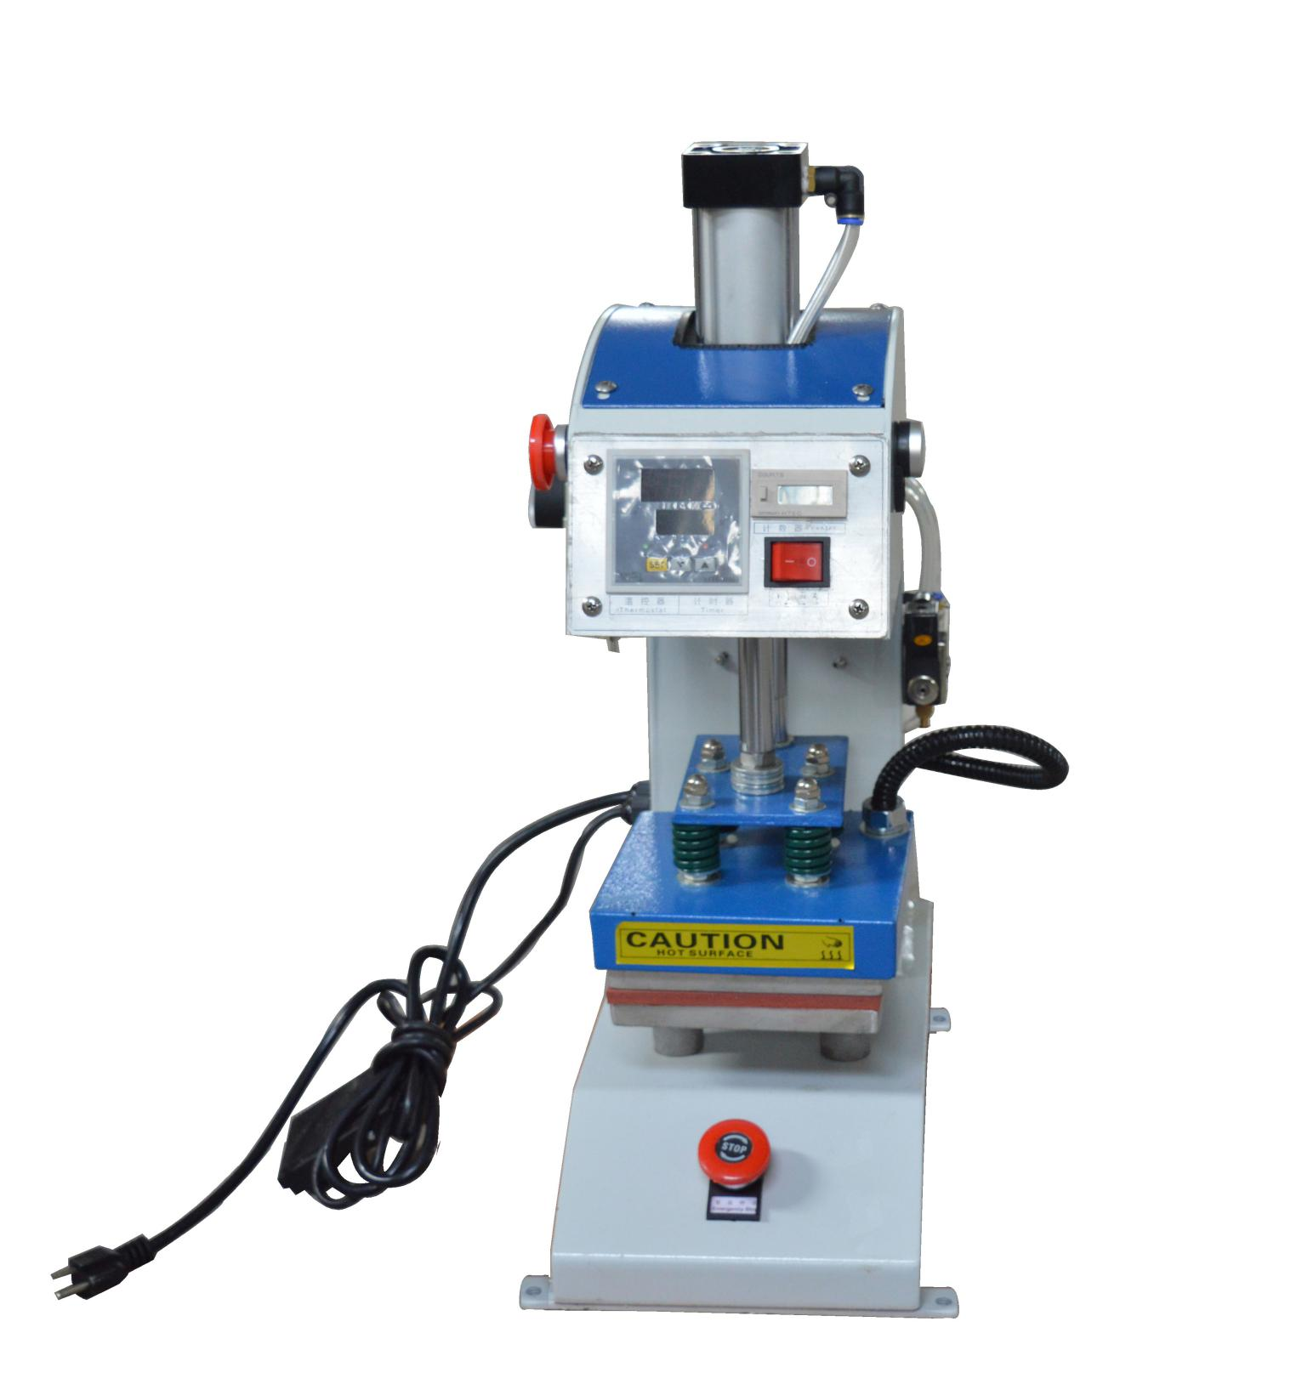

This machine is suitable for factory mass production.
Feature
1.The operation controlled by digital, working procedure complete situation uses signal indication, has the high accuracy
2.The radiation pipe and the hot plate is whole, safe, durable, and the thermal energy distribute averagely
3. Extra thick heat plate with TEFLON coating provides even temperature, clean and convenient, long life service.
4. Free to adjust the pressure, widely used in the factory assembly line operation
5.The bottom plate is laid with high temperature silica sponge, wide presses range
6.The radiation pipe and the heating plate in whole, short heating time, even temperature, widely used in factory operation line
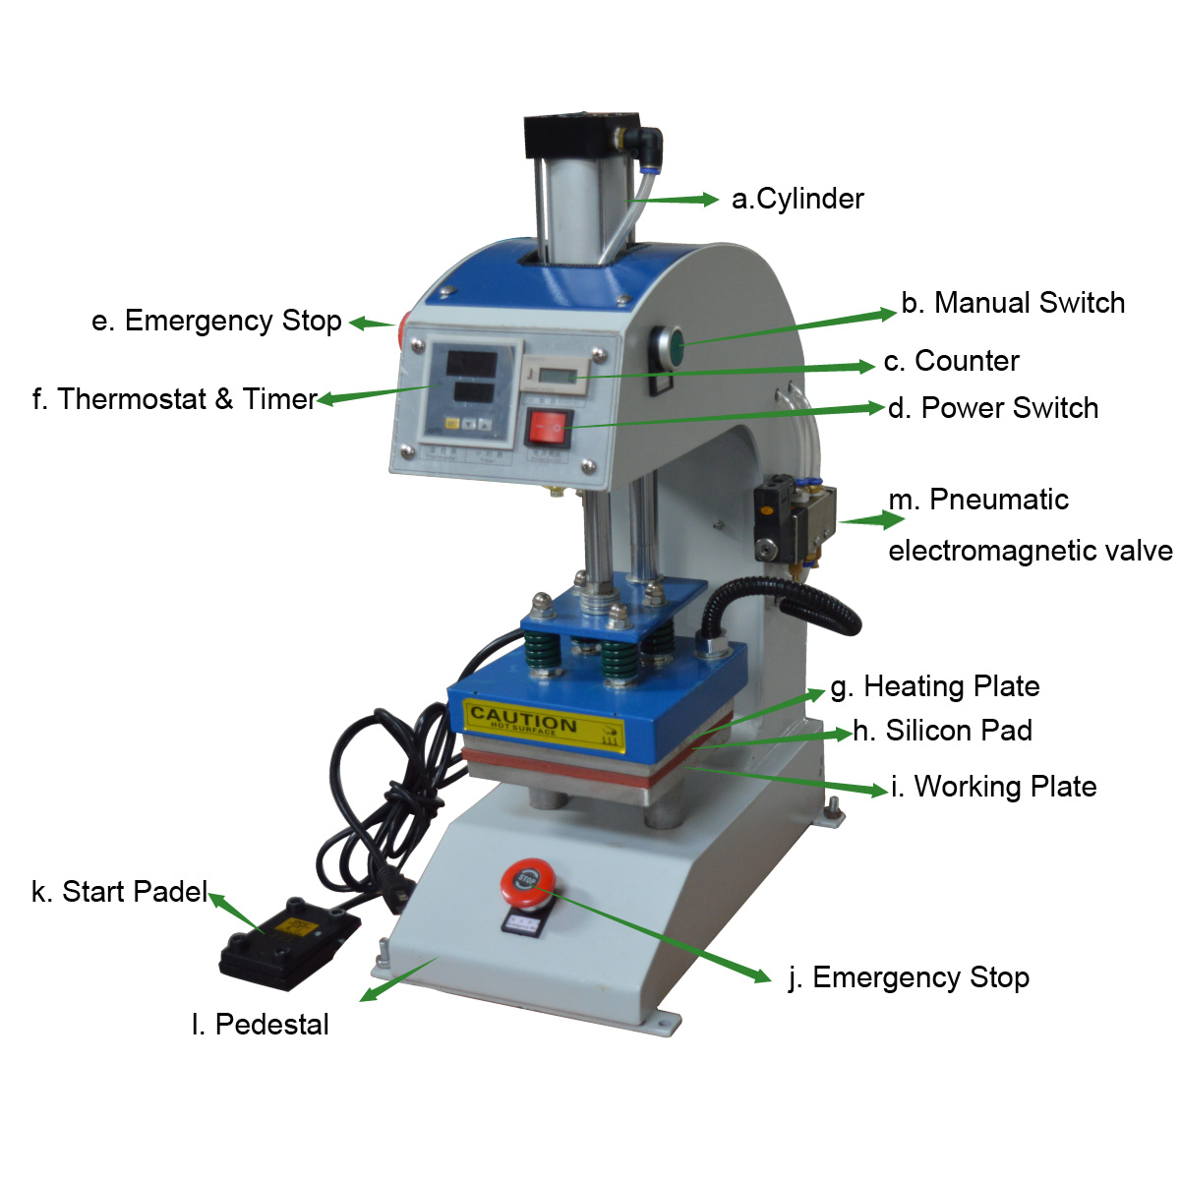

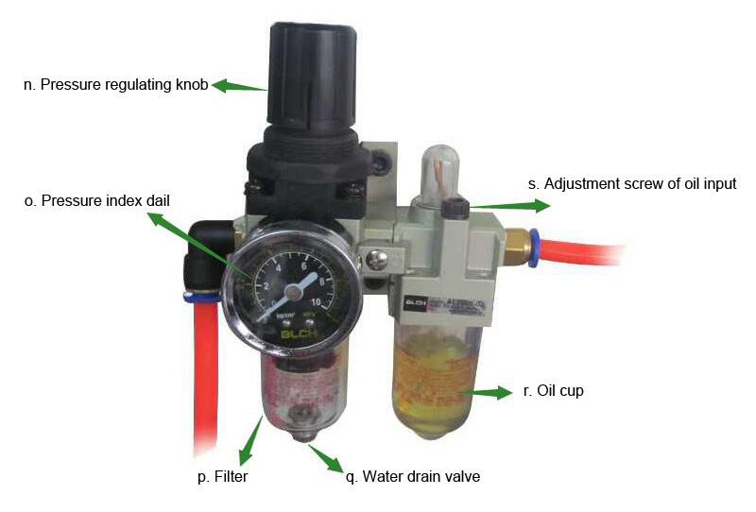

Technical parameter
Voltage | Power | Temperature range  (Celsius) | Time Range | Working table size | Weight
110v | 1200w | 0-399℃ | 0-999Sec | 23*30cm | 50kg
110v | 900w | 0-399℃ | 0-999Sec | 20*20cm | 48kg
110v | 900w | 0-399℃ | 0-999Sec | 18*18cm | 48kg
110v | 600w | 0-399℃ | 0-999Sec | 15*15cm | 45kg
110v | 400w | 0-399℃ | 0-999Sec | 10*10cm | 35kg

Operation guide
Attention:This machine must have reliable and protective ground line.
1.Insert power, turn on the power switch, then the power indicating lamp light.
2.Connect 4~8kg of pressure to the air entering gate which on the air filter(The air filter can adjust the pressure), when the cylinder work, the heating plate will rise.
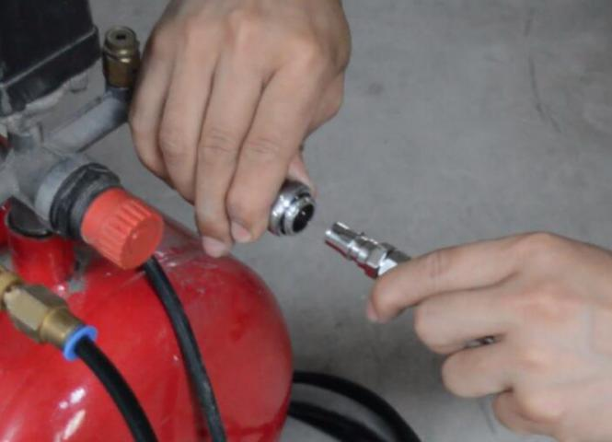
- Press “Set” once to set temperature. Adjust the “up” and “down” to the needed temperature. (When the temperature reach the preset temperature, then the operation can start.)
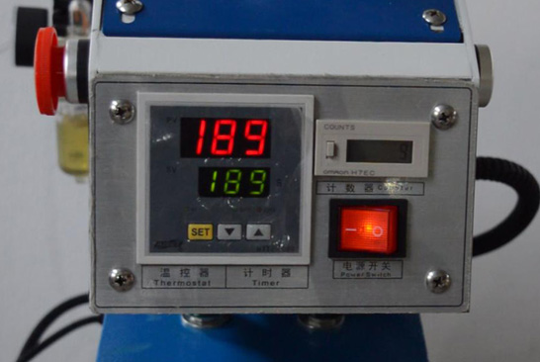
- Press “Set” for the second time to set time. Adjust the “up” and “down” to the needed time.
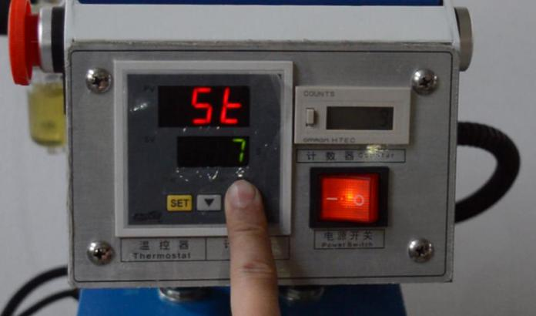
5.When get the preset temperature, press the green manual switch, then the machine start working. When the time is up, the heating plate return up. You can also stamp on the padel to operate the machine.(If any of the emergency stop button is locked , the machine won't work.)
6.Please note that when your hands between the heating board and bottom board make sure not to start the machine by pressing the manual switch or stamp the padel.
Maintenance
1.Pressure: If the pressure is not big enough, adjust the Pressure regulating knob, first need lift the knob gently, and then revolve the knob clockwise to increase the pressure, revolve it anticlockwise to decrease the pressure.
2.Time: When the preset time finish, but the heating plate doesn't return to the top.
1)Check the air pressure if it is normal.
2)Check the electric wire if it get damage."
3.Temperature: After you set the controller, the machine's indication light is bright, but the heating plate is not hot, please check the circuit.
4.To make sure the slide rail more smooth, please add lubricant oil once half a month to maintain.
5.Check the filter frequently.
A.Make sure the oil cup have cylinder lubricating oil so that can maintain the air cylinder.
B.The adjustment screw of the oil input should be tightened suitably. If it is too loose the oil will get in the cylinder too much and it will flow out from the machine head, then you need screw it anticlockwise. If it is too tight, it will can not get in the air cylinder to maintain it, then you need screw it clockwise.
C.Make sure the cup on the left of the oil cup is empty, if you found there is some water , please jack up the water drain valve use your finger to make it flow out, because if there is too much water , it will destroy the cylinder easily."

ASC365 International Ltd
http://asc365.com

