Instruction of the ASC365 Extrusion Laminator
Application:
This extrusion laminator is specially made for beautifying and protecting laser, inkjet photo paper, coated paper, back adhesive paper or other stuff after being printed. It is convenient, cheap and energy-saving, protecting photos, card, poster and so on from wearing, humidity, liquids, UV, fading, and enhancing strength and appearance and extending storage life.

Basic parameters:
- Laminating speed:39.4”/m(1000mm/min)
- Laminating thickness:0.008"-0.004'(0.2mm-1mm)
- Laminating width:0-14.17"(90-360mm)
- Input voltage: 220V 50HZ-60HZ
- Power : 450W
- Consumption :5-10ml/㎡
- Net weight:100lb(45kg)
- Package size:24"x22"x9.7"(606x556x246mm)

Installation and Operation
1) :Open the carton and take out the machine .Put it on the table. Take out the eight machine feet from the sealing bag and install them under the machine and the tray.

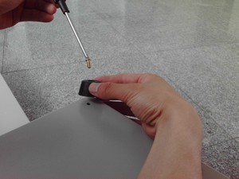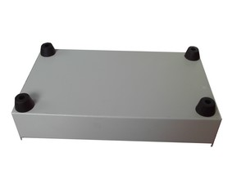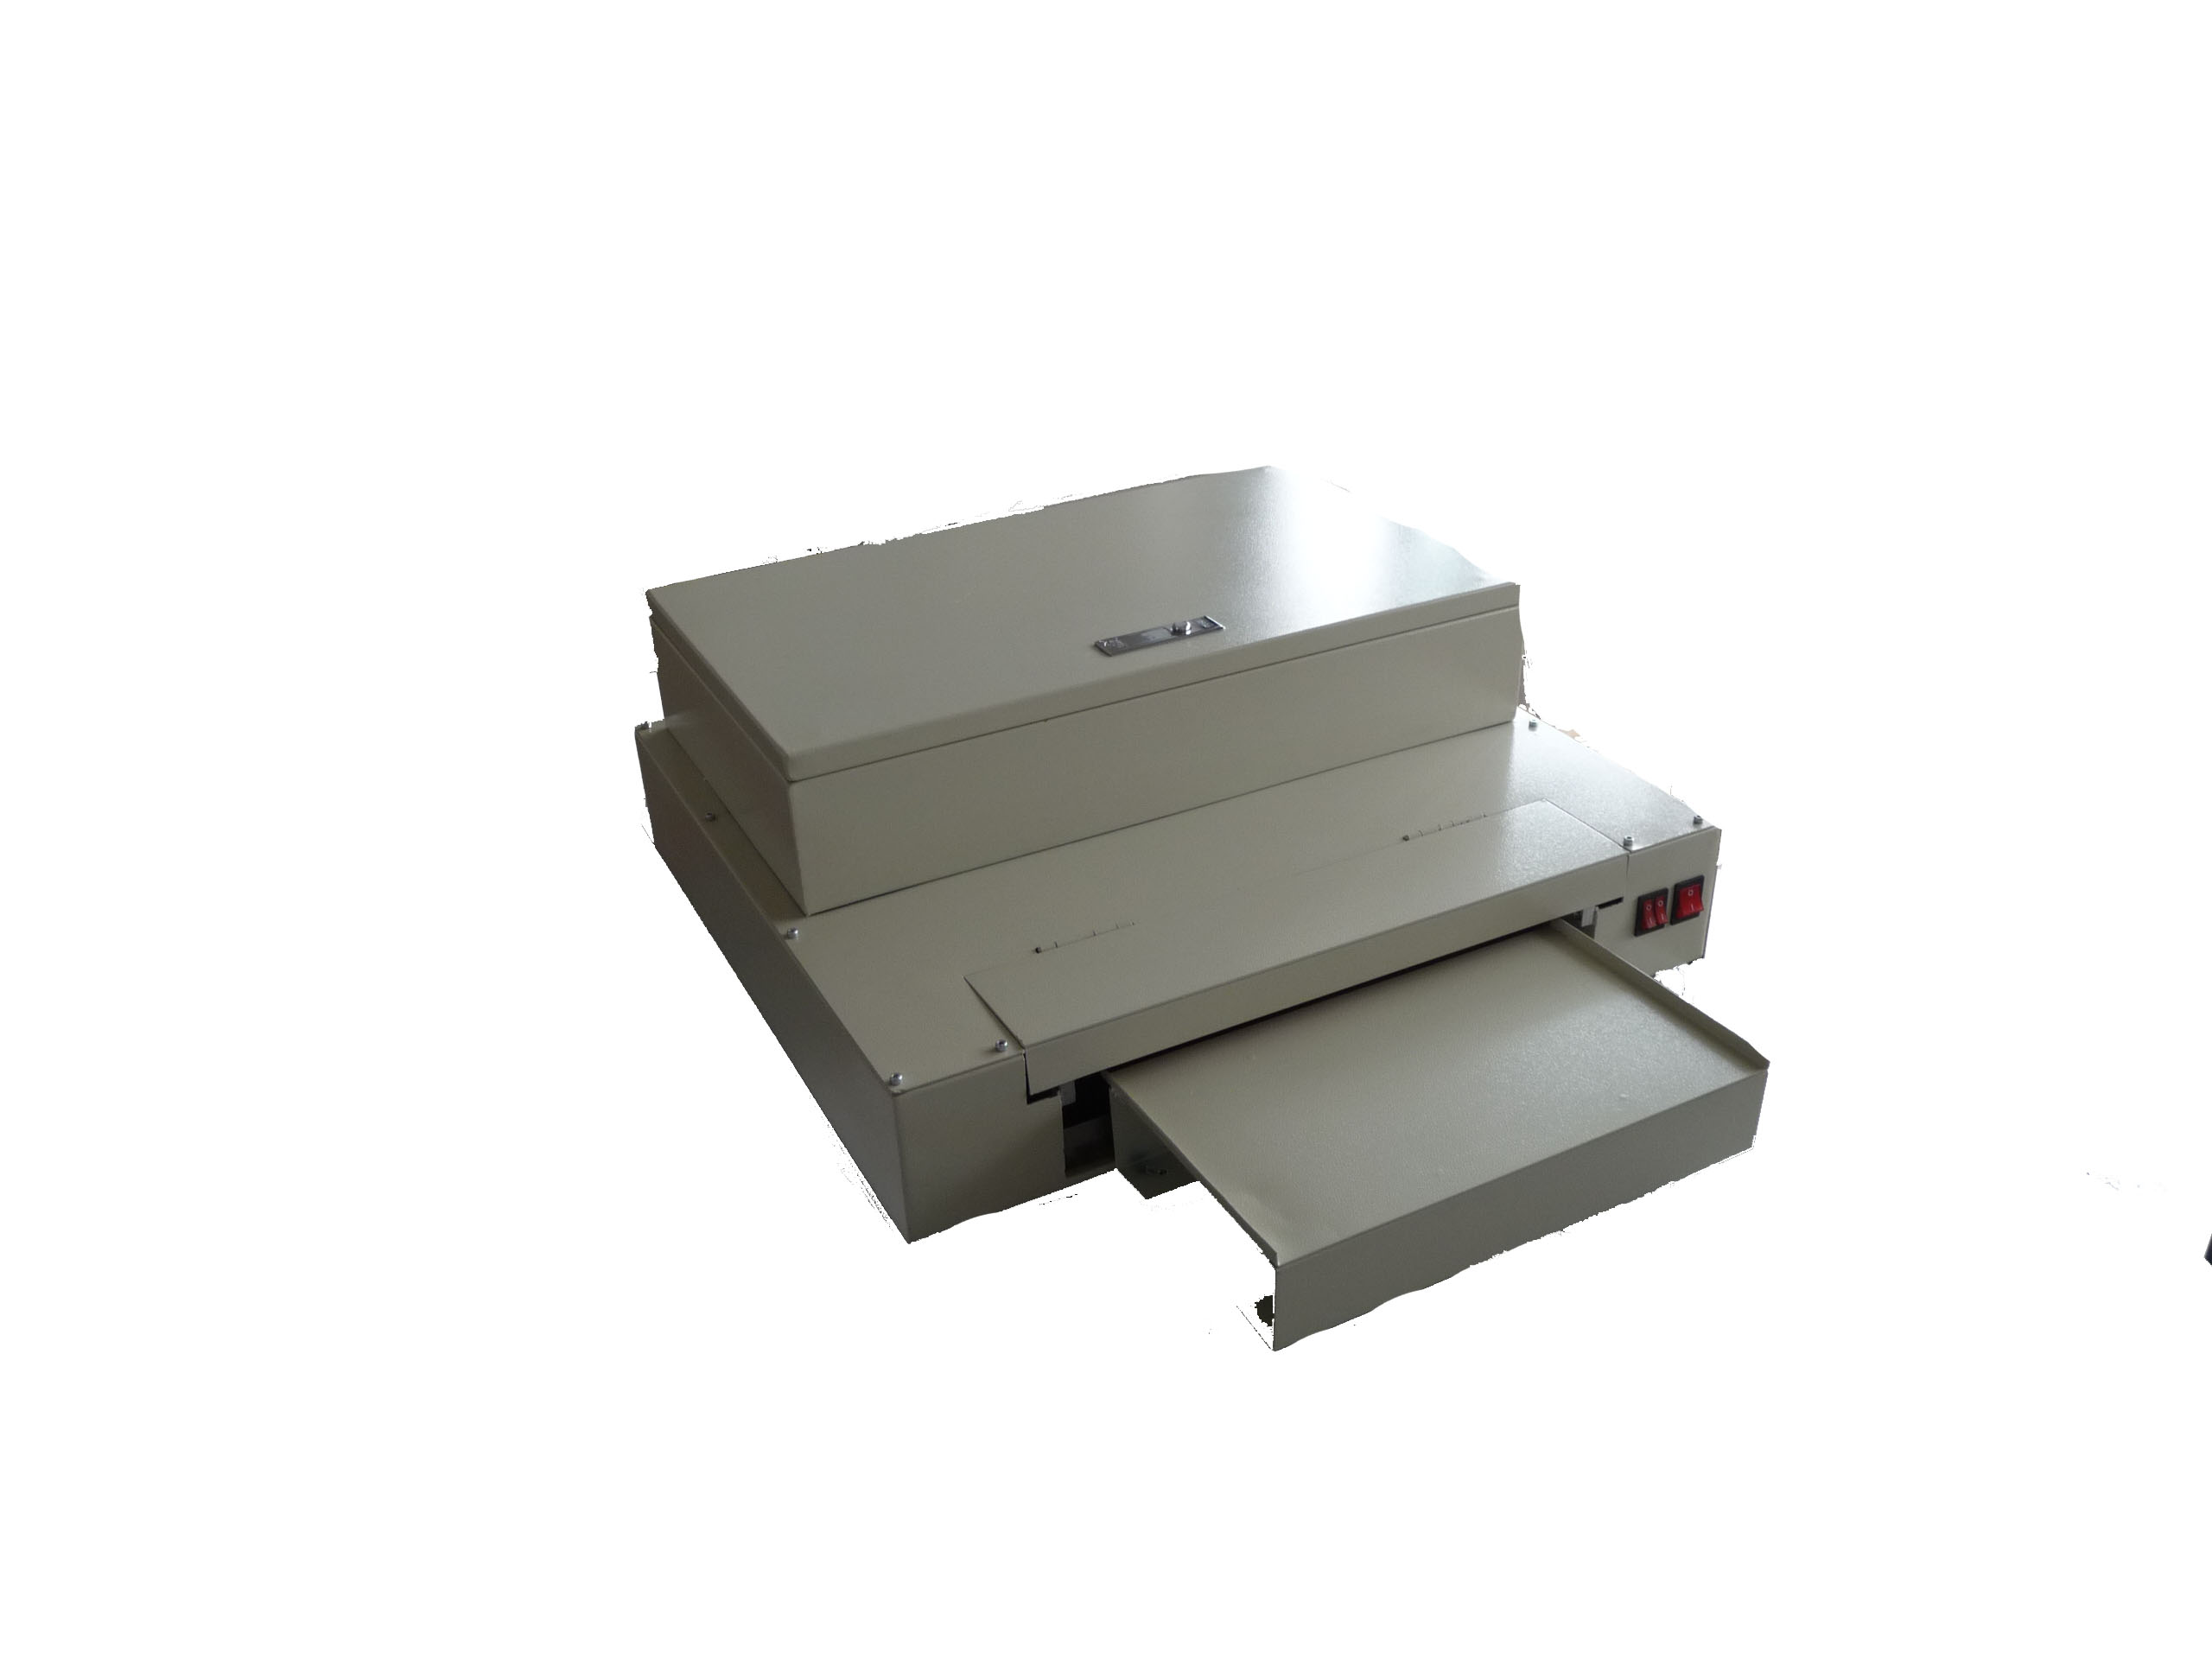

2): Observe if the chains of the machine are in the right place and if they get stuck and skewed, reset them.
3): Open the cover of the machine box .Cut off the white belt.
4): Put the film liquid into the groove, and the depth of the liquid should be less than 0.6” (1.5cm).Put the liquid groove under the glue roller and put the absorbing pipe into the liquid groove.
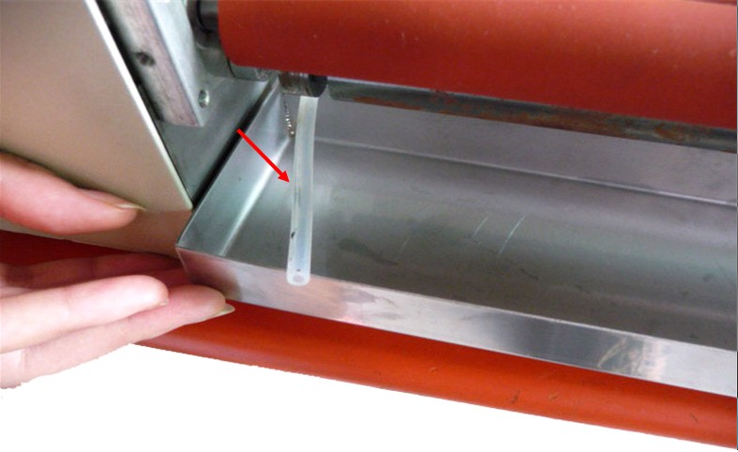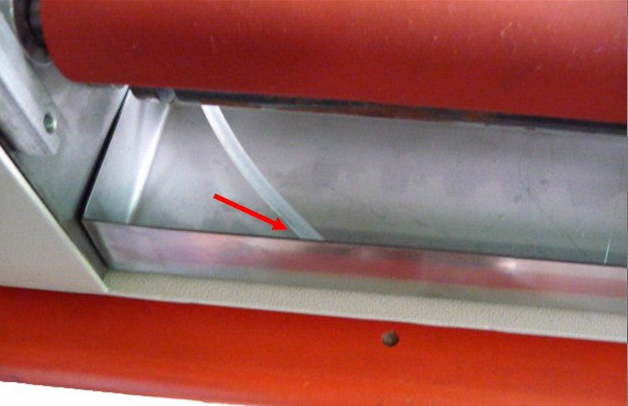
5): Put the power line into the socket and open the power. Open three switchs (the right is the head power switch, the middle is the UV tube switch and the left is the film liquid circulating switch.) the machine now works. The tube of the UV need preheating and it takes about three minutes. The first time it is used, observe the glue roller from the entrance of the machine .When the glue roller is filled with membrane liquid, it can work.
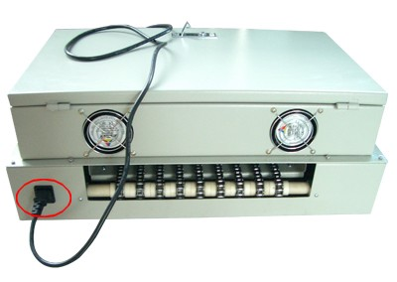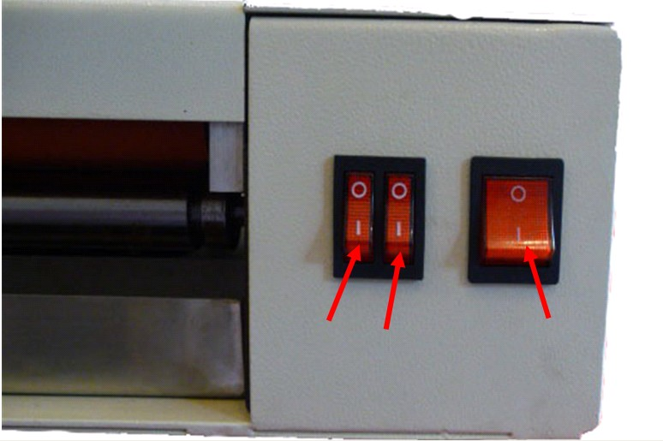
6): Put the picture into the tray making the picture face up ,then put it under the glue roller. when the Wait the picture come though the machine, laminating is finished.
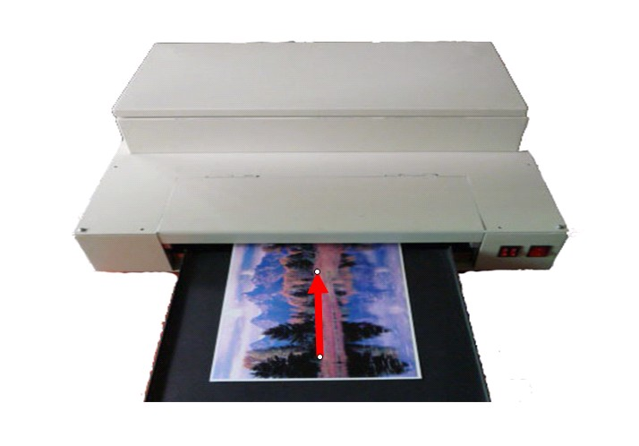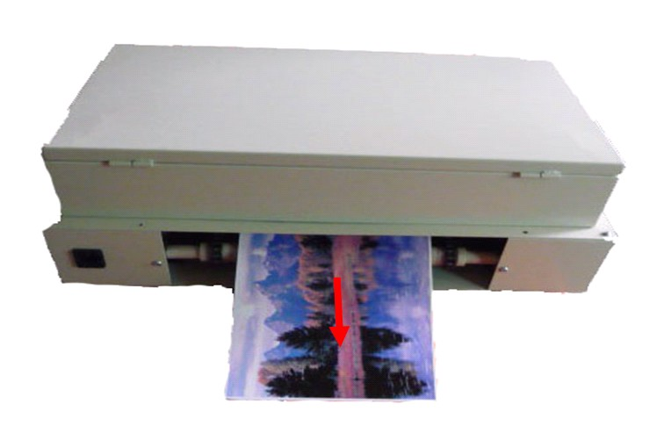
7):If the paper for laminating is too thin ,you can put one paper under it .Increasing its thickness can make it better .
8):If the laminating film is too thin or too thick ,you can adjust the space between the glue roller to make it. Open the cover of the glue roller ,you can see two screws clearly at two sides of the glue roller. Adjust these two screws clockwise with a small hexagon ,the space will become small and the laminating film will become thin .Adjust it anticlockwise ,the space will become large and the lanimating will become thick.
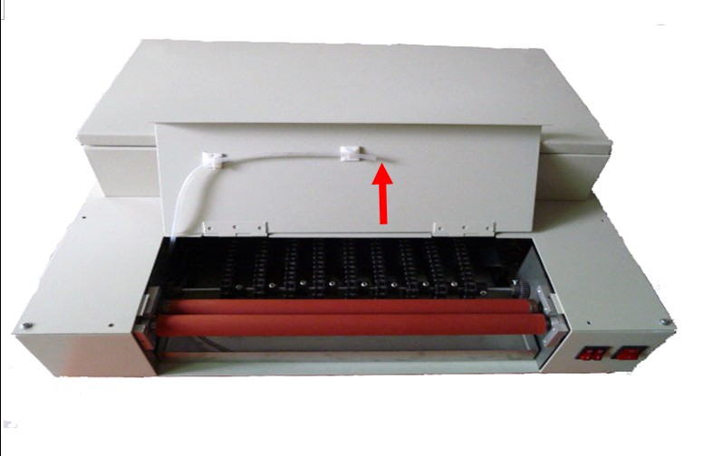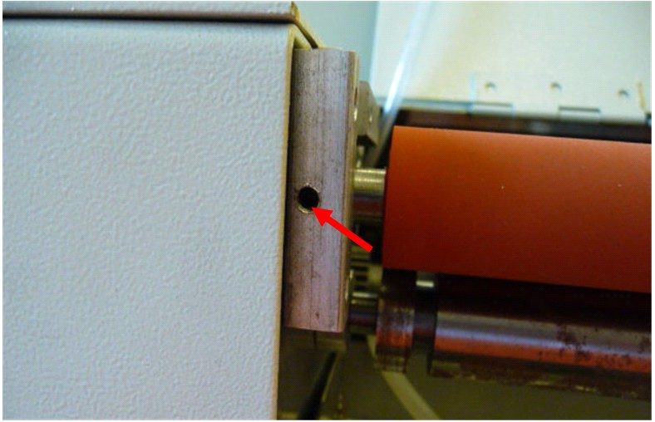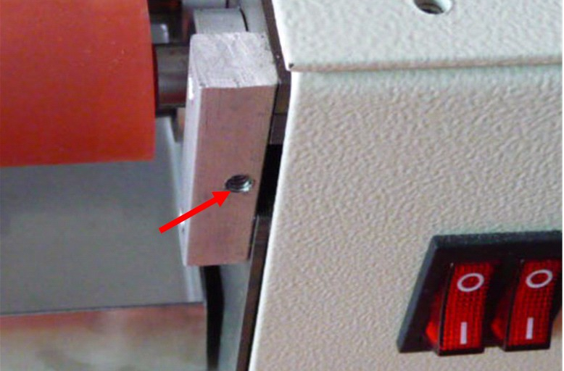
9):If the machine will not be used for a long time ,it is better to clean glue roller. Change the film liquid in the groove into alcohol, and let it work for a while. Or you can open the cover of the glue roller ,and pour the alcohol between the two glue rollers .Or take out the absorbing pipe out of the groove, let the machine work emptily for a while and then it also can get clean.
Notice:
1) This machine request that the paper must be plat and can endure the high temperature. It will not be curly when it is heated.
2) The thickness of the Input medium should between 0.008” and 0.004”(0.2mm and 1mm).If it is less then 0008”,put one piece of paper under the medium and put them together into the glue roller.
3) The machine must work on horizontal platform.
4) The environment of the workplace should be clean and ventilated, and do not expose in the sunlight.
5) You must not turn on the UV light instantly when you just turn it off, do not start working until the UV tube is cool about 2 mins.
6) The UV tube’s lifetime is about 800-1000 hours. If you find the light tube can not light and the film become sticky. It means the light tube’s life come to an end and you should change it.
Change the UV tube
1) Put the UV light beside the machine, open the cover of the machine box carefully.

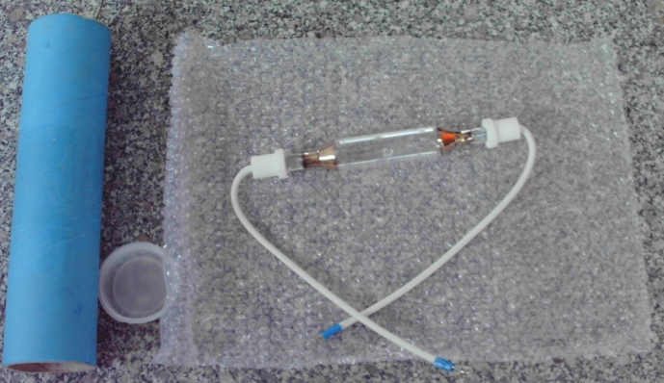
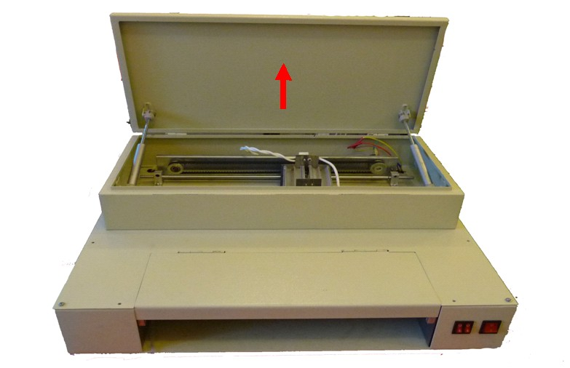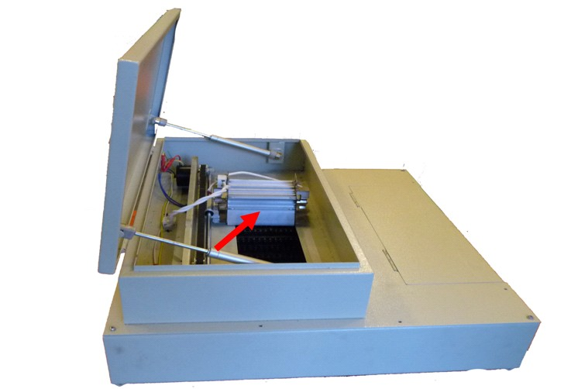
2) Take apart two wires of the tube from the porcelain seat .Take off the tube carefully and put the new one right there.
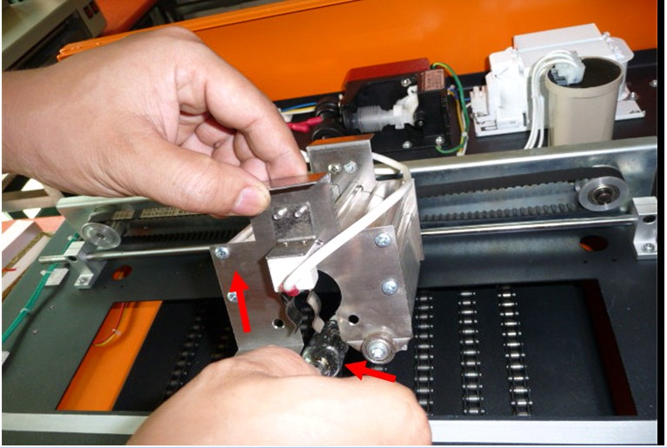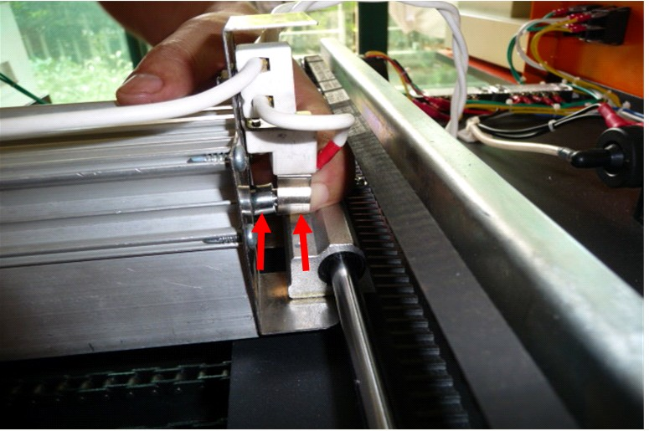
3) Install the cover of the machine box as it used to be .

ASC365 International Ltd

www.asc365.com

