006591 SPE-A级QMH170型曲面丝印机

006591 SPE-A Type QMH170 Curved Screen Printing Machine

本机主要用于圆柱型，圆锥体型类产品；如各种塑料，玻璃，金属材料制成的圆柱型，圆锥体型产品等，包括酒瓶，药瓶，化妆品瓶等各种包装瓶；马克杯，保温杯，啤酒杯，红酒杯等各种杯子；玻璃管，钢笔,圆珠笔，鱼竿，球棒等小型圆柱型产品。

Curved screen printing machine is mainly used for printing cylindrical type, cone type products; Such as a variety of plastic, glass, metal materials made of cylindrical, conical shape products, including wine bottles, medicine bottles, cosmetics bottles and other packaging bottles; Mugs, thermos mugs, beer mugs, red mugs, etc. Glass tube, pen ,ballpoint pen, fishing rod, bat and other small cylindrical products;

对圆柱型，圆锥体型类产品印刷面有较大凹陷起或凸起，印刷面内有麻点等非平面的不适合本机的印刷。

For cylindrical or conical type products, the printing surface has a large concave or convex, the printing surface has spots and other non-plane printing is not suitable for the machine.

本曲面丝印机主要用于直径170毫米以下圆柱型，圆锥体型类产品的印刷。

This curved screen printing machine is mainly used for the printing of cylindrical and conical products with the diameter below 170 mm.

1. 本机采用左右推拉式结构；可根据需要调整安装件，适用左手或右手方便操作；适合印刷高度200毫米；长度150毫米内图案；适合外径260\*450毫米以内，厚度35毫米以内各种网板的使用。

The machine adopts left and right push-pull structure.Installation parts can be adjusted as needed, it is suitable for left or right hand easy operation. Suitable for printing patterns with width less than 200mm; Length less than 150 mm ; Suitable for all kinds of screen plate with the outer diameter less than 260\* 450mm and thickness less than 35mm.

1. 本机为后主架高度调节定位，后部主横梁根据承印物高度，通过调整立柱丝杆螺丝进行上下调整。上下调整范围为200毫米。可印刷直径170毫米内的圆柱型，圆锥体型类产品。

the machine is positioned by adjusting the height of the rear main frame , the rear main beam according to the height of the substrate, by adjusting the stand column screw to adjust up and down .The upper and lower adjustment range is 200 mm.It can used for printing cylindrical and conical products with the diameter below 170 mm.

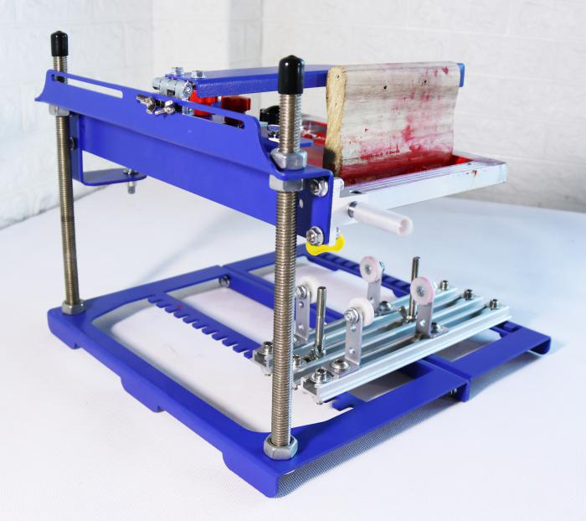

1. 承印物印刷架为可左右前后移动式设计，底部的三个固定铝条直接安装在底座上，安装铝条可左右移动290毫米；两边为承印物放置架安装条，中间的为承印物定位架安装条。三只安装条可根据需要左右移动，并卡位在底座前后19个U型孔中（每孔间距15毫米），保证安装条定位准确。

安装条移位：将安装条两头螺丝松开，将安装条向机器后方推动至长条孔，左右移动安装条，至合适位置后，将安装条拉向固定U型槽，拧紧两头螺丝即可定位完成。

Substrate printing rack can move from left to right ,front to rear, three fixed aluminum bar in the bottom can be directly installed on the base, the aluminum bar base can move 290 mm from left to right ; Both sides aluminum alloy strips are substrate placement rack installation strip, the middle is substrate positioning rack installation strip. Three mounting bars can be moved around as needed. Lock position in the base front and rear 19 u-shaped holes (each hole spacing 15 mm), to ensure that the installation strip positioning accurate.

Installation of aluminum bar movement: loosen the screws at both ends of the installation bar . Push the installation strip to the rear of the machine to the long hole of the strip, move the installation strip left and right until it is in a proper position, then pull the installation strip to the fixed U groove .Tighten the screws at both ends to complete the positioning.

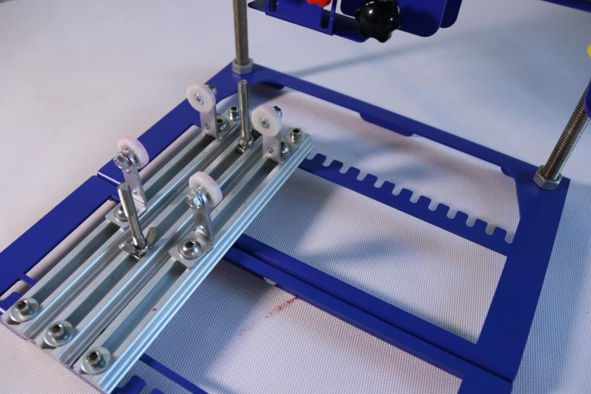

1. 采用三套承印物放置滚轮，分别为金属轴承滚轮（直径19毫米）；尼龙轴承滚轮（直径25毫米）；塑胶轴承滚轮（直径50毫米），使用者可根据需要更换使用。主架与附件架均可安装三款滚轮。

轴承安装架直接固定在铝条安装孔中，根据承印物高度可前后移动最大160毫米；

附加安装架4只，拆掉原主安装架上的轴承，直接用螺丝将附加安装架固定在主安装上，主要用于圆锥型产品的印刷。附加安装架可上下移动20毫米。

Adopts three sets of substrate to place rollers, respectively, metal bearing rollers (diameter of 19 mm); Nylon bearing roller (diameter 25 mm); Plastic bearing roller (diameter 50mm) can be changed according to the user's needs. Main frame and accessory frame can be installed with three rollers.

The bearing mounting bracket is directly fixed in the hole of the aluminum bar mounting strip. It can move up to 160 mm according to the width of the substrate; 4 additional mounting frames, remove the bearings of the original mounting frame and fix the additional mounting frames on the main mounting frame directly with screws. It is mainly used for printing conical products. Additional mounting frame can move up and down 20 mm.

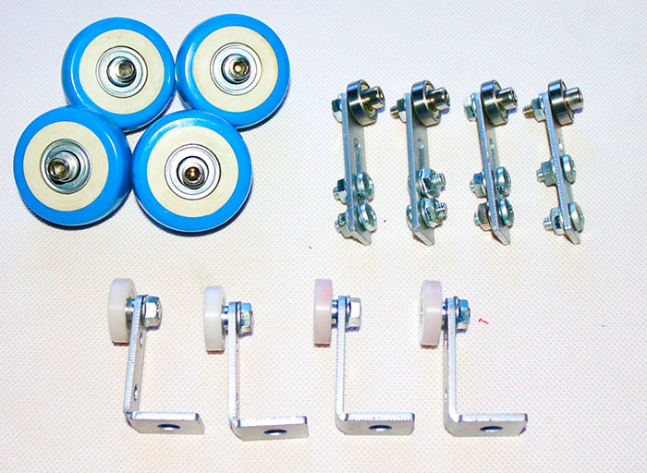

1. 网板安装采用双向固定式，上部把手固定网框；夹头中部挡板根据网框宽度调整，紧贴网框内侧后将两个把手固定即可将网板紧紧固定，可适用高，寛10-35毫米的各种网板。

The installation of the screen plate is bidirectional fixed, the upper handle fixed screen frame; The baffle in the middle of the chuck is adjusted according to the width of the screen frame. After sticking to the inside of the frame, fix the two handles to fix the screen plate tightly. It can be applied to all kinds of screen plates with high, wide 10-35mm.

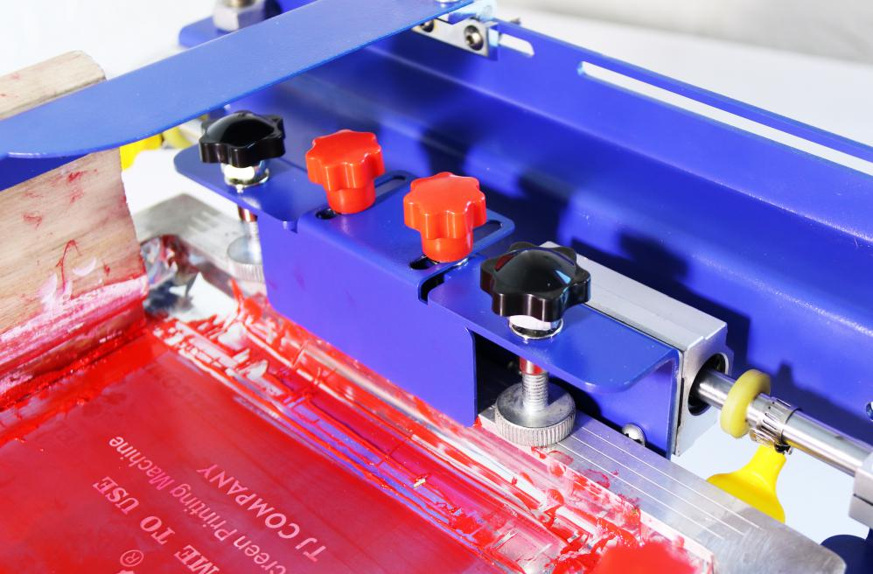

1. 网板支撑座主要用于支撑网板印刷后的放置，防止网板在手扶时落下；该支撑座可根据网板厚度上下调整以适合最佳支撑。

The screen plate support base is mainly used to support placement of the screen plate after printing , prevent the screen plate falling down when support by hand; The base can be adjusted up and down according to the thickness of the screen plate to suit the best support.

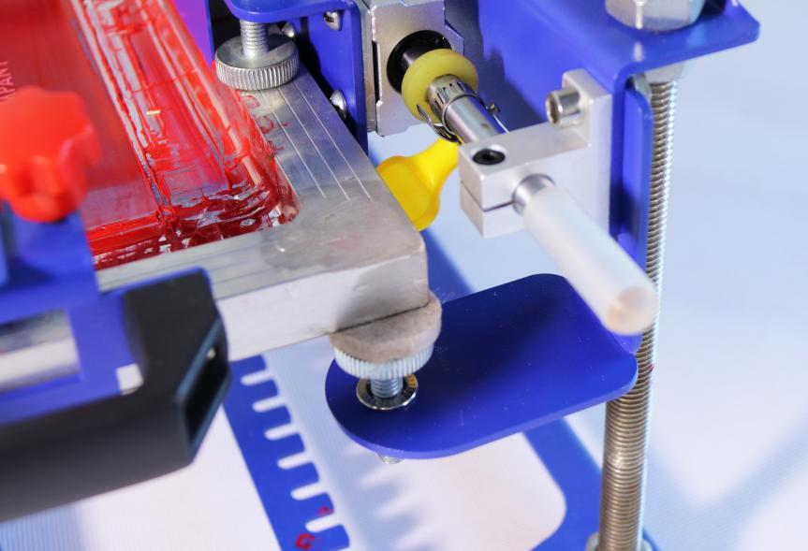

1. 网框配有专用把手直接固定在网框上，两种安装方式，可安装在网框上部，也可安装网板侧面，左右推拉方便快捷，该把手可任意固定在网框的任何部位，上部红色把手与前部挡板固定网板，保证网板牢牢固定在把手上。该把手适合厚度和宽度35毫米内的各种网框。

the screen frame with a special handle directly fixed on the screen frame, two installation methods, it can be installed in the upper part of the screen frame,it also can be installed on the side of the screen plate,it is easy to push and pull from left to right, the handle can be arbitrarily fixed in any part of the screen frame, the upper red handle and the front baffle fixed screen plate, to ensure that the screen plate firmly fixed on the handle. The handle fits various mesh frames within a thickness and width of 35 mm.

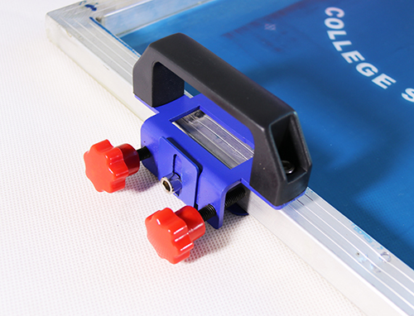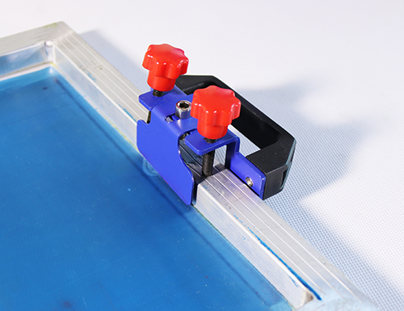

1. 刮板架用于使用自攻丝固定木柄刮板，适合使用长度200毫米内的木柄刮板。该架可根据网板图案位置左右移动250毫米。

Squeegee rack is used for self-tapping wood handle squeegee, and it is suitable for the length of 200mm wood handle squeegee. The rack can be moved about 250mm according to the position of the pattern of the screen plate.

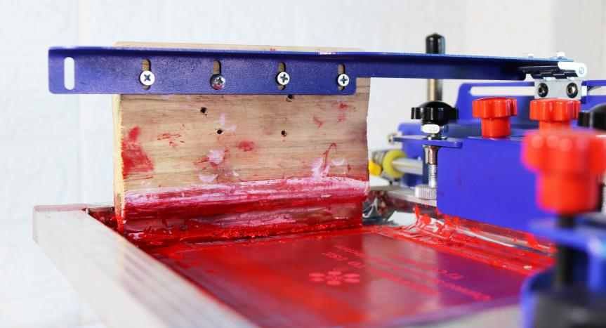

1. 网板移动距离定位；光轴两边配有定位圈与防撞击胶圈，根据图案尺寸左右调整定位圈达到合适位置；防撞击胶圈可防止金属之间碰撞发出的异响，保护机器部件。

The screen plate movement distance positioning; Both sides of the optical axis are equipped with positioning rings and anti-impact rubber rings. The positioning rings are adjusted to the appropriate position according to the pattern size. Anti-impact apron can prevent the metal between the impact of abnormal sound, protect machine parts.

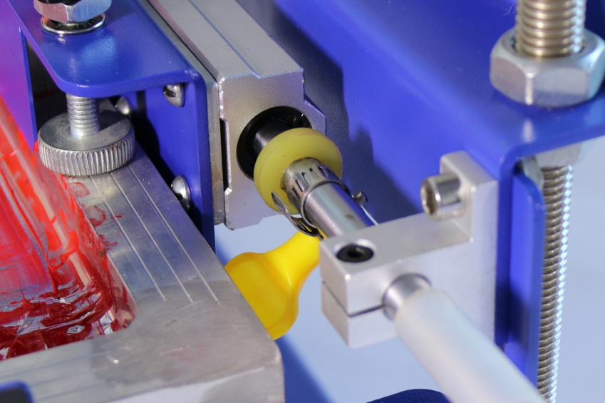

十，本机可通过调整三个部件完成对左手主操作的实现；调整网框把手；调整滑块轴承位置；调整网板支撑座等三个部件即可完成。

This machine can realize the main operation of the left hand by adjusting three parts. Adjust the screen frame handle; Adjust the position of the slider bearing; Adjusting the support base of the screen plate.

十一，使用方法（仅供参考）：Usage (for reference only) :

1. 安装网板并调整网板下支撑座至网板基本水平；安装网框拉动把手；

Install the screen plate and adjust the support seat under the screen plate to the basic level of the screen plate; Install screen frame pull handle;

1. 安装刮板并调整刮板距离图案1-2厘米处固定；

Install the scraper and fix it at a distance of 1-2 cm from the pattern;

1. 调整承印物印刷架与滚轮轴承位置，放置承印物，承印物顶部与网板间距1-3毫米；并使承印物最顶部与刮刀底部对齐；

Adjust the position of the substrate printing frame and roller bearing, place the substrate, and the spacing between the top of the substrate and the screen plate is 1-3 mm; And make the substrate the top and the bottom of the scraper aligned;

1. 根据图案左右尺寸调整网板距离定位旋钮；

Adjust the distance positioning knob of the screen plate according to the left and right dimensions of the pattern;

1. 网板内放入油墨；

Put ink into the screen frame;

1. 左手（或右手）压住刮板；右手（或左手）拉动网框上的把手即可印刷。

Press the scraper with the left hand (or right hand); Pull the handle with right hand (or left hand)on the screen frame to print.