006593 SPE-B级QMH170型曲面丝印机

本机主要用于圆柱型，圆锥体型类产品；如各种塑料，玻璃，金属材料制成的圆柱型，圆锥体型产品等，包括酒瓶，药瓶，化妆品瓶等各种包装瓶；马克杯，保温杯，啤酒杯，红酒杯等各种杯子；玻璃管，钢笔,圆珠笔，鱼竿，球棒等小型圆柱型产品。

Curved screen printing machine is mainly used for printing cylindrical type, cone type products; Such as a variety of plastic, glass, metal materials made of cylindrical, conical shape products, including wine bottles, medicine bottles, cosmetics bottles and other packaging bottles; Mugs, thermos mugs, beer mugs, red mugs, etc. Glass tube, pen ,ballpoint pen, fishing rod, bat and other small cylindrical products;

对圆柱型，圆锥体型类产品印刷面有较大凹陷起或凸起，印刷面内有麻点等非平面的不适合本机的印刷。

For cylindrical or conical type products, the printing surface has a large concave or convex, the printing surface has spots and other non-plane printing is not suitable for the machine.

本曲面丝印机主要用于直径170毫米以下圆柱型，圆锥体型类产品的印刷。

1. 本机采用前后推拉式结构；适合印刷宽度200毫米；长度250毫米内图案；适合外径280\*450毫米以内，厚度40毫米以内各种网板的使用。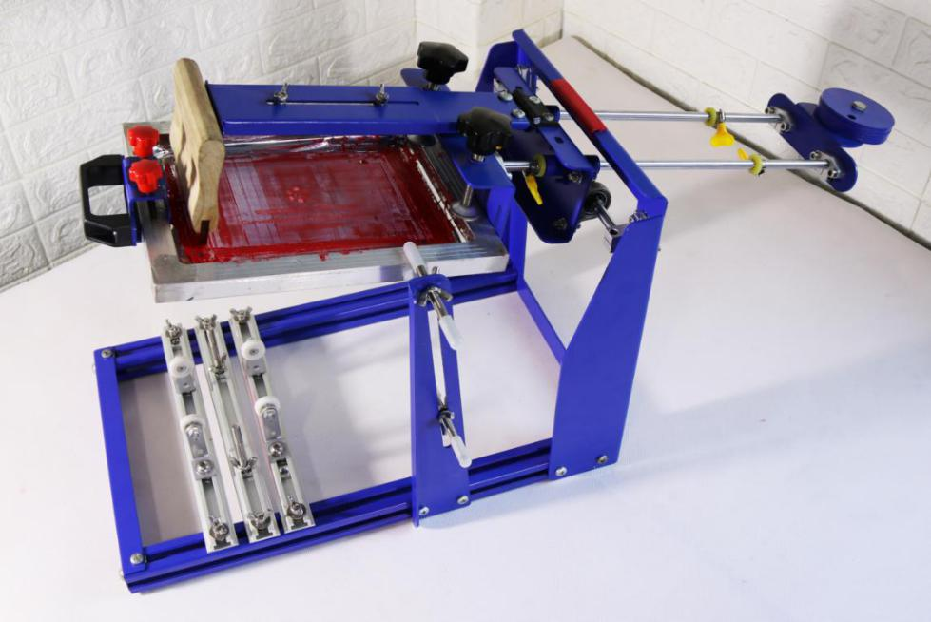
2. 本机为后主架高度调节定位，后部主横梁根据承印物高度，通过调整网板主架与后部连接螺丝松动（无需拆下螺丝），整体移动至长条空中上下移动至合适位置即可。上下调整范围为160毫米。

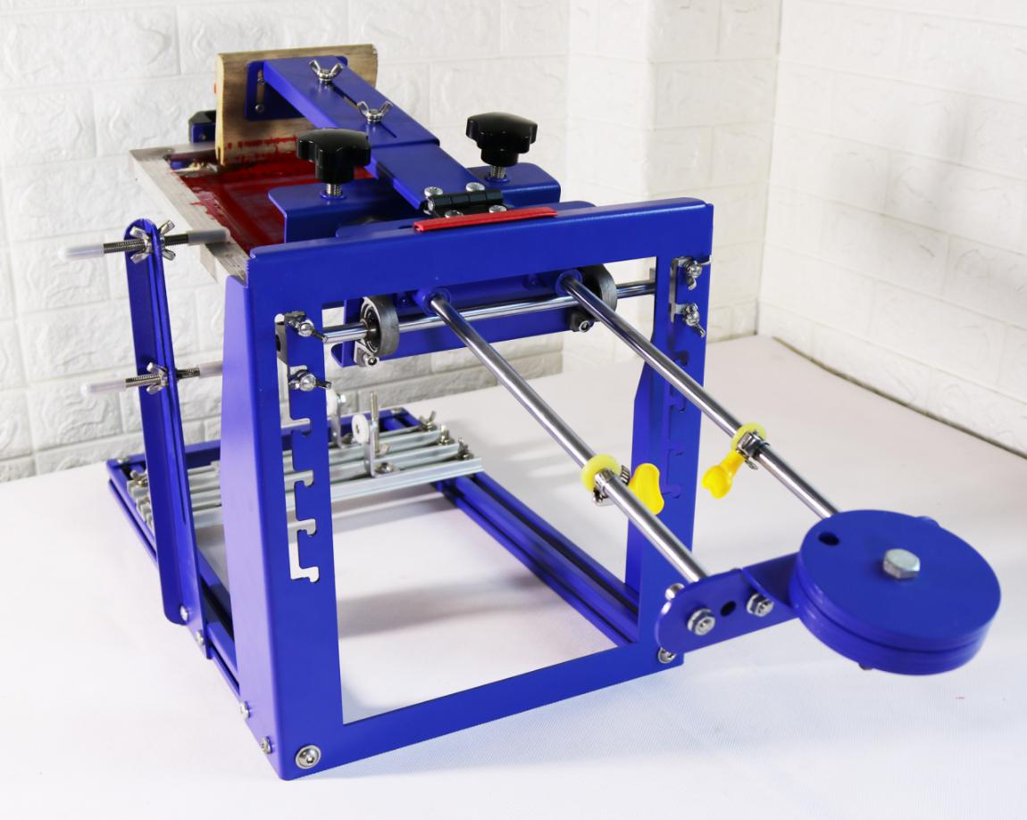

1. 承印物印刷架为可左右前后移动式设计，底部的三个固定铝条直接安装在两边底座上，铝条底座可前后移动300毫米；两边铝条为承印物放置架安装条，中间的为承印物定位架安装条。三只安装条可根据需要左右移动。

安装铝条移位：将安装条两头螺丝松开，移动至合适位置后，拧紧两头螺丝即可定位完成。

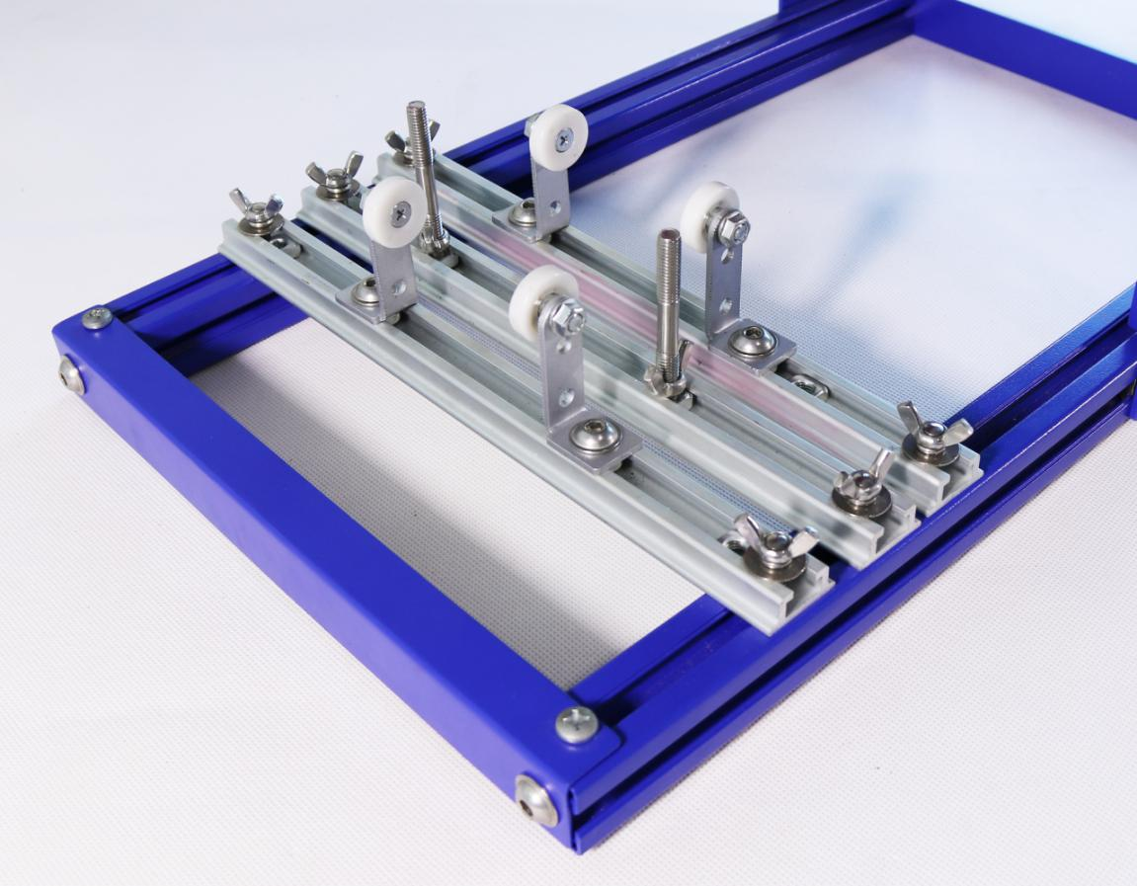

1. 采用三套承印物放置滚轮，分别为金属轴承滚轮（直径19毫米）；尼龙轴承滚轮（直径25毫米）；塑胶轴承滚轮（直径50毫米），使用者可根据需要更换使用。主架与附件架均可安装三款滚轮。

轴承安装架直接固定在铝条安装长条孔中，根据承印物宽度可左右移动最大110

毫米；附加安装架4只，拆掉原主安装架上的轴承，直接用螺丝将附加安装架固定在主安装上，主要用于圆锥型产品的印刷。附加安装架可上下移动20毫米。

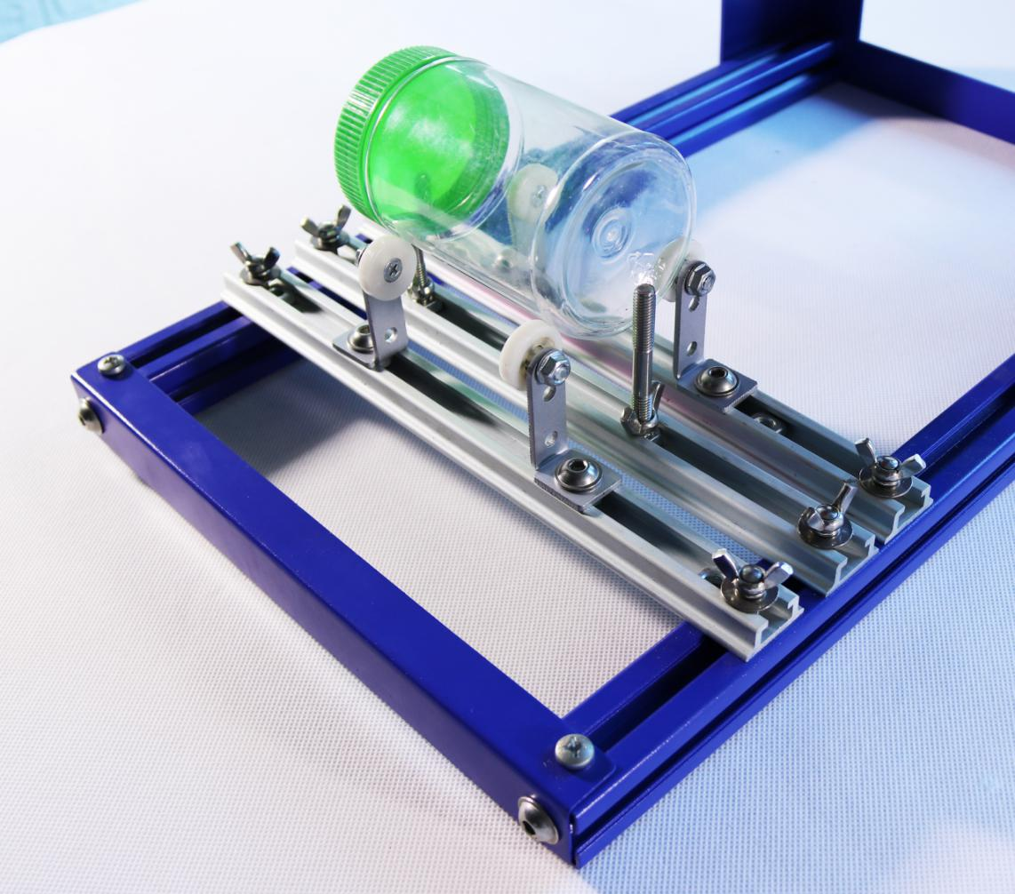

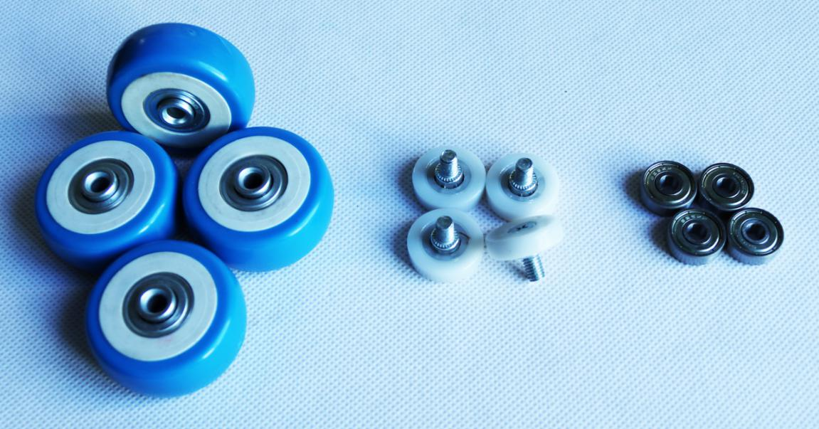

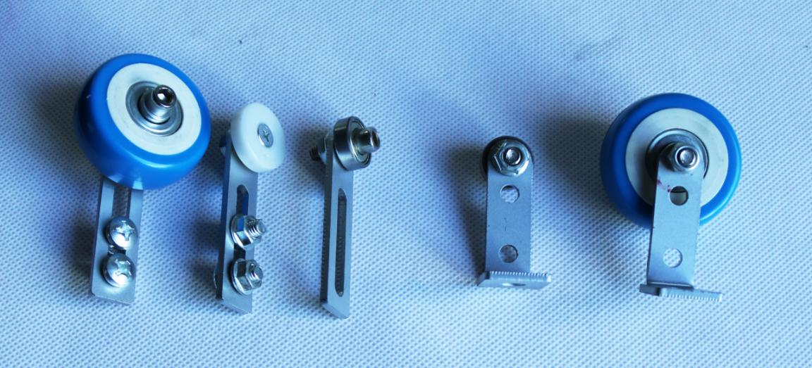

1. 网框配有专用把手直接固定在网框上，两种安装方式，可安装在网框上部，也可安装网板侧面，左右推拉方便快捷，该把手可任意固定在网框的任何部位，上部红色把手与前部挡板固定网板，保证网板牢牢固定在把手上。该把手适合厚度和宽度40毫米内的各种网框。

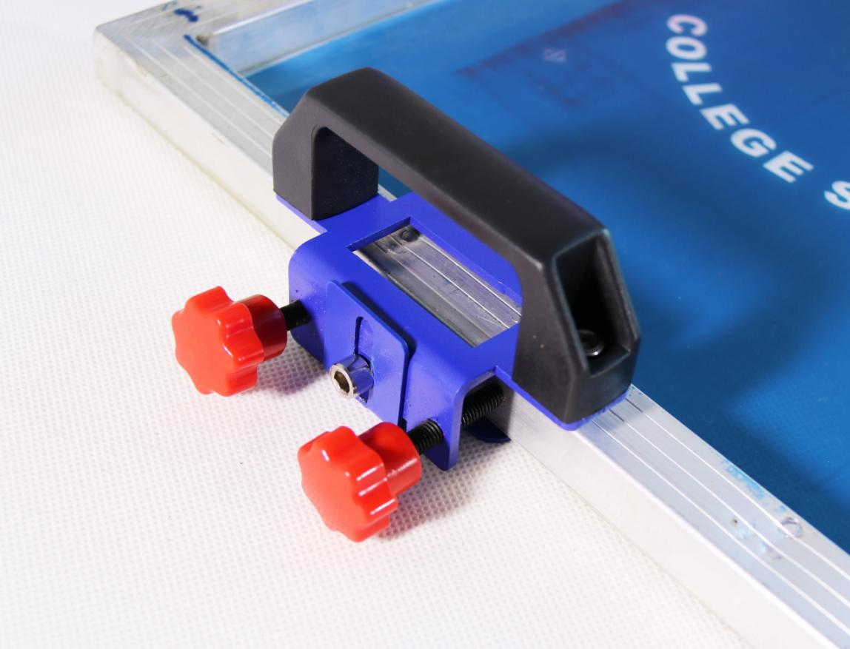

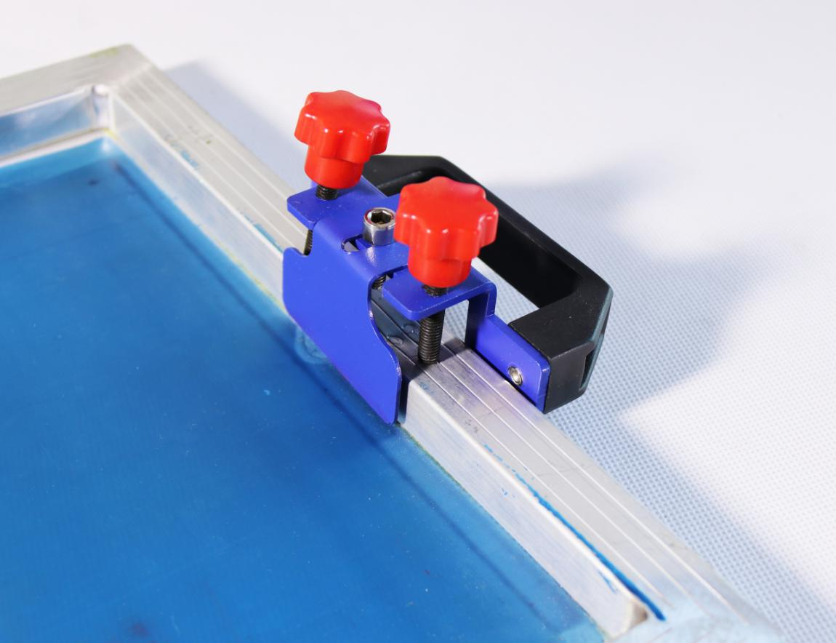

1. 机器后部的重力盘可使印刷后网板自动抬起，配有2个重力盘，可根据网板部分的重力调整安装达到平衡，前部过重可在重力盘处加挂重物。

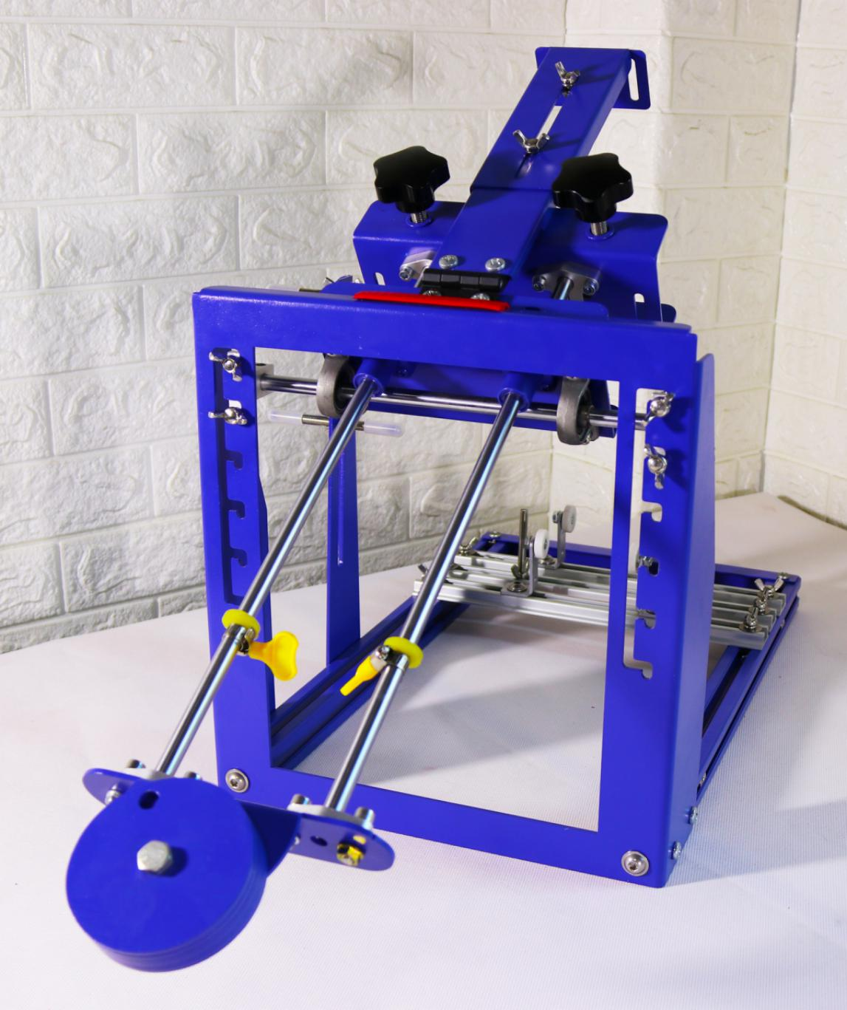

1. 网框上支撑架可控制网框抬起后的角度，下支撑架根据网板高度进行调节，放置网板达到平行，防止网板前部掉落损坏网板。两只支撑架均可根据需要上下调整。

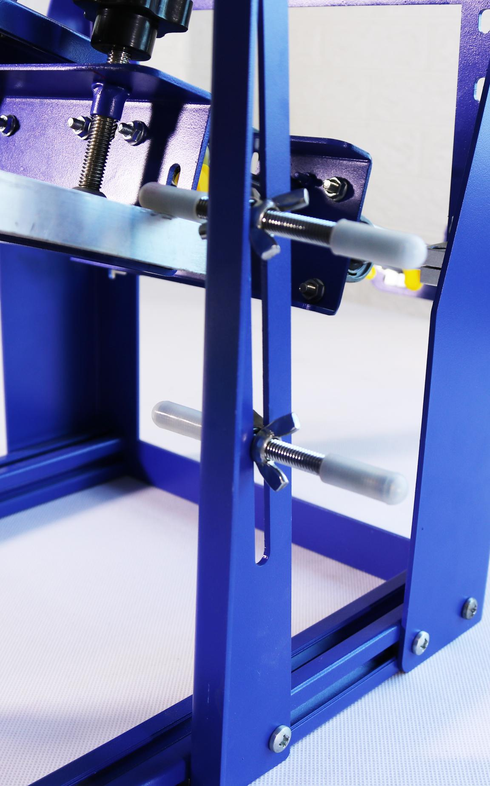

1. 刮板架使用自攻丝固定木柄刮板，适合使用长度200毫米内的木柄刮板。该架可根据网板图案位置左右移动250毫米。

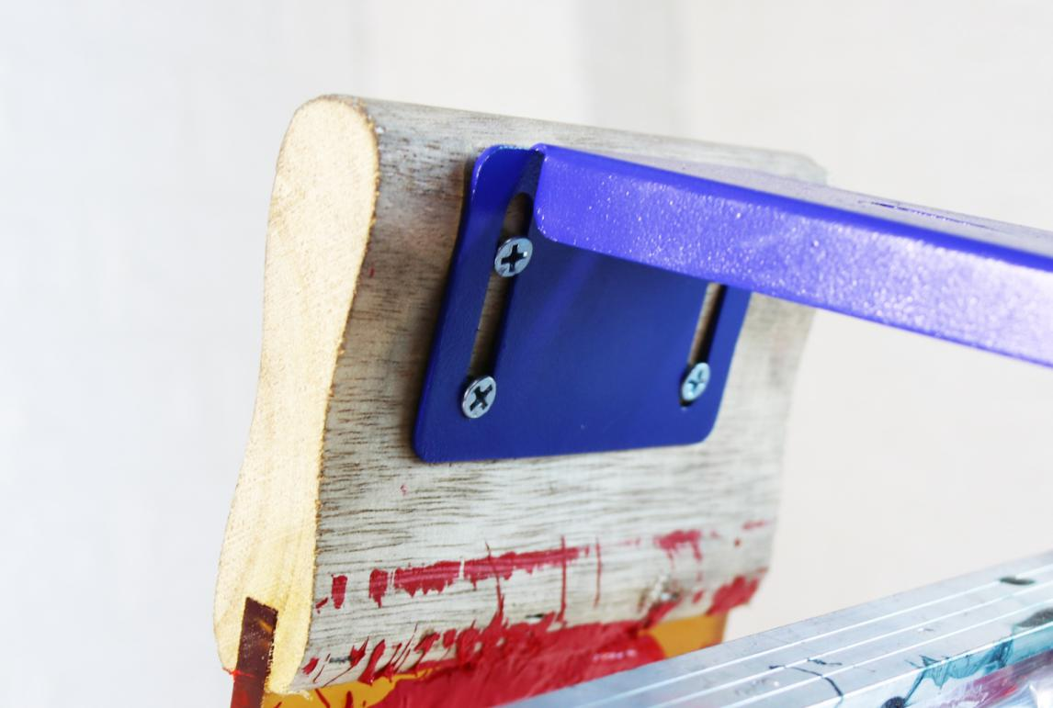

1. 网板移动距离定位；两只光轴两头均配有定位圈与防撞击胶圈，根据图案尺寸前后调整定位圈达到合适位置；防撞击胶圈可放置金属之间碰撞发出的异响，保护机器部件。



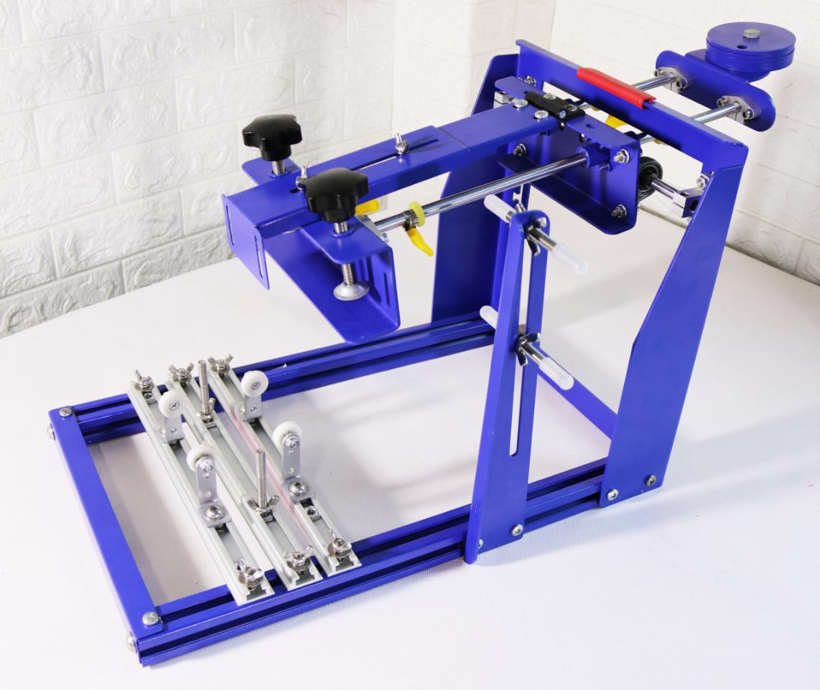

十一，使用方法（仅供参考）：

1. 安装网板并调整网板下支撑座至网板基本水平；安装网框拉动把手；
2. 安装刮板并调整刮板距离图案1-2厘米处固定；
3. 调整承印物印刷架与滚轮轴承位置，放置承印物，承印物顶部与网板间距1-3毫米；并使承印物最顶部与刮刀底部对齐；

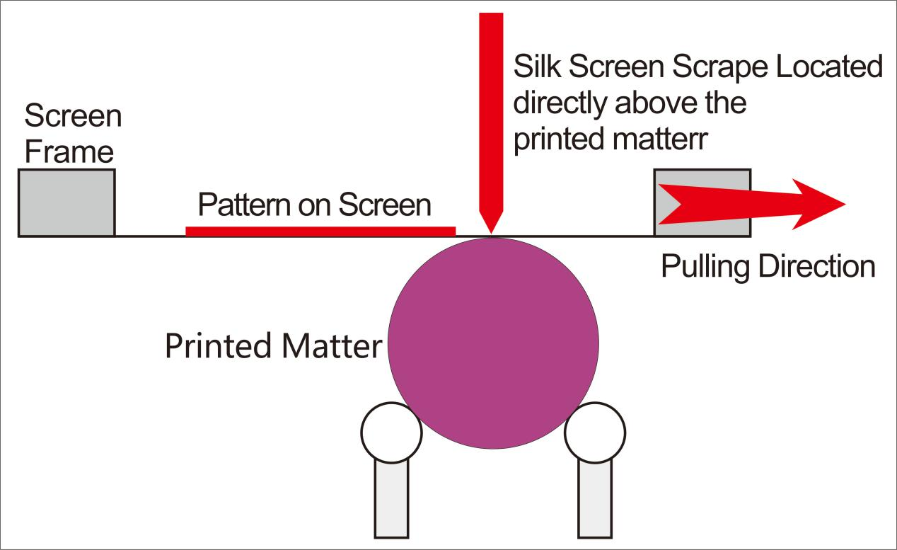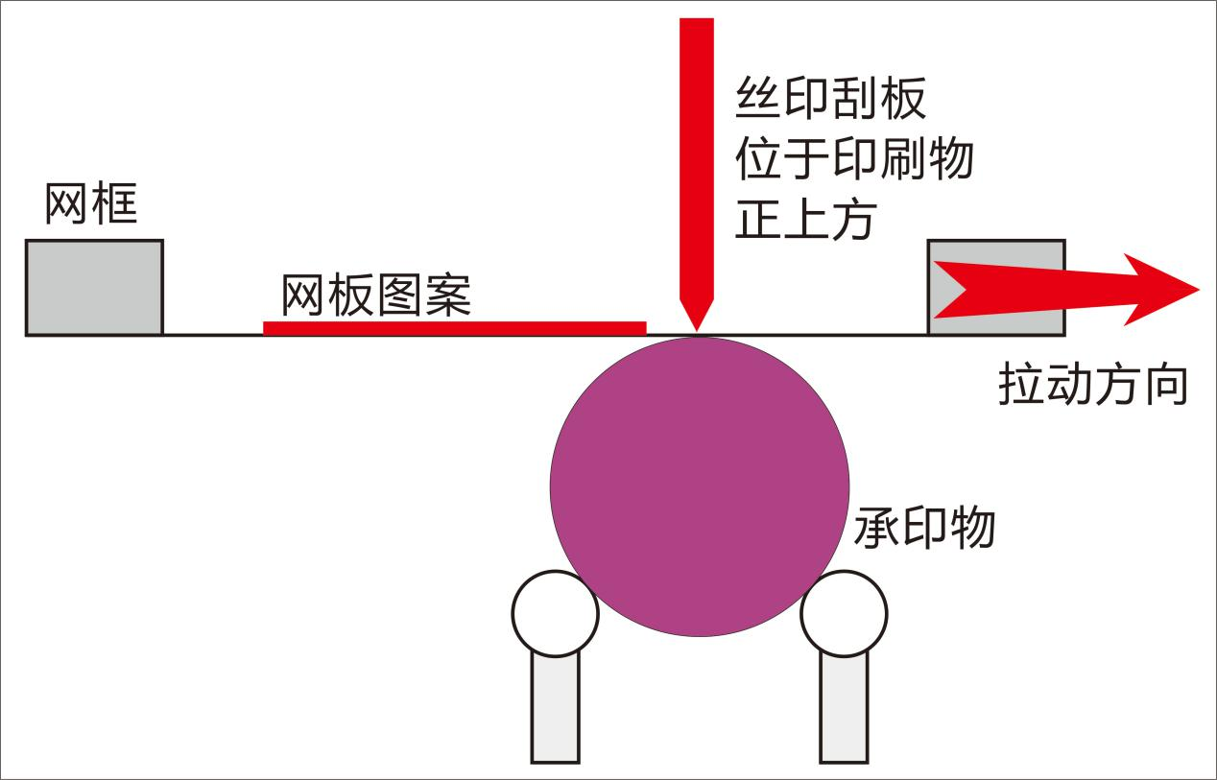

1. 根据图案左右尺寸调整网板距离定位旋钮；
2. 网板内放入油墨；
3. 左手（或右手）压住刮板；右手（或左手）拉动网框上的把手即可印刷。
4. 安装取出网框简单方便。只需从印刷网板架下面将网板放入后支撑板，然后将网板放入前支撑板，拧紧网板固定螺丝即可。（限于本机的设计要求，本机网板必须使用外径尺寸560\*410毫米，高度30毫米以内的网框）本机附带网框2个。

It is easy to install and remove the screen frame. Just put the screen plate into the back support plate from below of the printing plate rack, and then put the screen plate into the front support plate, tighten the screen plate fixing screw. (limited to the design requirements of the machine, the screen board of the machine must use the screen frame with the outer diameter of 560\*410 mm and the height within 30 mm.) 2 screen frames are attached to the machine.

网板安装方法

Installation Methods of the Screen Plate

1. 将网框从安装台下面放入后支撑板

Place the screen frame into the rear support plate from the bottom of the installation table.

2，将网框前部移动至前支撑板，拧紧四个螺丝即可固定住网框

Move the front of the frame to the front support plate, tighten four Screws to fix the

screen frame.

1. 网框前后滑动使用6个滑块与光轴连接，推拉运行轻松顺畅。

6 sliders connected to the optical axis to make the screen frame slide back and forth,it is easy and smooth to push and pull .

1. 网框前后滑动距离可通过光轴上的定位环控制；使用者可根据制作的网板图案位置与承印物放置台调整完成后，将定位环锁定。特加放碰撞胶皮圈在定位环与滑块之间，可使网框前后滑动过程中滑块不与金属定位环直接接触，不会发出金属之间撞击的声音，同时也保护各金属部件。

The back and forth sliding distance of the frame can be controlled by the positioning ring on the optical axis; The user can lock the positioning ring after adjusting the position of the screen plate and the substrate placement table. Especially add the collision rubber ring between the locating ring and the slide block, which can prevent the slide block from directly contacting with the metal locating ring during the back and forth sliding of the screen frame, and prevent the sound of metal striking with each other, and meanwhile protect the metal parts.

1. 印刷刮胶条架与回墨胶条架采用双板夹式，安装卸下方便快捷，主架两边与框架连接螺丝中部附加弹簧，在印刷过程中，可根据需要微动调整印刷刮板和回墨板压力。

The printing scraper rack and the return ink rack adopt the double board clip type, the installation and unloading is convenient and quick, two sides of the main frame and the frame connect the screw middle additional spring, in the printing process, user can adjust the printing scraper and the return ink plate pressure according to the need.

刮胶条与回墨条的安装方法

Installation Methods of Scraping and Returning Ink Strips

1，打开刮条安装板

Open the scraper mounting plate

2，放入刮胶条，刮胶条下刀口面与丝网面自然平整贴合

Put in the scraper rubber, the lower edge of the scraper and the mesh surface will

fit smoothly and smoothly.

3，将下面三个螺丝固定上（不要拧紧）；拧紧上面2个白色旋钮即可固定住刮胶条

Fix the following three screws (don't tighten them); tighten the top two white knobs to

fix the scraper tape.

1. 网板推拉把手可根据操作者需要立式安装或平行安装。

Push and pull handle can be installed vertically or in parallel according to the operator's needs

1. 承印物放置台采用旋钮升降并锁定结构。承印物放置台可通过放置台下的升降把手控制，先将两边挡板上的旋钮松开，升降至合适高度后，将两边挡板上的锁定旋钮拧紧即可稳定升降台在此高度上，承印物放置台两边高度是否一致可通过两边挡板上下的凹条齿调整。

Substrate placement platform adopts knob lifting and locking structure. Substrate placement platform can be controlled by the lifting handle under the placement stage, first release the knob on both sides of the baffle, lift to the appropriate height, the locking knob on both sides of the baffle can be tightened to stabilize the lifting platform at this height, substrate placement platform on both sides of the height is consistent or not can be adjusted by the concave teeth on both sides of the baffle.

1. 承印物印刷架底部为可左右前后移动式设计，底部的三个长铝条安装在升降放置台上，两边的为承印物放置架安装条，中间的为承印物限位柱安装条。

Bottom of the substrate printing rack is designed around back and forth mobile , the three long aluminum bars in the bottom installed in the lifting placement platform, both sides are substrate placement rack installation bar, the middle is the substrate limit column installation bar.

1. 承印物放置架安装条可前后移动140毫米，为移动尽量准确，可根据放置台面上两边的凹条齿进行平行移动。

Substrate placement rack installation bar can be moved around 140 mm back and forth, in order to move as accurate as possible, according to the concave tooth on the placement table to make parallel movement.

1. 承印物限位柱安装条上两边安装有限位柱，调整好所有印刷步骤后，将承印物放置在印刷架上，将2个限位柱分别移动至承印物的两头并与承印物面留有1-2毫米的间距（注意不要紧靠，否则可能会影响承印物的转动），用扳手将限位柱拧紧即可。

Limited post is installed on both sides of the substrates limited post installation bar, after adjusting all printing steps, place the substrate in the printing rack, move two limited posts respectively to the two ends of the substrates and substrates surface with 1-2 mm spacing (Note: not too close please , otherwise it may affect the rotation of the substrates), using a wrench to tighten the limited post.

限位柱的主要作用：Main functions of the limited post:

1. 放置承印物的准确性提高，保证所有放入承印物后印刷位置基本相同，避免因每次放入承印物后位置不一样，造成印刷位置偏离的情况。

Improve the accuracy of substrate placement, ensure that all printing positions are basically the same after substrate placement, and avoid deviation of printing positions caused by different substrate placement.

1. 放置承印物更快捷，无需再做记号或手动调整，直接放入承印物即可。

Substrate placement faster, no need to mark or manually adjust, directly put into the substrate.

1. 限定承印物在印刷过程中不偏离。

limit the substrate in the printing process does not deviate.

1. 承印物放置轮配有两套，一套为直径50毫米蓝色转动轮，一套为直径26毫米白色转动轮，两套转动轮均可安装在放置主架和附加架上，使用者可根据需要更换调整。

There are two sets substrate placement wheels, one set is diameter of 50 mm blue rotation wheel, the other set is diameter of 26 mm white rotation wheel, two sets rotation wheel can be installed in the placement of the main frame and additional frame, users can replace according to the needs of adjustment.

1. 本机配置的附加板与承印物放置主架配合使用，主要用于圆锥体型的产品印刷，附加板可用两个螺丝与主架直立连接，也可用一个螺丝与主架斜体交叉连接。

The attached plate configured by the machine is used in conjunction with the substrate placement in the main frame, which is mainly used for printing products with conical shape. The attached plate can be connected with the main frame vertically with two screws, or cross connected with the italic body of the main frame with one screw.

1. 本机出厂前已做完整调试，客户只需要将弹簧和网框起落板安装上即可使用。

The machine has been fully adjusted before leaving the factory. The customer only needs to install the spring and screen frame landing board for use.

1. 本机主体采用高级静电喷涂金属表面处理，耐酸碱，耐腐蚀，耐清洁，不生锈，可长期使用；部分部件采用不锈钢材料和铝合金材料。

The main body of the machine uses advanced electrostatic spraying metal surface treatment, acid and alkali resistance, corrosion resistance, clean resistance, no rust, can be used for a long time; Some parts are made of stainless steel and aluminum alloy.

十六，配有全套安装工具和详细安装说明书；用户不需另配工具即可轻松安装。

Equipped with a full set of installation tools and detailed installation instructions; Easy installation without additional tools.

十七，出口欧美标准免熏蒸木箱包装，箱内各种金属件均单独包装或隔离摆放，保证各种金属部件不直接接触；

Export to Europe and America standard fumigation-free wooden box packaging, all kinds of metal parts in the box are individually packaged or placed in isolation to ensure that all kinds of metal parts do not contact directly;