006594 SPE-BGQM180硬质圆管圆棒

专用曲面丝印机

006594 SPE-BGQM180 special curved screen

printing machine for hard round pipe and bar

本机主要用于圆管，圆棒类产品的弧面丝印；适用于金属，塑料，玻璃，木制等圆管，圆棒等材料；

This machine is mainly used for arc screen printing of round pipe and round bar products. Suitable for metal, plastic, glass, wood and other materials such as round pipe, round bar;

不适用椭圆型管，棒材料的印刷。

It is not suitable for printing elliptical pipes and bars.

不适用圆管印刷面有较大凹陷起或凸起，印刷面内有麻点等非光滑平面产品的印刷。

It is not suitable for the printing of non-smooth products with large dents or bulges on the printing surface and pitting points on the printing surface.

1. 本曲面丝印机主要用于直径20-180毫米内的圆管，棒型类产品的印刷。

This curved screen printing machine is mainly used for the printing of round tubes and bar type products with diameter of 20-180 mm

1. 适合印刷宽度300毫米；长度250毫米内图案；

Suitable for printing width within 300 mm; 250mm within length;

1. 适合外径400\*350毫米以内，厚度40毫米以内各种网板的使用。

Suitable for all kinds of screen plates with outside diameter of 400\*350 mm and a thickness of 40 mm.

四，本机采用前后推拉式结构，需双手操作，一手按住刮板，另手拉动网框，管棒随网

板移动而自然转动，即可将图案印刷至管棒表面。

The machine adopts a push-pull structure, which requires two hands to operate, one hand holding the scraper, the other hand pulling the screen frame, rod following the screen plate moves and rotates naturally, so that the pattern can be printed on the surface of the bar.

五，本机为后主架高度调节定位，后部主横梁根据承印物高度，通过调整网板主架与后

部连接螺丝松动（无需拆下螺丝），整体移动至长条孔中上下移动至合适位置即可。上下调整范围为160毫米。

the machine is positioned by adjusting the height of the rear main frame , the rear main beam according to the height of the substrate, by adjusting the screen plate main frame and the rear connection screw loose (no need to remove the screw), the overall movement to the strip air up and down to the appropriate position. The upper and lower adjustment range is 160 mm.

1. 承印物主印刷架左右宽度为300毫米，可左右前后移动式设计，底部的二个固定铝条直接安装在两边底座上，铝条可前后移动300毫米；承印物支撑架可根据需要左右移动。

Main printer printing frame width is 300 mm, can move from left to right ,the two fixed aluminum strips on the bottom directly installed on both sides of the base, aluminum strip can be moved forward and backward 300 mm; Substrate support frame can be moved around as needed.

1. 主机两边分别可安装延长架附件，单边附件长度460毫米，用户可根据需要单边安装；两边安装或两套附架一边组合连接主架；主架+附架总宽度达1200毫米。

The extension frame accessories can be installed on both sides of the main machine. The length of unilateral accessories is 460mm, and the user can install unilaterally according to the needs. The two sides are installed or two sets of supporting frames are combined to connect the main frame on one side; The total width of the main frame and supporting frame is 1200 mm.

1. 本机配置三套承印物放置滚轮，分别为金属轴承滚轮（直径19毫米）；尼龙轴承滚

轮（直径25毫米）；塑胶轴承滚轮（直径50毫米），使用者可根据需要更换使用。主架与附件架均可安装三款滚轮。

轴承安装架直接固定在铝条安装长条孔中，根据承印物宽度可左右移动最大110毫米；附加安装架4只，拆掉原主安装架上的轴承，直接用螺丝将附加安装架固定在主安装架上，附加安装架可上下移动20毫米。

the machine is equipped with three sets of roller, respectively for metal bearing roller (diameter: 19mm); Nylon bearing roller (diameter: 25mm); Plastic bearing roller (diameter: 50mm) which can be replaced as needed. Three rollers can be installed on both the main frame and the accessory frame.

The bearing mounting bracket is fixed directly in the aluminum strip mounting hole and can be moved up to 110mm according to the substrate width. 4 additional mounting racks. Remove the bearings from the original mounting racks and fix the additional mounting racks on the main mounting racks directly with screws. The additional mounting racks can be moved up and down 20mm.

九，网框配有专用把手直接固定在网框上，两种安装方式，可安装在网框上部，也可安装网板侧面，左右推拉方便快捷，该把手可任意固定在网框的任何部位，上部红色把手与前部挡板固定网板，保证网板牢牢固定在把手上。该把手适合厚度和宽度40毫米内的各种网框。

the screen frame with a special handle directly fixed on the screen frame, two installation methods, it can be installed in the upper part of the screen frame,it also can be installed on the side of the screen plate,it is easy to push and pull from left to right, the handle can be arbitrarily fixed in any part of the screen frame, the upper red handle and the front baffle fixed screen plate, to ensure that the screen plate firmly fixed on the handle. The handle fits various mesh frames within a thickness and width of 40mm.

十，机器后部的重力盘可使印刷后网板自动抬起，配有2个重力盘，可根据网板部分的

重力调整安装达到平衡，前部过重可在重力盘处加挂重物。

The gravity plate at the rear of the machine can automatically lift the screen plate after printing. It is equipped with two gravity plates, which can be adjusted and installed to balance according to the gravity of the screen plate.Heavy weight can be added to the gravity plate when the front part is overweight.

十一，网框上支撑架可控制网框抬起后的角度，下支撑架根据网板高度进行调节，放置网板达到平行，防止网板前部掉落损坏网板。两只支撑架均可根据需要上下调整。

The upper support frame can control the angle of the upper support frame after lifting, and the lower support frame can be adjusted according to the height of the screen plate. The screen plate is placed parallel to prevent the front part of the screen plate from falling and damaging.

Both supports can be adjusted up and down as needed

十二，刮板架使用自攻丝固定木柄刮板，适合使用长度200毫米内的木柄刮板。该架可根据网板图案位置左右移动250毫米。

Squeegee rack use self-tapping fixed wooden handle scraper, and it is suitable for the length of less than 200 mm wood handle scraper. The rack can be moved about 250mm according to the position of the pattern of the screen plate.

十三，网板移动距离定位；两只光轴两头均配有定位圈与防撞击胶圈，根据图案尺寸前后调整定位圈达到合适位置；防撞击胶圈可放置金属之间碰撞发出的异响，保护机器部件。

the screen plate movement distance positioning; Both ends of the two optical shafts are equipped with positioning rings and anti-impact rubber rings. The positioning rings are adjusted front and rear according to the pattern size to reach the appropriate position. Anti-impact apron can be placed between the metal collision issued by the abnormal sound, to protect the machine parts.

十四．本机也可用于圆柱型，圆锥体型类产品；如各种塑料，玻璃，金属材料制成的圆柱型，圆锥体型产品等，包括酒瓶，药瓶，化妆品瓶等各种包装瓶；马克杯，保温杯，啤酒杯，红酒杯等各种杯子；玻璃管，钢笔,圆珠笔，鱼竿，球棒等小型圆柱型产品。

The machine is mainly used for printing cylindrical type, cone type products; Such as a variety of plastic, glass, metal materials made of cylindrical, conical shape products, including wine bottles, medicine bottles, cosmetics bottles and other packaging bottles; Mugs, thermos mugs, beer mugs, red mugs, etc. Glass tube, pen ,ballpoint pen, fishing rod, bat and other small cylindrical products;

十五，使用方法（仅供参考）：Usage (for reference only) :

1. 安装网板并调整网板下支撑座至网板基本水平；安装网框拉动把手；

Install the screen plate and adjust the support seat under the screen plate to the basic level of the screen plate; Install screen frame pull handle;

1. 安装刮板并调整刮板距离图案1-2厘米处固定；

Install the scraper and fix it at a distance of 1-2 cm from the pattern;

1. 调整承印物印刷架与滚轮轴承位置，放置承印物，承印物顶部与网板间距1-3毫米；并使承印物最顶部与刮刀底部对齐；

Adjust the position of the substrate printing frame and roller bearing, place the substrate, and the spacing between the top of the substrate and the screen plate is 1-3 mm; And make the substrate the top and the bottom of the scraper aligned;

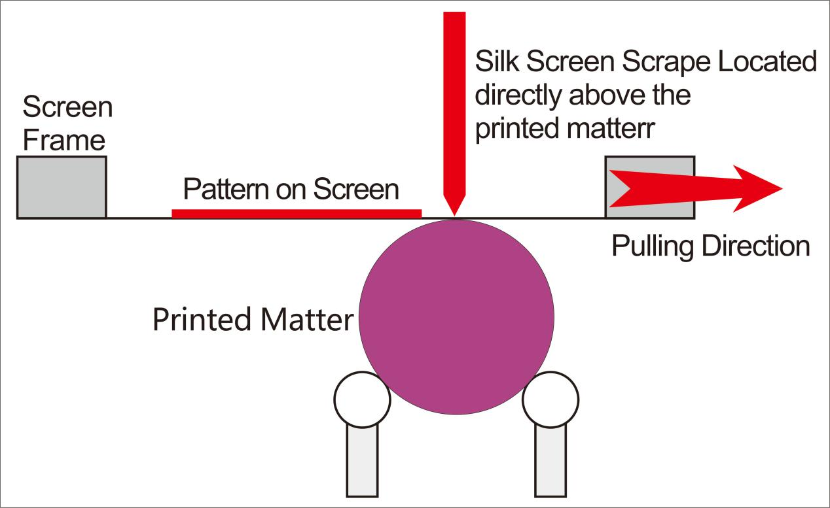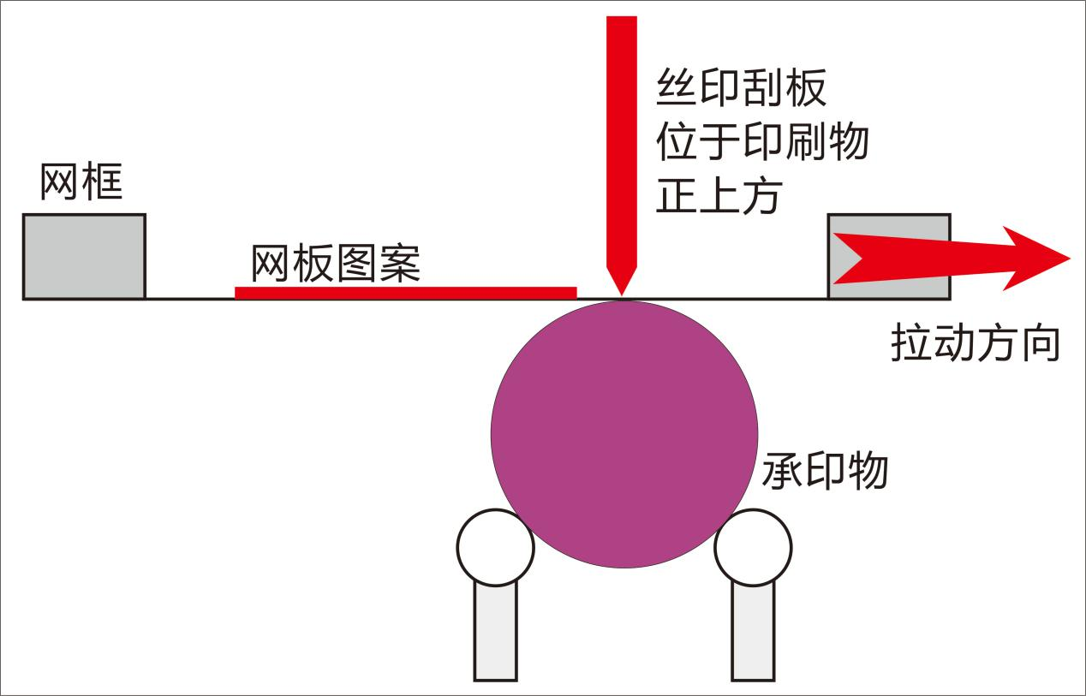

1. 根据图案左右尺寸调整网板距离定位旋钮；

Adjust the distance positioning knob of the screen plate according to the left and right dimensions of the pattern;

1. 网板内放入油墨；

Put ink into the screen frame;

1. 左手（或右手）压住刮板；右手（或左手）拉动网框上的把手即可印刷。

Press the scraper with the left hand (or right hand); Pull the handle with right hand (or left hand)on the screen frame to print.