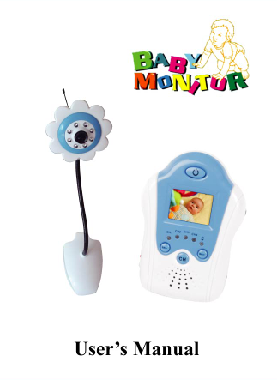

1.5“，1.8”LCD Video baby monitor

Content List:
1:Welcome 7: Monitor Set-up and operation
2:Warning 8:AV connection
3:Safty 9:Technical information
4:Product Content 10:Trouble Shooting
5:Product Feature 11: Warranty
6:Camera Set-up and operation 12:EU Envioronmental Protection

1:Welcome
Congratulations on choosing to buy a baby product,
This Baby product is manufactured to the highest standards of performance and safty. As part of our philosophy of customer service and satisfaction this product is backed by a comprehensive 1 year warranty.
We hope you will enjoy using your purchase for many years.to come.

2: Warning!
For carefree and saft use of this product,please read this manual and safety information carefully and follow all instructions.This product is approved to Australian standards.Internal manipulation of this product or any modification to this product is forbidden,due to safety,security and electrical authority approval issues.
In case of improper usage or if you have opened,altered and repaired the product yourself,ahe sull warranties expire.The supplier does not accept responsibility for additional damage other than indicated in this owner’s manual and the included warranty card..

3. Safety
* To prevent short circuits,this product should only be used inside and only in dry spaces. Do not expose the components to rain or humidity.
*This product is designed for use with standard 110V~240V AC power. Do not connect to other source of power.
* Never connect an adaptor or power cord when it is damaged.
* Avoid extreme ambient temperatures and strong vibrations.
* Do not disassemble any part of the product: the device contains live parts and no user-serviceable parts are inside.

4.Product Content
Check that you have received the following parts:
①: 1 X Camera ⑤: 1 X AV cable
②: 1 X LCD monitor ⑥：1 X User’s manual
③: 2 X Power adaptors
④: 2 X Lithiumion batteries(INBUILT,NOT SHOWN)

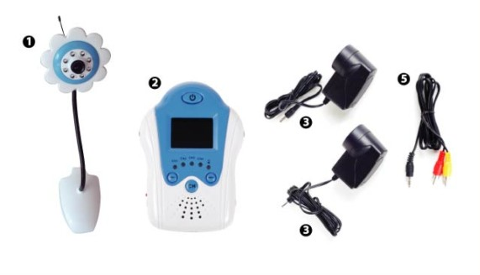
5：Product Features:
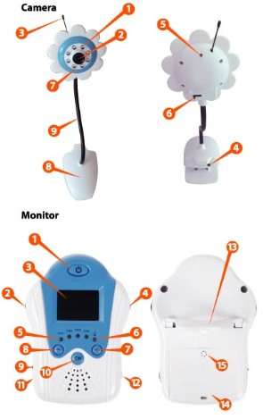
1 Infra-red LED
2 Lens
3 Antenna
4 DC input
5 Light sensor
6 Channel switch
7 Microphone
8 Clip
9 Flexible hose

1 Power button
2 Volume button
3 TFT-LCD monitor
4 Voice control tune
5 Channel indicator
6 Low power indicator LED
7 Image Bright
8 Image Dim
9 Charge button
10 Channel button
11 AC adaptor 5V DC input
12 A/V output
13 Stand
14 Battery compartment
15 Voice control switch(located behind battery)
Before use.
1.5” baby monitor is pre-installed with rechargeable batteries,Before use fully recharge the batteries in the Monitor and Camera.The camera and monitor can be operated while recharging the battery or left connected to the DC power adaptors for use.

6. Camera set up & operation
- Connect 6V AC adaptor with (4)
- Ensure that the channel switch (6) is set to channel
- Make (8) of the camera fired well
- Place camera on a firm surface facing the baby
-Up or down to face the baby
-The camera will automatically switch to night vision in a dark environment
*When in night vision mode the picture will appear in black and white
*Night vision mode will switch off as soon as the camera is exposed to light

7.Monitor set up & operation
-Press the power button(1) to turn on
-If the CH1 LED (5) is not lit press the CH button (10) until it is
- Ensure that the camera is recharged and turned on.The image from the camera will be shown on the monitor
-Use the Bri-(7) & Bri+(8) buttons to adjust the brightness of the image
-Open the stand(13) and place in a location suitable for viewing
-Adjust camera to show baby if required
-Ue dial(2) to adjust volume
-if the image is subject to interference try moving the location of the monitor or changing the transmission channel by pressing the CH button (10)
* Onece the channel is changed on the monitor it is necessary to change the channel on the camera using the Channel Switch (10)
- The voice control function can be turned on or off with switch (15)
* This function will allow the camera to switch to standby power saving mode after a short of period of time if no sound is detected
* The camera will switch back to active mode after sound is detected
* Use the Voice Control Tune dial(4) to adjust the sensitivity of the voice control feature.

8. AV Connection
The monitor can be connected to a TV or other visual display by using the AV cable
- Connect the AV cable 3.5mm jack to the AV output (12) on the monitor
- Connect the Yellow and red RCA jacks to an AV input on the TV or visiual display
- Use the colour coding of the RCA jacks to match the colour coding on the TV or visual display
- Use the AV or source select on the TV or visual display to select the channel that the monitor is connected to and display the image.

9. Technical information
Camera frequency:24GHz Lens: F6.0mm,F1.8
Channel frequencies:CH1 2414MHz, Night vision distance: 3-5m
CH2 2432MHz, CH3 2450MHz,CH4 2468MHz Camera power: DC6V
A/V modulation method: FM Monitor power: DC5V or lithiumion battery
Antenna:Built in omni-directional Operation temperature:0-40*C/32-104*F
Image sensors:1/3 cmos Monitor frequency:2.4GHz
Effective pixels: NTSC 510(h) X 492 (v)/ Display inch:1.5” Display: Full colour
PAL 628(h)X582(v) Receiver sensitivity:-83DBM
Recharging time:2-3 hrs
10. Trouble shooting
No picture or sound
Ensure both the camera and the monitor are turned on. Confirm the power indicator light (4) on the camera and one of the channel lights (5) on the monitor are lit.
- Make sure low power indicator lights are off
- If they are on, the batteries need to be recharged
- If no lights on the camera or monitor come on batteries need to be recharged
- Adjust the Bri + (8) button,the brightness may be sent to low
- The monitor may be in standby mode due to the voice control feature
- Turn voice control function off using the switch (15) on the monitor or;
- Adjust the voice control tune (4) on the monitor
Image interference
This may be caused by other 2.4GHz products operating in the area,mobile phones,appliances or other electrical devices
- Change the channel on the camera and monitor to find a channel that is not affected
- Move the location of the monitor
- Ensure that no metal barries or reinforced concrete walls are between the monitor and camera
- Try turning off devices that may be cauing interference to identify the device causing the problem.

11. Warranty
1.5” baby monitor is warranted against faulty workmanship for a period of 12 months from the date of purchase. Supplier’s liability is limited to replacement of the product and claims for associated or consequential loss or damage will not be accepted by supplier’s.Warranty is void and does not apply if, at supplier’s discretion,the product has been damaged or rendered faulty by accident,abuse,misuse,incorrect application or if the product has been modified or tampered with. Proof of purchase is required to validate warranty claims.All claims outside the warranty period will be rejected.

12. EU Environmental Protection
Waste electrical products should not be disposed of with household waste.Please recycle where facilities exist.Check with your Local Authority or retailer for recycling advise 