Packing List of Grinder for Saw Blade
It includes 1 package; please check the following before installing
Name | Unit | Quantity | Picture
Grinder for Saw Blade | Set | 1 | 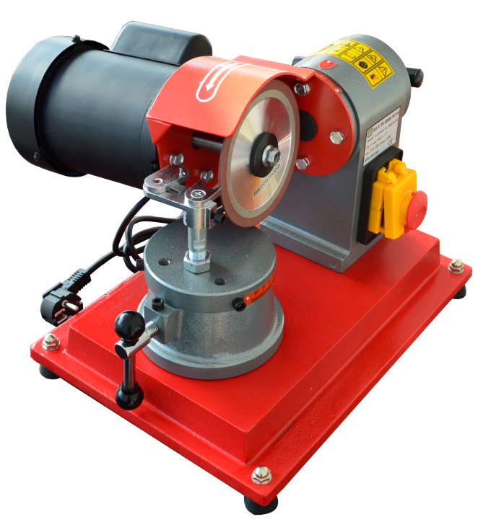
Working Table | Set | 1 | 
Component | Pc | 8 | 
Tools | Pc | 4 | 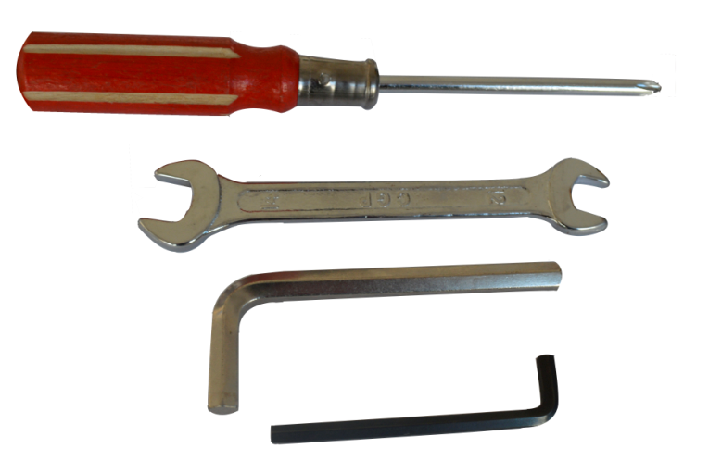
Grinding blade | Pc | 1 | 

