Package List of ASC Cutting Plotter Platform Frame And Accessories
(It includes 1 package; please check the followings before installing.)
Cutting Plate | White Platen |  | Platform Frame
pc | pc |  | set
1 | 2 |  | 1
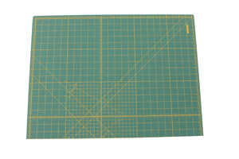 | 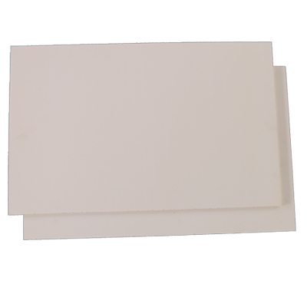 |  | 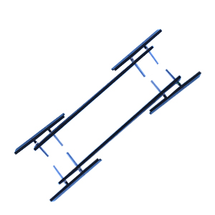
40*50 Screen Frame With 40 Mesh Screen | Water Gun |  | Transparent Tape
pc | Set |  | roll
1 | 1 |  | 1
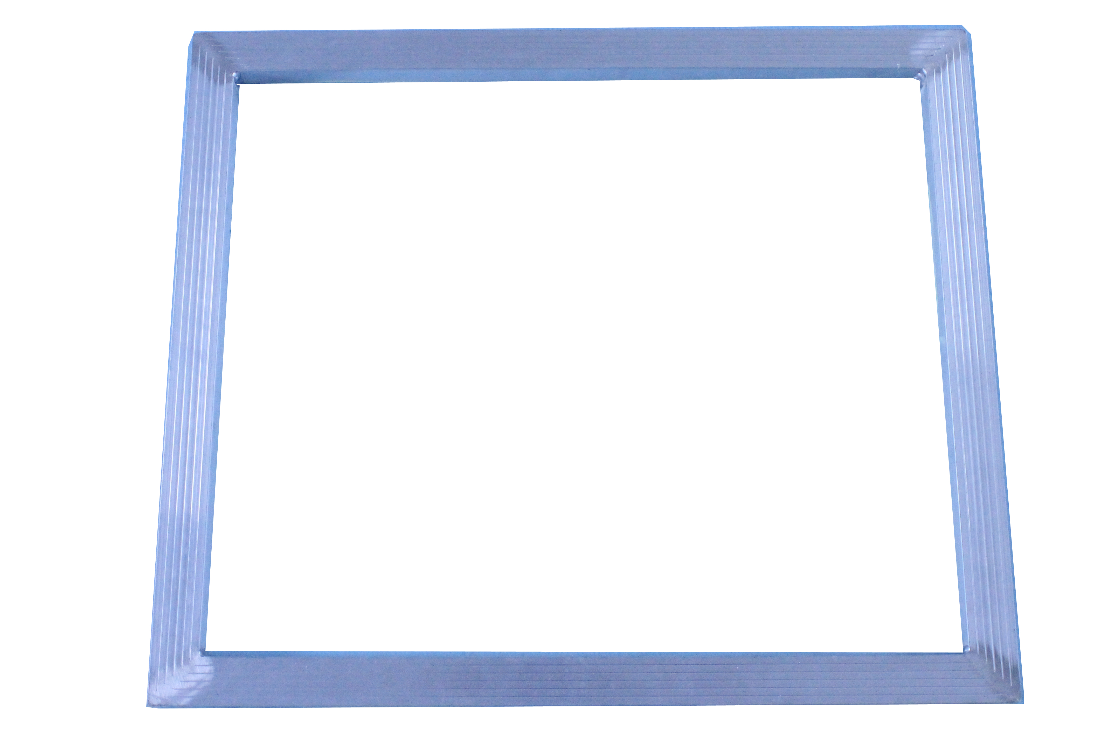 | 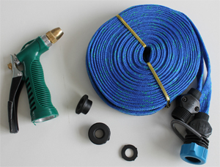 |  | 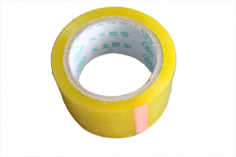
Sponge Tape | Squeegee |  | Spatula
roll | pc |  | pc
1 | 1 |  | 1
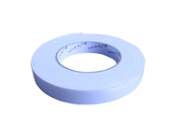 | 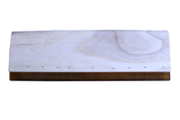 |  | 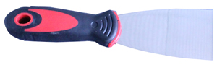
Screen Frame Adhesive | Tools For Installation
box | pc
1 | 2
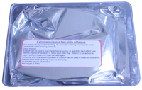 | 

ASC365 International Ltd
http://asc365.com

