Pack list of 6-colour 6-station screen printing machine
（It includes 4 parts, please check them before installing.）
No.1 (There are CD and pack list in.)
Name of parts | Machine frame  Part one | Tool package | Fittings 1---spring | Fittings 2—bedplate knob
Unit | station | set | Entries | Entries
Amount | 1 | Eight in one set | 12 | 12
Practicality picture | 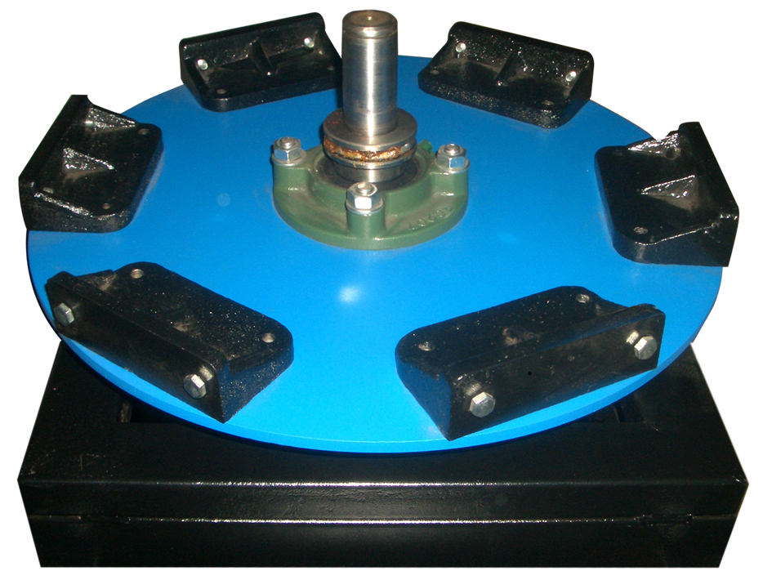 | 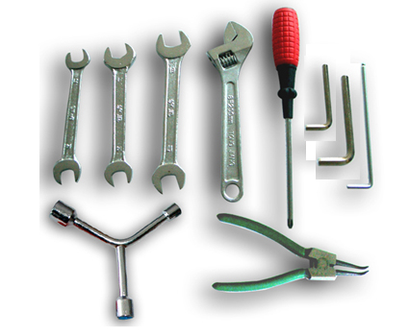 |  | 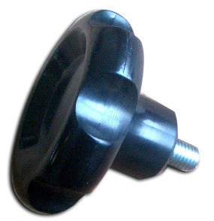

No.2
Name of parts |  | Machine frame  Part two | Rack
Unit |  | Entries | Set
Amount | 1 |  |  | Twelve in one set，including 4 adjusting robs with bowls.
Practicality picture | 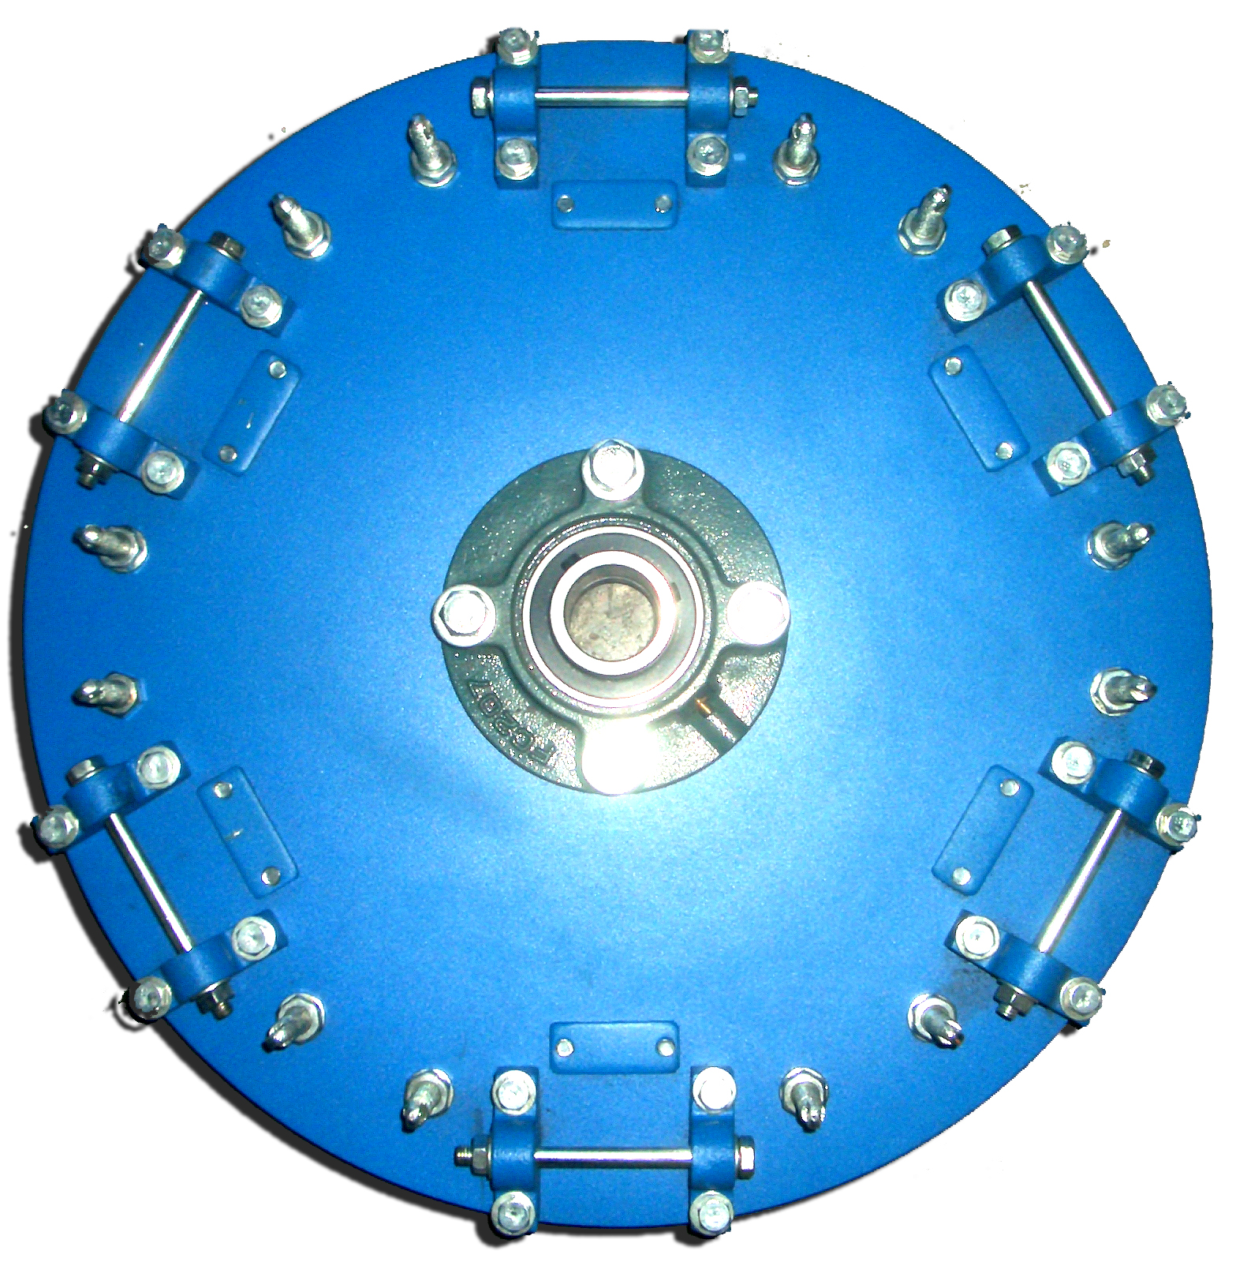 |  |  | 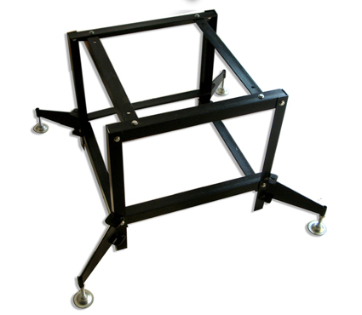

No.3 and No.4
Name of parts | Bedplate | Bedplate support | Screen frame support
Unit | Entries | Entries | Entries
Amount | 6 | 6 | 6（with one alnico block each）
Practicality picture | 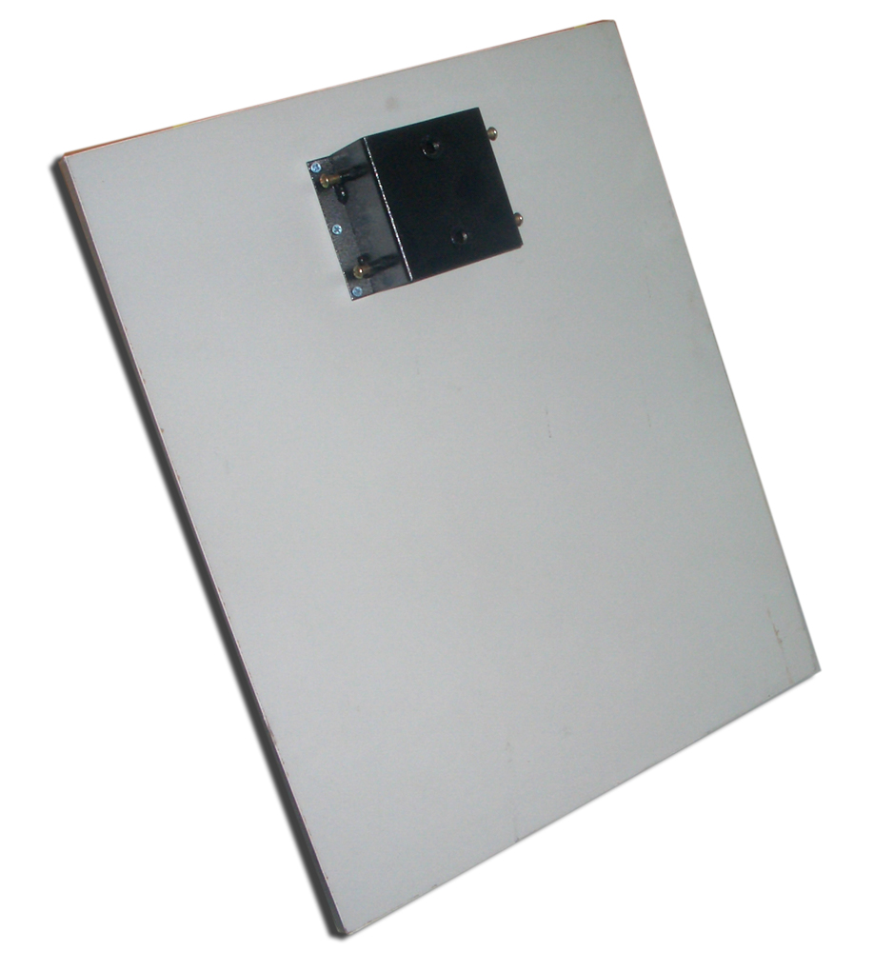 | 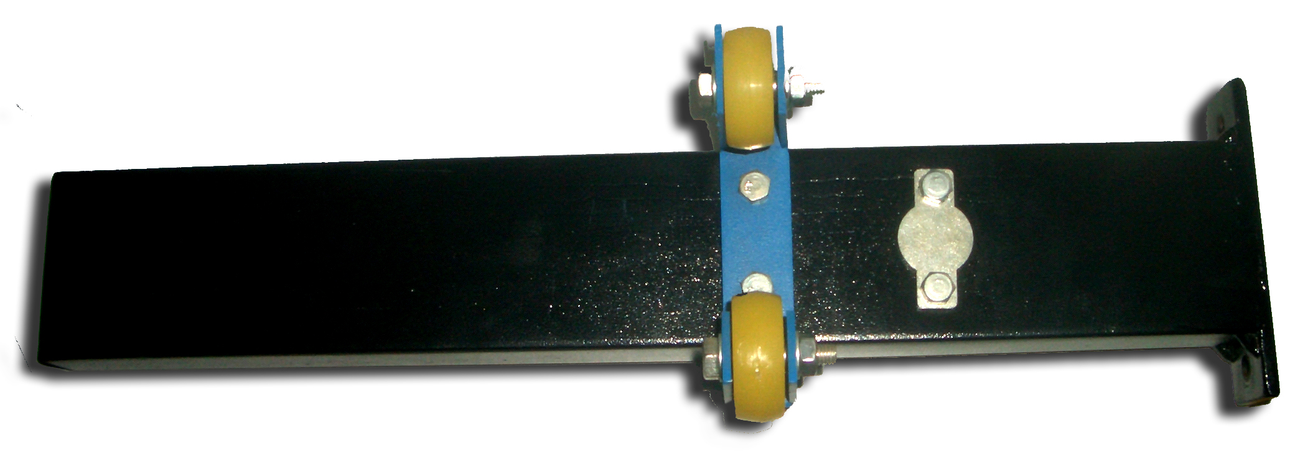 | 