Package List of 4-2 Screen Press
(It includes 1 package; please check the followings before installing.)
(1, CD; 2, Instruction; 3, Package List)

Mainframe | Platen Holder | Platen Support Arm
set | pc | pc
1 | 1 | 4
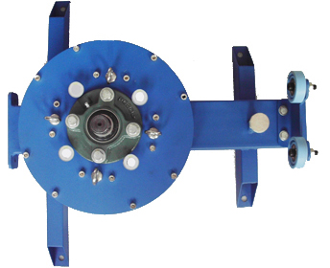 | 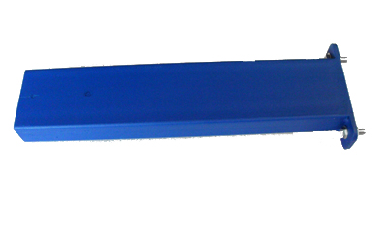 | 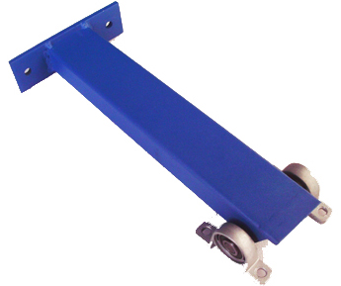

Screen Frame Chuck | Platen Mainframe | Clip Groove
pc | pc | pc
4 | 1 | 1
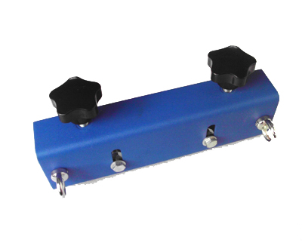 | 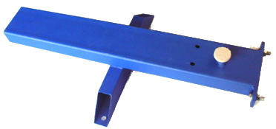 | 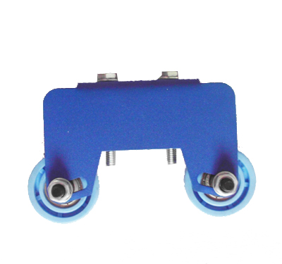

Platen | Platen Bracket | Platen Screw
pc | Pc | pc
2 | 2 | 12
 | 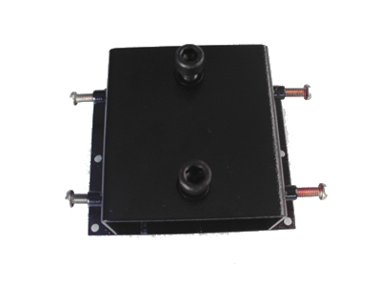 | 
Orchid Screw | Spring | Tool
pc | pc | set
8 | 8 | 1
 |  | 