Package List of 4-4 Screen Press
Carton 1
(Manual Instruction, Package List and CD are included)
Name | Unit | Amount | Picture
Mainframe | set | 1 | 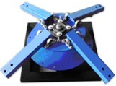

Carton 2
Name | Unit | Amount | Picture
Pallet Support Arm | pc | 4 | 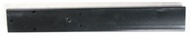
Orientation Block | set | 4 | 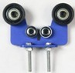
Printing Head Collet | pc | 4 | 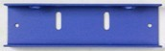
Printing Head  Collet Fastenings  (6 screws included) | set | 4 | 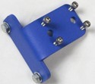
Screw A  (Connecting pallet support arm and mainframe bottom turntable) | set | 12 | 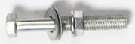
Screw B  (Connecting Collet fastenings and printing head support arm) | pc | 8 | 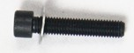
Position Knob  (Adjusting up-and-down height of printing head support arm) | pc | 4 | 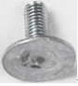
Control Pad  (Balancing printing head support arm during up-and-down adjusting process) | set | 4 | 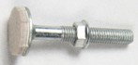
Spring | pc | 8 | 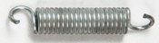
Collet Knob | set | 8 | 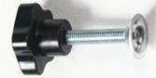
Turn-buckle | pc | 8 | 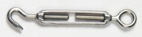
Rings  (Screws included) | pc | 8 | 
Installation Tool | set | 1 | 
Spare Part | pc | 3 | 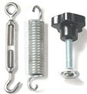

Carton 3
Name | Unit | Set | Picture
Right-angle Pallet  (45*55cm) | pc | 4 | 
Pallet Bracket  (4 adjustable screws included) | set | 4 | 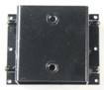
Pallet Bracket Knob | pc | 8 | 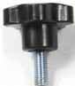
Screw C  (Connecting Pallet and Pallet Bracket) | pc | 24 | 

Carton 4
Name | Unit | Amount | Picture
Rack Part | pc | 16 | 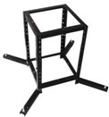
Balance Foot Stand | pc | 4 | 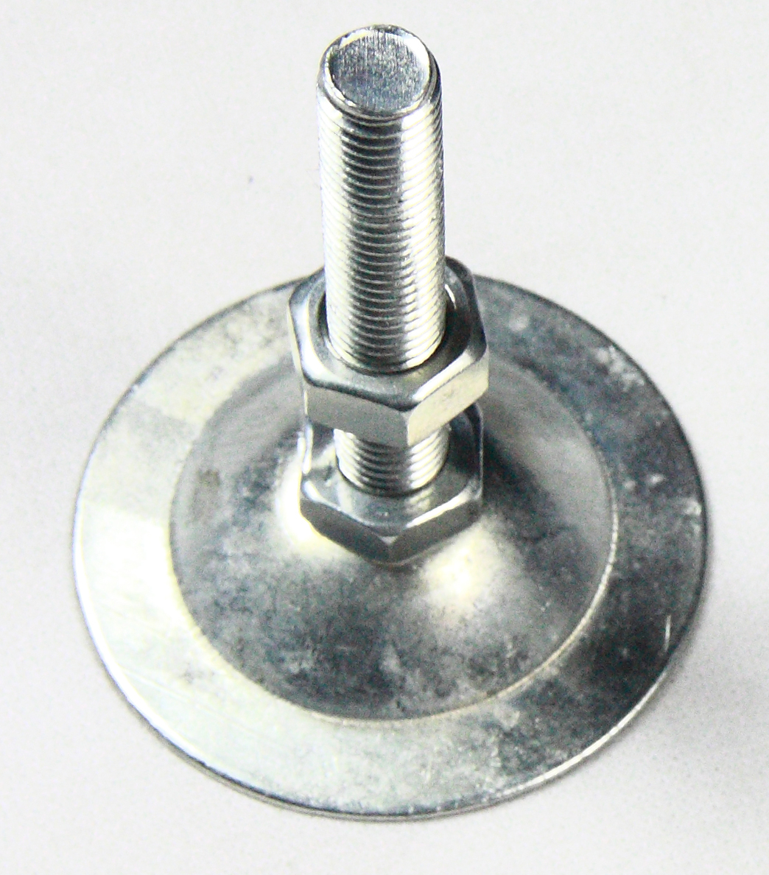
Screw D  (Connecting Mainframe and Rack) | set | 4 | 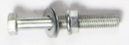
Screw E  (Installing rack) | pc | 32 | 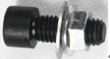

ASC365 International Ltd
http://asc365.com

