Package List of 2-1 Color Screen Press Equipped with Dryer
(It includes 2 package; please check the followings before installing.)

Carton 1
(Package List and CD are included)
Name | Unit | Amount | Picture
Dryer | set | 1 | 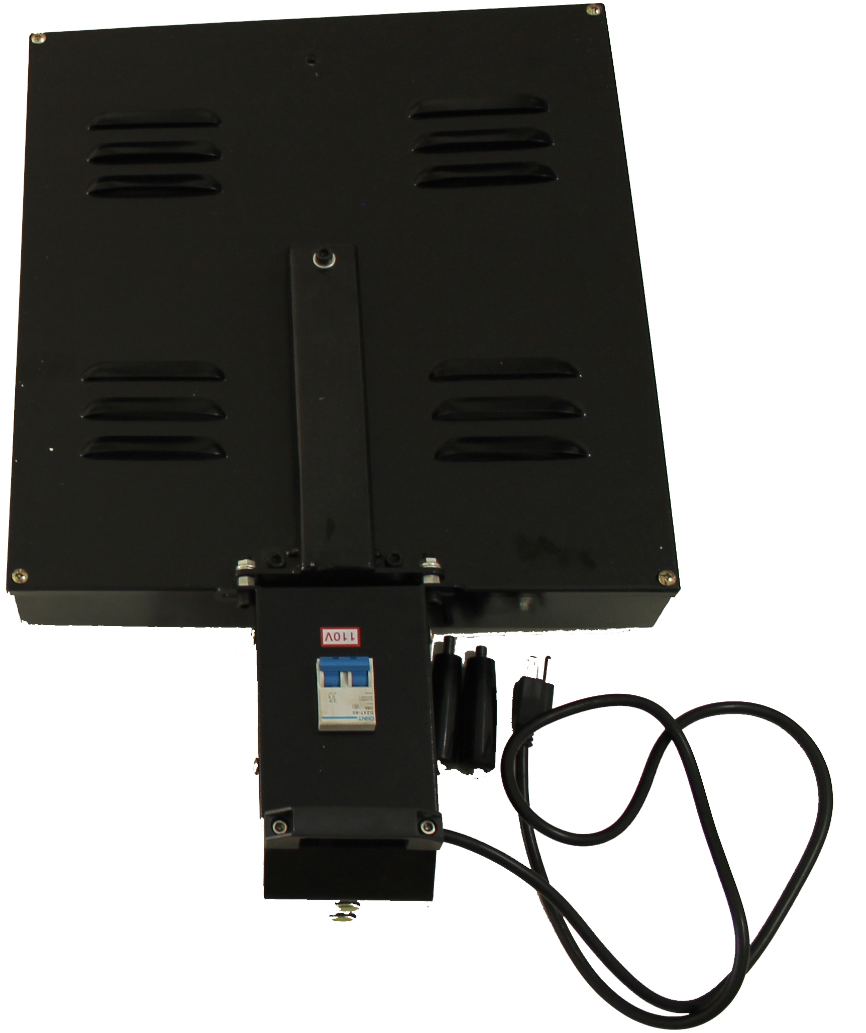

Carton 2
Mainframe | Platen Holder &  Dryer Connection | Platen Support Arm
set | pc | set
1 | 1 | 2
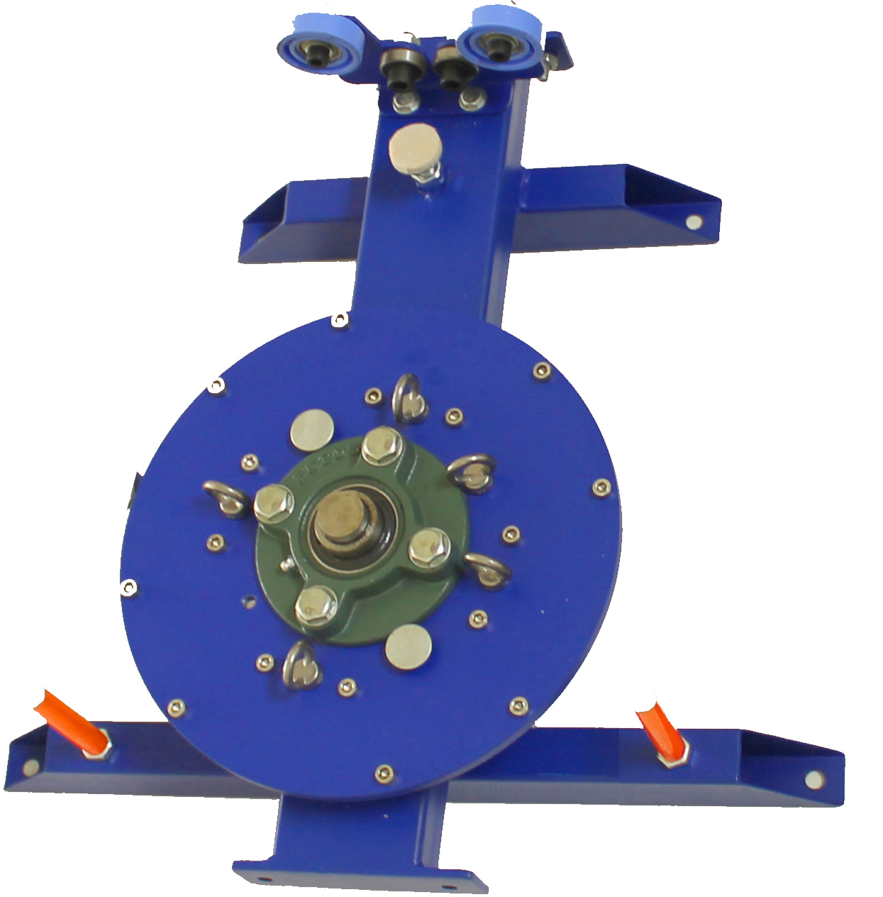 | 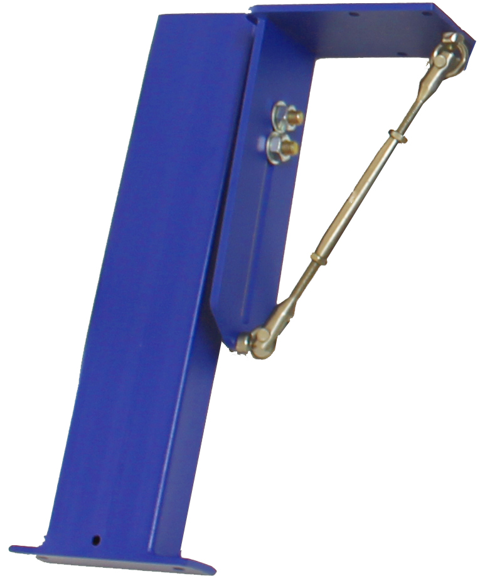 | 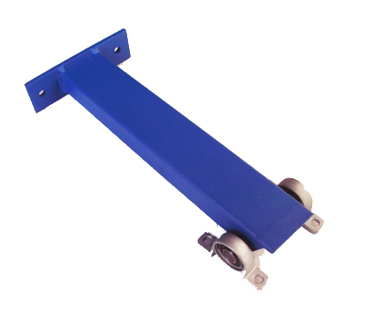

Screen Frame Chuck | Platen Bracket | Platen
set | set | pc
1 | 1 | 1
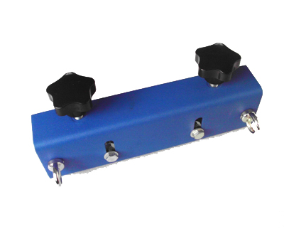 | 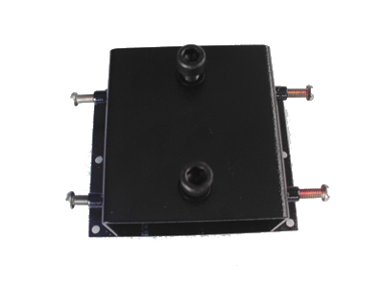 | 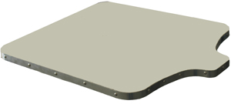
Turn-buckle | Spring | Platen Screw
pc | pc | pc
4 | 4 | 6
 |  | 
Tool | 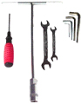
set
1

ASC365 International Ltd
http://asc365.com

