自动名片切卡机操作说明书
此款自动名片切卡机采用机电一体化设计，具有功效小、噪音小速度快、定位准的特点。
请您在使用此名片切卡机之前，请仔细阅读本手册，以便您正确了解该机的性能，并充分运用其各项功能。
非正常的操作，有可能会导致机器损坏。
1、第一道入纸口
将打印好的名片纸（标准A4纸210×297mm）平放在第一道入纸口，移动两边定位装置，使其紧靠纸张两边，将纸往前推至道口，利用刀口标志校正名片纸的位置，松手之后，它会自动完成。
2、第二道入纸口
将第一道切好的名片旋转90度平放入第二道入纸口，移动两边定位装置，使其紧靠纸张两边刀口标志，松手，将自动完成。最后清理纸屑。
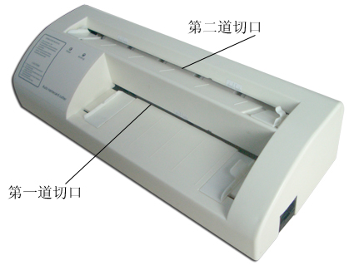
切卡机示意图：
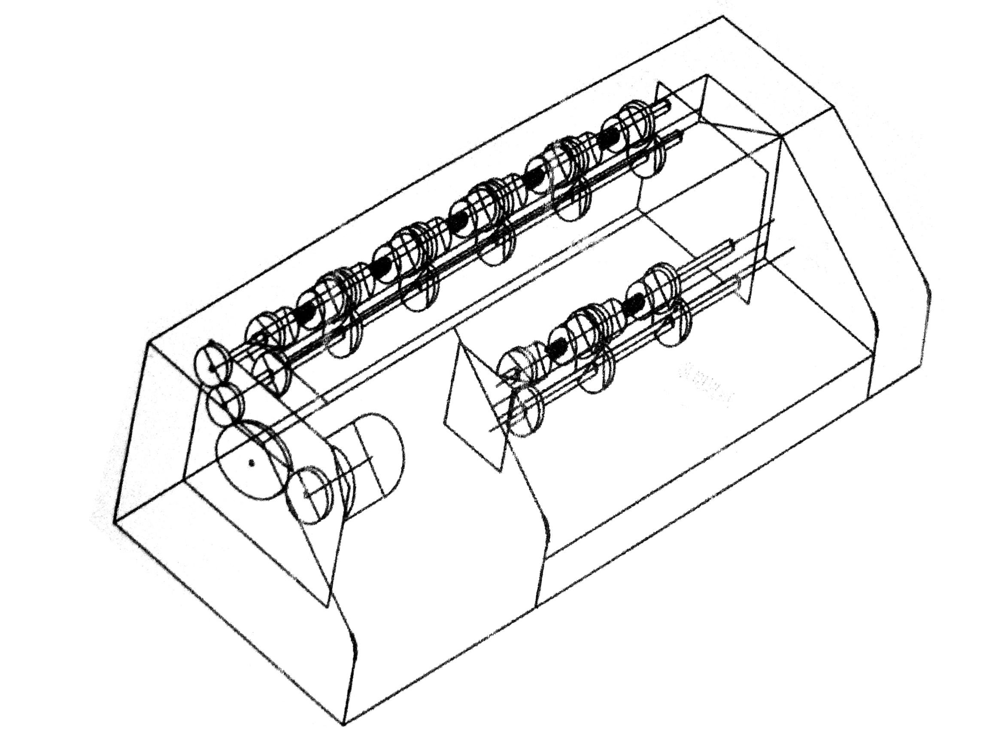
使用方法：
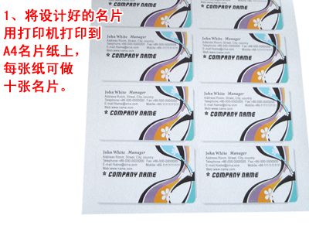 | 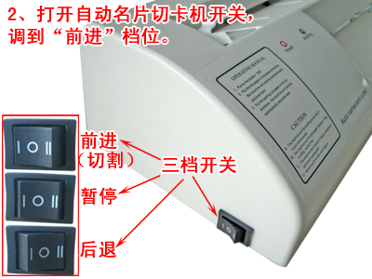
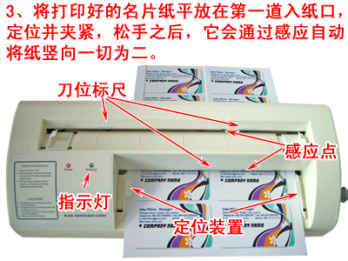 | 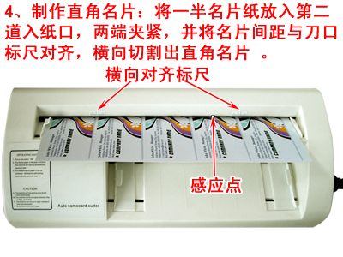
警告：
此切卡机只适用100克—350克的纸张，不能用于切割PVC卡及其他塑料卡片。
附：切卡机切割尺寸及调节示意图
图中均为A4纸之尺寸。虚线内框部分为成品名片尺寸大小，排版时请参考以下格式，以免造成误差而浪费。
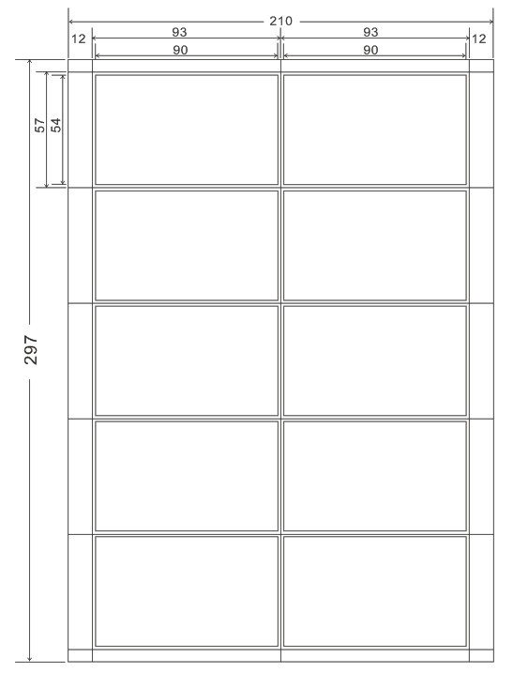
单位：mm 规格：54×90mm
打印时注意点：
- 将十张名片居中放于A4页面中心。
- 打印时正在属性栏中设置打印纸张大小为2100×3100（可自行调节）。在版面设置中把页面设置为中上。
- 如是其他规格的卡片，请根据实际情况设定确保安全的使用方法
注意CAUTION：
- 机内不可入液体，掉入金属物件、小纸屑等。
- 不可用手指触摸刀片。
- 应把机器放在稳固的平面上。
- 切卡机每次只能放入一张纸进行切割。
- 如机器冒烟，发出异味，杂音等异常情况，请切勿使用。
警告  WARNING | 操作不当会导致人员受伤或设备受损  符号表示使用者需注意，三角形内的图样表明应注意的情况。左图表示“小心触电”。
注意  CAUTION | 操作不当会导致人员受伤或其他物体损失  符号表示必须禁止的举动，圆圈内的图样表明了所禁止的动作。左图表示“不得拆卸”。
使用维护提示：
- 在您清洁本机之前一定要先关闭电源开关和拔出电源插座方可进行。
- 在切割之前应先检查名片是否与本机的刀片对齐，并拧紧机子边上的螺丝，以免在切割时出现晃动，导致卡片的不整齐。
- 在正常运作的情况下应注意不要用手去触摸运转的刀片。
- 机器长期搁置后，开机前须检查和进行试运转。
- 刀具是易耗品，不提供保用，如果按照手册操作，切割纸张不会损坏，如果切割其他介质或操作损坏可向当地经销商有偿订购。
切卡机技术规格各特性：
名称 | 特性和参数
纸张类型 | A4(8.3"*11.7" 210mm*297mm)/(7.7"-8.3"*11.7" 195-212mm*297mm)
切割名片规格 | 3.5"*2.1" 90*54mm
页边距 | 左边边距9-12mm可调，上边距3-10mm可调
刀具寿命 | ≥10万次
机器精度 | ≤0.02" 0.5mm
切割速度 | 30片/分钟
电源 | AC220V 18W
包装尺寸 | 16.7"*4.7"*8.1" 425mm×120mm×205mm
毛重量 | 10.6LB 4.8KG

AUTO NAMECARD CUTTER OPERATION MANUAL
“Auto” business card cutter adopts a machine electricity integral whole to turn，have following characteristics: consume small, the noise is small, the speed is quick and fixed position quasi.
Please careful reading this manual before using the “Auto” business cars cutter, for the purpose of you exactitude understand the function of that machine and make the most of its various functions.
Not-function correctly, may be cause the machine damage.
1. The first paper inlet
Put the printed business card (Standards A4 paper 210*297mm) lie flat into the first paper inlet, move both sides fixed position device, make it depend paper both sides tightly, push to the edgy of knife before going toward paper position, after loosening hand, it will complete automatically.
2. The second paper inlet
Put the sliced business card circumrotate 90 degree and lie flat then into the second paper inlet, move both sides to make use of edge of knife mark tightly, correct business card paper, loose hand, will complete automatically, tidy up scraps of paper finally.
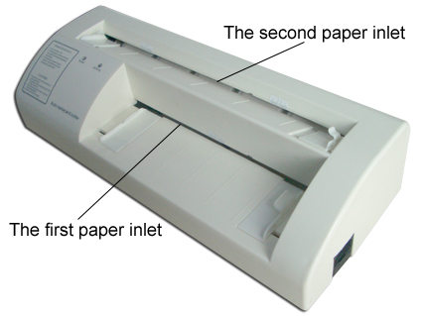
Cutter sketch map
Using method：
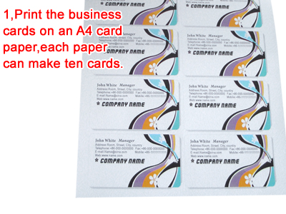 | 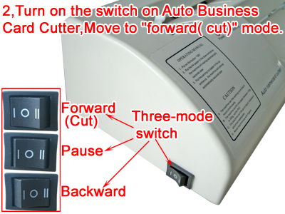
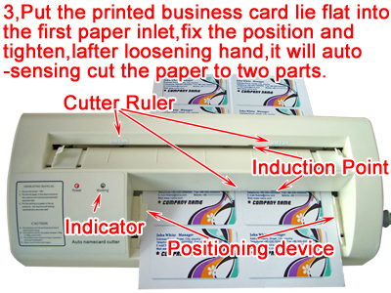 | 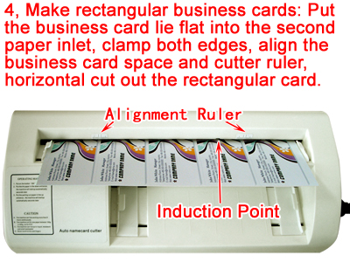
Warning:
This machine only apply to 100 gram to 350 gram of the paper, can’t incise the PVC card and other plastics cards.
Attach: the cutter incise size and regulates sketch map
All is a frame part inside the size dotted line of A4 paper for the size of the finished product business card in the diagram, please make referce to a following format while composing type, in oder to prevent error margin but waste.
Unit: mm Specification:54×90mm
Notice to order while printing:
- Put ten business cards in the center of A4 paper.
- The constitution in the attribute column prints the paper size as 2100*3100 while printing (can regulate by youself). Establish a page in the layout of printed sheet the constitution for in top.
- If is the card of other specifications, please insure safe operation method according to the actual circumstance enactment.
Caution:
- In the machine can’t go into liquid, drop into the metals article, small scraps of paper etc.
- Don’t touch the razor blade by hand.
- Should put machine on the flat surface of firmness.
- Each time only put a piece of paper into the machine to carry on incising.
- If the machine appear to emit smoke, send out strange smell or cacophony, or other abnormal circumstance, please stop using!
The caution explains:
Warning | Operate is not appropriate meeting to cause the personnel get hurt or the equipment damaged.  The drawing enunciation in the triangle should notice of circumstance. The left chart show “Caution, Electricity!”
Caution | Operate is not appropriate meeting to cause the personnel get hurt or other objects damaged. The sign means the user needs to be noticed,  The sign means the user needs to be noticed, the drawing enunciation in the triangle should notice of circumstance. The left chart show “Caution, Electricity!”
Using a maintenance hint:
- Before you clean the machine must turning off the power switch and pulling out AC outlet.
- Should first check whether business card align with the razor blade of this machine or not before incising, and the screw of the side of the tight machine son, in order to prevent while incising appear shake cause the card out of order.
- Under the situation that act normally should notice don’t touch the razor blade to operation by hand.
- The machine switches on after putting off over a long period of time need check and carry on trying operation.
- The knife is easily worn articles, don’t to provide to protect to use, if operate according to the manual incising the paper will not damage, if incise other mediums or operate damage can buy to the local dealer.
Characteristics and Parameters:
Name | Characteristics and parameters
Paper | A4 (8.3"*11.7" 210mm*297mm)/(7.7"-8.3"*11.7" 195-212mm*297mm)
Cutting business card spec | 3.5"*2.1" 90*54mm
Page edging saw | Left edging saw adjust from 9 to 12mm,top edging saw adjust from 3 to 10mm
Cutter life-span | ≥100000 times
Machine precision | ≤0.02" 0.5mm
Cutting speed | 30 piece per minute
Voltage | AC 220V 18W
Packing Size | 16.7"*4.7"*8.1" 425mm×120mm×205mm
G.W | 10.6LB 4.8KG

