All in one solar street light 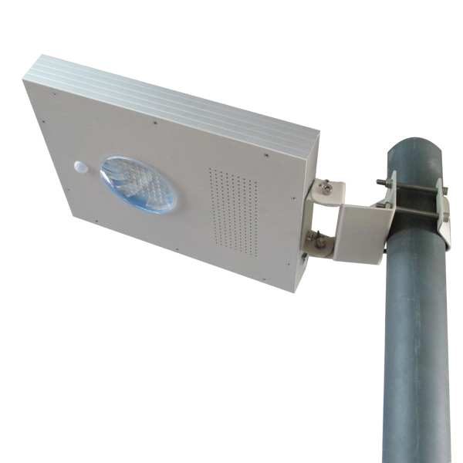
Instruction Manual(6W.8W.12W.15W)

Thanks for using all in one solar street light.

The design of the all in one solar street light comes from the inspiration and power of the universe, combined the best energy saving parts---solar panel, led lamp and special battery. With the help of the controller and PIR sensor, it realizes the functions of high brightness with low energy, long lifespan and free maintenance. At the same time, it is very convenient to ship and install. It is one of the best patent products of our company.

Specifications
Light source |  | □6W | □8W | □12W | □15W
Solar panel |  | 12W(Mono) | 15W(Mono) | 18W(Mono) | 25W(Mono)
Human body sensing |  | Yes | Yes | Yes | Yes
Dimension |  | 420*265*50mm | 480*320*52mm | 480*320*52mm | 700*360*52mm
Net weight |  | 4.15KG | 5.5KG | 5.8KG | 9KG
Luminous | Full load working | 780lm | 1040lm | 1560lm | 1950lm
Luminous | Less load working | 260lm | 350lm | 520lm | 650lm
Visual angle |  | 120° | 120° | 120° | 120°
Color temperature |  | □6000k-6500k | □6000k-6500k | □6000k-6500k | □6000k-6500k
Work time | Full power | ≥12Hr | ≥12Hr | ≥12Hr | ≥12Hr
Work time | Saving  mode | ≥24Hr | ≥12Hr | ≥24Hr | ≥24Hr
Work temperature |  | charging:0°C～+60°C discharging :-20°C～+60°C storage:0°C～+45°C
Install height |  | 3-4m | 3-4m | 3-4m | 4-5m
Light space |  | 8-10m | 8-10m | 8-10m | 10-15m
﹡The data of its working time was measured at latitude 22 °, 113 ° east longitude in sunny days.
The working time will be affected by the surroundings.

The following are tips and directions for all in one solar street light, please pay attention.

①“All in One solar street light” could not work without sunshine, please select the suitable model according to the local sunshine radiation and the annual total radiation.We suggest use the both AC and DC charging model in those places where lack of sunshine or have long-time rainy days.

②“All in One solar street light” adopts the long life Lithium battery for storing energy, charging temperature at day time is between: -30°C～+60°C,when temperature goes lower than -30°C ,the control system will stop automatically to protect the battery, and it will revive to charge the battery while temperature goes higher than -30°C. Discharging temperature at night is between: -30°C～+60°C, any ambient beyond will take damage to the battery. So please check these factors while selecting the street light.

③Battery of the “All in One solar street light” can be stored for 6 months long after fully charged. Therefore please examine and charge it periodically after long time transportation or storage to prevent damaging.

④When you install the lights in Northern Hemisphere, please adjust the solar panel to the South as much as possible to collect maximum sunshine radiation, while install them in Southern Hemisphere, By the same token, keep solar panel to north. At the same time please keep it away from any shadow of houses, trees etc.

⑤Keep clear of the surface of the All in One solar street light with normal detergent to get maximum power generation, clear the dust or tree leaves or any grease.

⑥All in one solar street light have got the standard of IP65.The vents on the surface is designed for radiating.The materials are made of aluminum alloy which can survive in the environment of seaside and desert.

⑦Please turn on the switch when using.
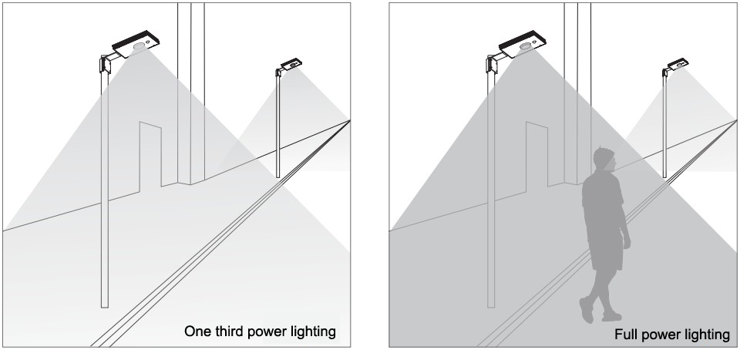

Installing Directions:

①To place the light pole into the best spot with good day lighting . The light pole should be the length 3-5m, the thickness 2.0mm with material iron or steel, the diameter 40-100mm.

②Please check if the components are all here when open the packing, the components are show below.

③Please turn on the switch before using.

④Place the lamp on the pole by its sleeve,and make sure it is steady,then it is OK.

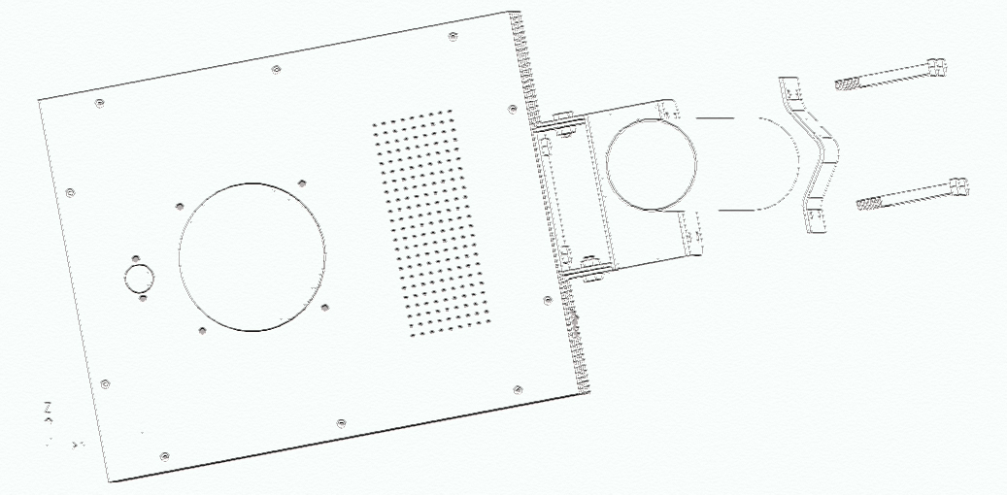
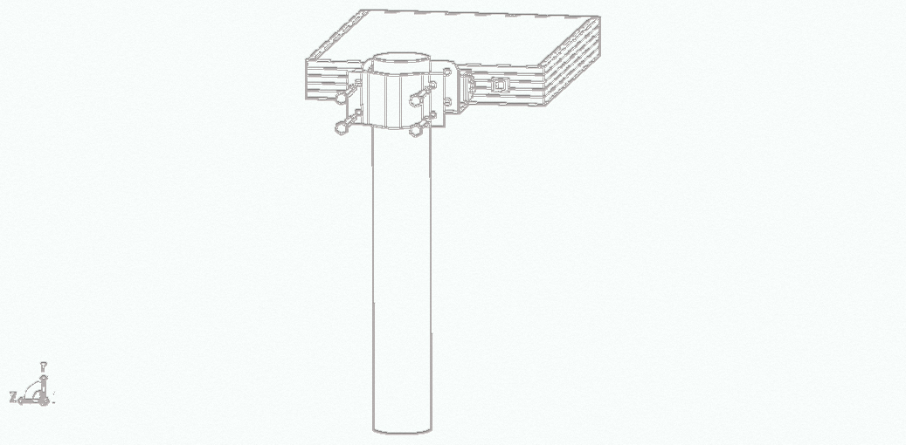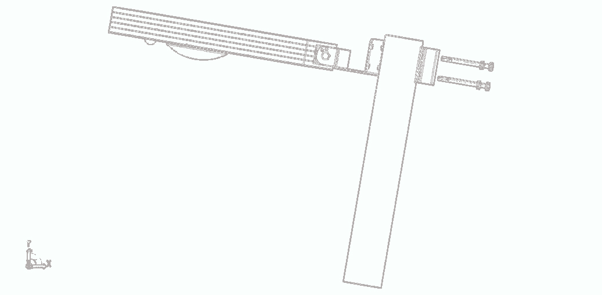
﹡We have right to improve the structure of our products without any special notice. If there is anything different from data here, please follow what it is.
We guarantee that we have done what we can to improve the contents of the instruction, so we will not assume any loss of this.

