XDT40 Hole Drilling Machine for Engineering Machinery

Operation Instructions

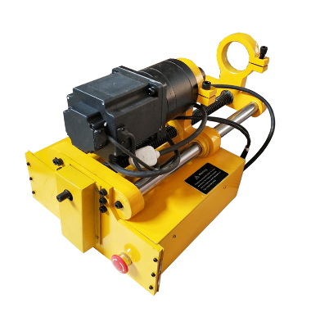

Content

Preface
I. Operation Instructions
II. Equipment Characteristics
III. Primary Structure
IV. Operation Process
V. Electric Cabinet
VI. Main Technical Parameters
VII. Equipment Maintenance
VIII. Appendix

Preface
Hole drilling machine for engineering machinery is a portable processing equipment developed for field service of engineering machinery, which is mainly used in processing of small-scale pipeline inner hole and concentric span hole, and widely applied in engineering machinery, including excavator, crane, loader, and hoist. This hole drilling machine is the best servicing installation for engineering machinery. Only one person is required for operation, and the actual operation difficulty greatly reduces for its focus on field in design concept and processing to make serviceman handier with the machine.
Main application scope: processing after repair welding, or bushing installation after hole expansion of rotation hole, hinge joint hole, and hinge pin hole in all engineering machines; repair and processing of concentric hole in excavator, loader, pressure machine, crane, etc.; and multiple holes lying alongside to conduct disposable positioning processing to multiple holes to ensure the coaxiality of these holes.
This machine is installed by fixed clamping, and uses different tool rest according to different diameter ranges. Please confirm the diameter of processing hole before use to select the appropriate tool rest.
This instruction is only suitable for hole drilling machine for engineering machinery: XDT40 type.
I. Operation Instructions
Please read the operation instruction carefully before using the machine, and check all the items according to packing list to know about operation safety precautions, machine performance, and usage specifications.
1. The operator should accept safety education and operation training, and have machining experience.
2. Work clothes and protective glasses have to be worn before operating the machine.
3. Check if the connected power voltage is consistent with the voltage required in nameplate before starting up.
4. Check if the card mount system has been locked before starting up.
5. Pull the work piece in alignment, or align the work piece at the minimum speed. Alignment in high speed is not allowed.
6. Do not put hand or other things close to the equipment before starting up to avoid personal injury.
7. Electric wire should be far away from the place with high temperature, oil, or sharp edge.
8. Turn off the power by remote control when failure or abnormal sound occurs before inspection and repair.
9. Do not operate the machine in unattended condition. Personal can only leave the site after confirming the drive system in neutral position and turning off the power when machine stops operation.
10. It is strictly prohibited to use this machine in processing range exceeding or lower than the noted range.
11. The machine should not exceed the regulated maximum cutting capacity to avoid damage and personal injury caused by machine.
12. It is strictly prohibited to directly change the feeding direction after the machine operates.
13. After processing, oil and filings on machine should be removed, and slushing oil should be sprayed on tool arm and principal axis.
II. Equipment Characteristics
2.1 Driving of hole drilling machine
By adopting 110V continuous current motor with characteristics of low-speed of revolution and high torque, the complete machine can realize stationary machining in superior performance.
2.2 No vibration in end travel and cutting process.
2.3 Feeding and processing can realize electrodeless speed regulation. Feeding process can be set according to demands, and processing can automatically stop after reaching the limit switch.
2.4 Boring bar adopting high-strength alloy and structural steel is featured with high hardness, high accuracy, high tenacity, good abrasion resistance, etc.
2.5 In effective travel, the tool rest can be fixed at any position of boring bar.
2.6 The boring bar can be disassembled separately to make installation convenient.
2.7 Electric motor controller is equipped with dynamic delay brake program to avoid vibration in shutdown.
2.8 The control cabinet is installed below the main engine to be beneficial to safety operation.

III. Primary Structure
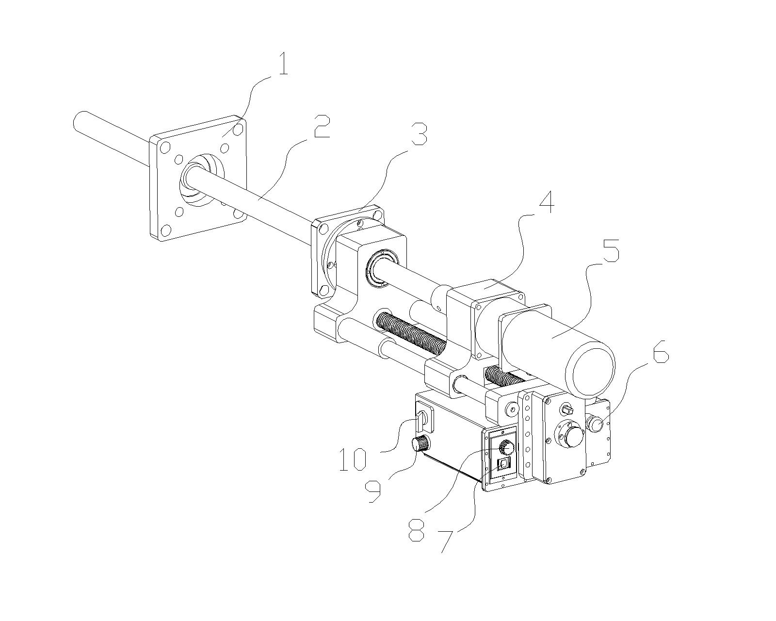

1. Supporting seat A
2. Boring bar
3. Supporting seat B
4. Rack
5. DC motor
6. Emergency stop switch
7. Feeding turning button
8. Feeding speed governing button
9. Speed governing button for motor rotation
10. Alternate switch of motor steering

IV. Operation Process
4.1 Support installation
A. Location of boring bar
Fixed seat can be installed in position allowing work piece welding. Push the boring bar into the hole requiring processing with nylon locating taper sleeve, and lock the locating boring bar with tool rest on both sides to ensure the concentricity of two holes.
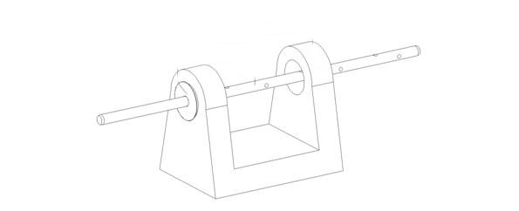
Locating taper sleeve Boring bar Locating taper sleeve

B. Fit supports into boring bar, and weld these two supports in appropriate position of work piece.
C. Take off the locating taper sleeve (please ensure that the boring bar can rotate and slip axially freely).
4.2 Installation of main body
A. Fit the main body into support (see following figure)

B. Connect the main body with support at spot 1 and spot 2, respectively. (See in right figure)

1处用M10×65的螺栓连接，必须连接牢固。
Three bolts will be used in connection at spot 2 firmly.

4.3 Power connection
A. The power voltage should be 110V, and insert the plug of electricity box into 110V power.
4.4 Selection of tool rest
The aperture is between Φ45mm and Φ90mm. Put the tool rest into bar-type slot of boring bar, and fix it with compression screw.
Different tool rests should be selected according to aperture size when it is larger than 90mm.
A. Installation of tool rest. Fix the milled tool rest in boring bar or tool rest according to the processing hole size (the cutter sharpening of tool can take the angle of boring cutter as reference).
B. Please choose the neutral position in tool setting, turn the boring bar, and adjust the tool to make tool nose grazing the surface of work piece (the tool has to be installed firmly).
4.6 Cutting depth for one side should be 0.2~1.0mm in trial cutting.
4.6 Please rationally arrange the feed amount according to the size in cutting by adjusting feed button from zero slowly in general range between 0 and 10 on button. The adjustment should not be too fast, or damage may occur for fast feeding.
4.7 Please select rational tool and tool angle in processing (the angle can be the tool angle of boring cutter)

V. Electricity Box
As the control part of hole drilling machine of engineering machinery, electricity box has two major functions which are feed control and boring bar rotation control. (see in figure)
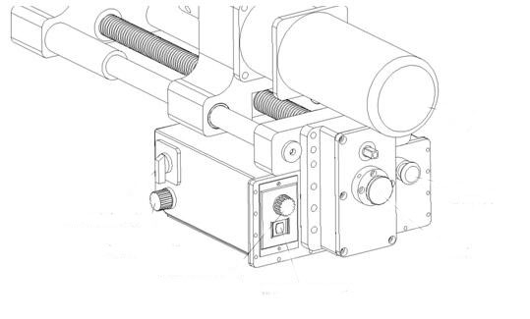
5.1 The red button at right lower corner is emergency stop button.
5.2 Direction control button of main motor has three gears of 1, 0, and 2. “2” refers to clockwise rotation, “0” to stop, and “1” to “counterclockwise rotation.
5.3 Speed control button of main motor. The speed of motor rotation in clockwise rotation will be faster and faster, otherwise, it will decelerate. The maximum rotation speed output by this driving motor is 50rpm.
5.4 There are three gears in feeding direction control button. Gear II refers to withdrawal, Gear I to feed, and the middle gear to stop.
5.5 Feeding speed control button can control the speed of feed and withdrawal. The speed should be adjusted from zero slowly in processing. The needle should point to no more than 10 on the dial in feed, while the speed can be the maximum in withdrawal.
5.6 Feed can be done when pulling out the gear rod. When the gear rod is pushed, no reaction will occur when pressing feed switch.
VI. Main Technical Parameters
6.1 The maximum processing hole diameter: Ф180mm
6.2 The minimum processing hole diameter: Ф45mm
6.3 The maximum processing travel: 380mm (the maximum processing travel can be designed according to customer requirement)
6.4 The maximum feed depth: 2mm on one side (A3 steel)
6.5 Surface roughness: Ra3.2
6.6 Deviation from circular form≤0.02mm
6.7 Rotate speed: 0-83RPM
6.8 Boring bar: 40*1500mm

VII. Equipment Maintenance
In order to ensure the use of hole drilling machine for engineering machinery become more convenient and rapid and every component can work smoothly, regular cleaning and maintenance have to be done to hole drilling machine.
7.1 Slushing oil should be painted to boring bar and feed screw which are not used very often.
7.2 Appropriate grease oil should be added to the feed box every half a year.
7.3 Spindle box and feed box should be stored by sealing if these parts are not used for a long time.
7.4 Appropriate grease oil should be added to guide post and screw before processing.
7.5 Boring bar should be hanged for hoisting to avoid deformation when it is not processed.

