Ultrasonic Humidifier
□For RM-03 to RM-18

INSTRUCTION

Read it before installing/using the machine！

Index
1. Company profile 3
2. Working principle 3
3. Features 3
4. Parameter 5
5. Attention matters 7
6.Regular failure and failure elimination 8
7. Operation： 9
8.Installation 11
9．Annex list 12
10. Maintance： 12
11. Warranty: 13
12. IMPORTANT NOTICES 13

Thanks for using this humidifier of our company. In order to let you experience the product swimmingly, detailed instruction is provided which you can find the product's introduction, usage and other information. Before using this product, please read the manual carefully, so that you can correctly use it. In case of any printing or translation error, we apologize for the inconvenience. As for the content change, we are sorry for no further notice. This manual is apply to all DRS series product of our company.

1. Company profile
Our company is a high-tech manufacturer and solution provider specialized in air humidity control machines in China, product range includes: ultrasonic humidifier, cleansing cooling equipment, ultrasonic spray/disinfecting/deodorization equipment, etc.
Ruiya can offer the comprehensive technical services in the humidifier field, via kinds of our ultrasonic industrial humidifier, according to the different needs of users.

2. Working principle
Ultrasonic humidifiers use a piezo-electric transducer to create a high frequency mechanical oscillation in a body of water. The water tries to follow the high frequency oscillation but cannot because of its comparative weight and mass inertia. Thus, a momentary vacuum is created on the negative oscillation, causing the water to cavitate into vapor. The transducer follows this with a positive oscillation that creates high pressure compression waves on the water's surface, releasing tiny vapor molecules of water into the air. This is an extremely fine mist, about one micron in diameter, that is quickly absorbed into the air flow. Since the mist is created by oscillation, not heat, the water temperature need not be raised. Ultrasonic humidifiers, therefore, can create instantaneous humidity, and don't have to wait for a heating element to boil the water. This precise on/off humidity control is the hallmark of ultrasonic humidifiers. In addition, unlike wet pad humidifiers, ultrasonic units can be of comparatively small size, and still produce significant amounts of vapor. When the sensors which pick up ultrasonic humidifier has decreased below a certain level of humidity of the air ultrasonic humidifier comes into operation. When, however, capture a high degree of moisture the cool mist humidifier is turned off. In this way is very simple to maintain a high degree of humidity within a room as the cool mist humidifier works automatically.

3. Features
3.1. Internal adopting integrated type ultrasound machine, no mechanical drive, no noise, producing certain negative ion and low failure rate and easy maintenance, the output fog grain diameter only be 1-10 μ. The stainless steel body, powder coated, beautiful appearance, standard filling water mouth, switch and outlet water spill, including nozzle to be automatic filling water, automatic control water level;
3.2. High atomization efficiency (nearly 100%): producing small and even fog, quickly meeting the requirements of the relative humidity, saving water;
3.3. Droplet Size: Steam-size droplets. One micron droplets allow for immediate evaporation like steam. Competitive spray nozzle systems create up to 20 micron droplets, risking wetness on equipment and in ductwork.
3.4. Health: All dissolved liquids are removed from the water feeding into ultrasonics.
3.5. Energy Cost: Ultrasonics generate 1 micron size droplets for as little as 1/13 the price of steam. This can save thousands of dollars in annual operating costs. In addition, ultrasonics turn on and off instantly, while steam units preheat, using more electricity.
3.6. Maintenance: Since water is purified before entry into the ultrasonic humidifier, there is considerably less maintenance required of an ultrasonic system as opposed to steam.
3.7. RH Accuracy: Ultrasonics provide instant on/off of mist. As soon as the air strays from the relative humidity set point, an ultrasonic humidifier instantly turns on. Steam canisters have flush cycles that may shut down the humidifier for up to 15 minutes or more. Heating elements inside those systems take time to reboil water to create humidity.

4. Product description & parameter
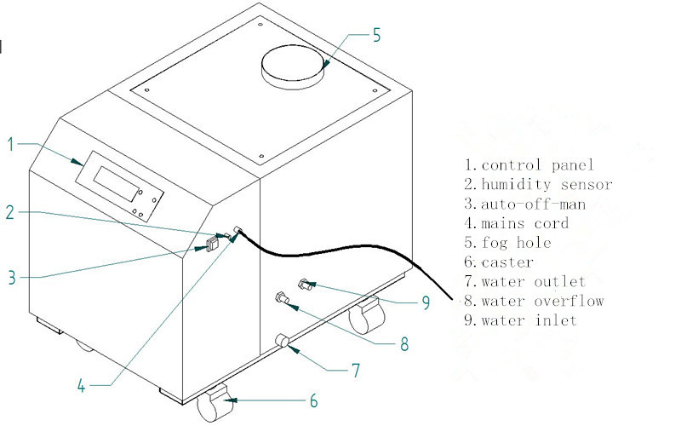
RM-03 RM-06

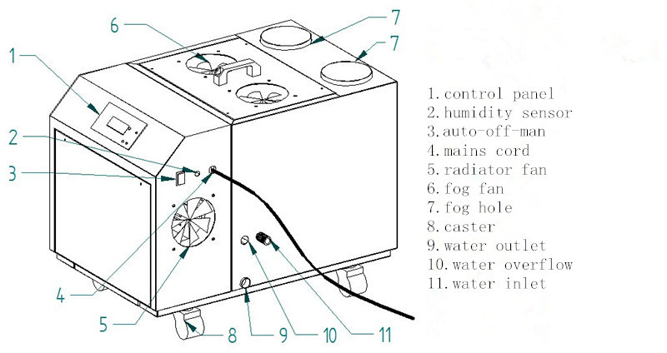
RM-09 RM-12

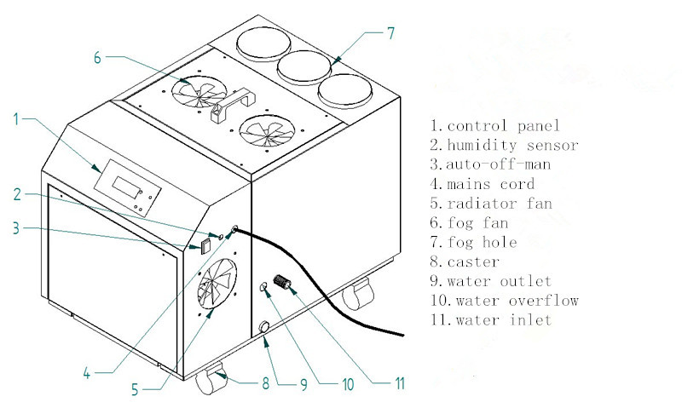
RM-15 RM-18

Model | Voltage | Power | Capacity（kg/h） | Control | Air duct（mm） | Size(mm)
RM-03 | 200V/50Hz/1Ph | 300W | 3 | Auto | 110*1 | 600*330*500
RM-06 | 200V/50Hz/1Ph | 600W | 6 | Auto | 110*1 | 600*330*500
RM-09 | 200V/50Hz/1Ph | 900W | 9 | Auto | 110*2 | 640*420*500
RM-12 | 200V/50Hz/1Ph | 1200W | 12 | Auto | 110*2 | 640*420*500
RM-15 | 200V/50Hz/1Ph | 1500W | 15 | Auto | 110*3 | 640*550*500
RM-18 | 200V/50Hz/1Ph | 1800W | 18 | Auto | 110*3 | 640*550*500

5. Attention matters
5.1 The atomizing air contains very high moisture around the mouth, avoiding these atomizing air backflow inside the equipment, eusure straight pipe goes up 1.5m minimum requirements.
5.2 The best water level(as below) 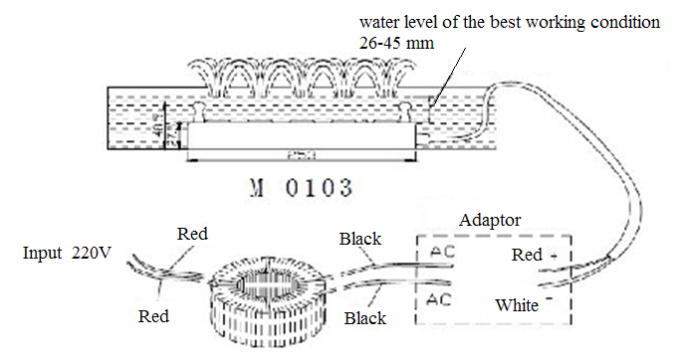5.3
Ambient temp | 1-40°C | Water Pressure | 1-4KG/CM2
Ambient RH | ≤85%RH | Water  temp. range | 1-30°C
Water  quality | Soften Clean water | Surrounding | i.No high temp. Source  ii.No high intensity magnetic field;  iii.No much dust

6.Regular failure and failure elimination
Fault | Reason | Ways
Stop working | A、No power；  B、Fuse blown；  C、Switch is off；  D、Humidity is reached; | A、Checking power supply；  B、Changing same fuse；  C、Turn switch on；
Don't feed water | A、No water supply；  B、The floating ball is clogged；  C、Water pressure is not enough； | A、Checking the water supply pipe；  B、Cleaning floating ball；  C、Water pressure must be 5KG；
Don’t stop feeding water | A、The floating ball is dislocated;  B、The floating ball is clogged;  C、The floating ball is broken; | A、Locate correctly;  B、Clean the clog;  C、Replace the ball;
No Mist but the light works | A、The water tank is too dirty；  B、Voltage is low； | A、Check the voltage；  B、Cleaning water tank；
Water Spill from tank | A、Water tank is broken;  B、The fog flow backward; | A、Change or repair water tank;  B、Check the fan；
Mist grows small or no | A、Much scale in tank；  B、Atomizer is ageing；  C、Voltage is low； | A、Clean water tank；  B、Changing or clean atomizer；  C、Checking the supply voltage,

7. Operation：

Operating instructions
- Auto-off-Man:
Auto----auto control
Off----unit stops working
Man----manual control
2.Power:Press”power”,the unit will be on/off;
3.Set:Press”Set” to set the humidity and cleaning/time;
4.+,-:Press+/- to set the humidity and time;

Control panel:
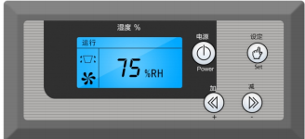
1.Plug in the power,connect the humidity sensor,turn Auto,the LCD screen displays the ambient humidity;press ,the screen displays  and the Run indicator illuminates;press twice, disappers and the Run indicator is off.The fan will continue to work for 30 seconds.If you turn the Auto/Man to the middle,the fan stops working immediately.
2.Plug in the power,turn the Auto/Man to Man,the LCD screen no display,press On to start the machine and the Run indicator illuminates;press On twice to stop the machine and the Run indicator is off. If turn the Auto/Man to the middle,the fan stops working immediately.
3.When the ambient humidity is higher than the set humidity,the machine is standby;when the ambient humidity is lower than the set humidity,the machine starts working automatically;
4. Press  to set the humidity,press ﹢- to set the required humidity,no pressing for 5 seconds the datas will be saved;
5.Press twice to enter the cleaning mode,when the clock on the screen flashes,press ﹢,the machine will stop working after 150 hours to remind that it is time to clean; press – cancels the set. No pressing for 5 seconds the datas will be saved;

Waters outlet: Must be close while working. It can be open while you clean it machine.
Water inlet：Water pressure range 0～4kg/cm, avoid 100μm granules. Hardness less 5. Watering from the mist outlet is not advisable, the reason is the control board will not acquire the precise water level.
Fuse pipe：Avoiding device overload, and further breakdown. Do not change the large capacity fuse pipe randomness.
Power wire：220V/50Hz(±2Hz), the ground line must be needed。The total fluctuation≥1.2*Rating power
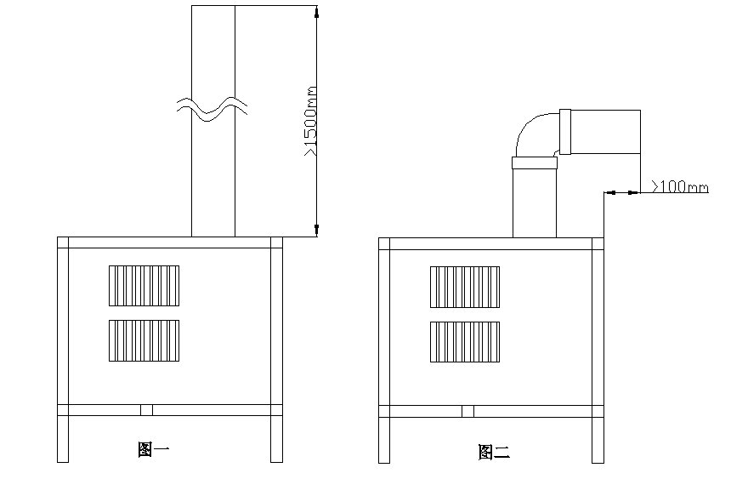

8.Installation

Reasonable pipeline, preventing leakage. When is in a larger area, small fog mouths can be drilled in pipe(same as figure 2). The pipe way showed in figure 3 is banned
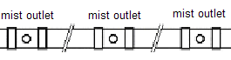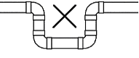
Figure 2 Figure 3
Installation drawing:
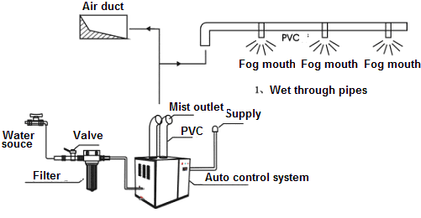
Examples:
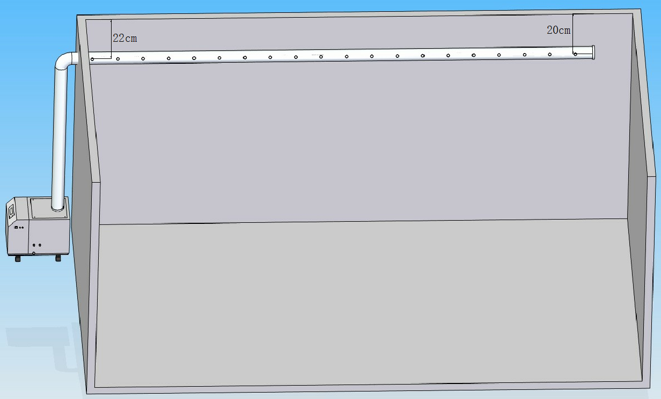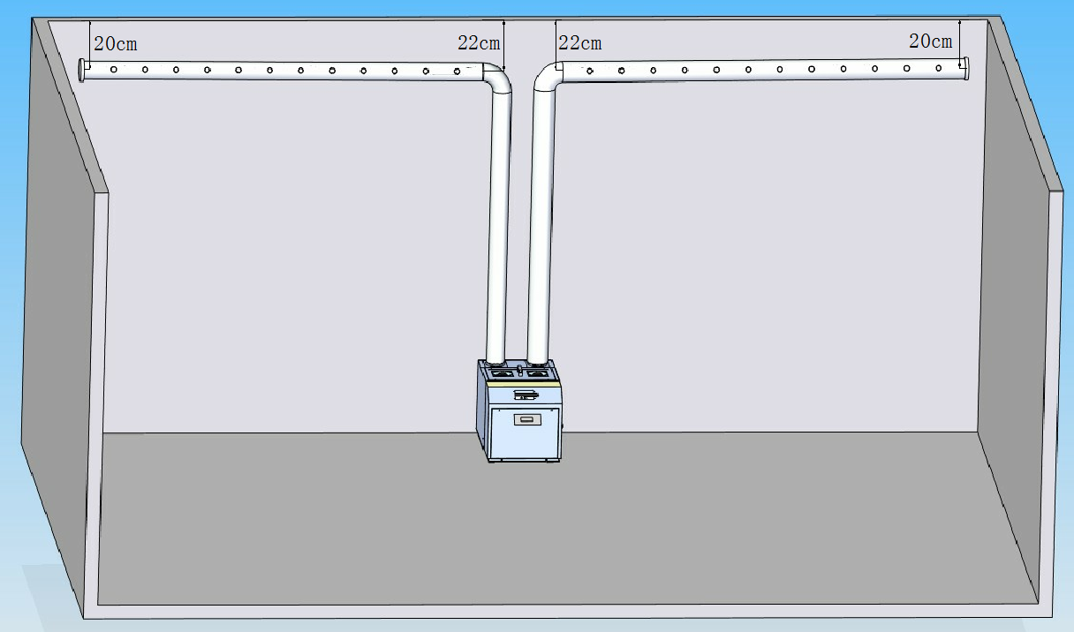

9．Annex list

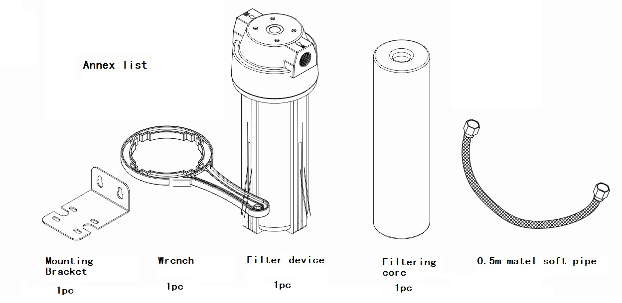
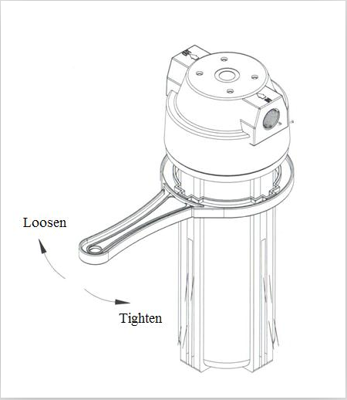

10. Maintance：
11.1. Ensure atomized humidifying effects, cleaning the inner machine regular, one time one month, cleaning method as follows:
A. Open cover, using soft cloth or brush cleaning atomization device(Do not scratch atomization device as well as water level induction switch, the home detergent can not be used), cleaning the scale, then washing by clean water;
B. While watering, do not pour the water into the circuit board to lead to short circuit.
C. Close cover
11.2. Ensure machine runs normally long time, water filter should be regularly cleaned, one time one month, cleaning method is as follows:
A. Open the cover of filter;
B. Removing dirt from filter;
C. Close it again.

11. Warranty:
1.The product has one-year free warranty from the date of purchase.
2.The warranty shall not apply: (i) to any Product subjected to accident, misuse, neglect, alteration, Acts of God, improper handling, improper transport, improper use, improper testing or unauthorized repair or (ii) to cosmetic problems or defects which result from normal wear and tear under ordinary use, and do not affect the performance or use of the Product.All warranties are void if the product is opened, altered, and/or damaged.
3. CUSTOMER MUST PRESENT THE SALES INVOICE OR RECEIPT FOR FREE WARRANTY SERVICES
4. Service Hotline: (86)
Fax Hotline: (86)

12. IMPORTANT NOTICES

IN NO EVENT SHALL OUR COMPANY OR THE SUPPLIER BE LIABLE TO YOU OR ANY OTHER PARTY FOR ANY DIRECT INDIRECT GENERAL SPECIAL INCIDENTAL CONSEQUENTIAL EXEMPLARY OR OTHER DAMAGES ARISING OUT OF THE USE OR INABILITY TO USE THE PRODUCT INCLUDING WITHOUT LIMITATION DAMAGES FOR INJURY LOSS OF PROPERTY BUSINESS PROFITS BUSINESS INTERRUPTION OR FROM ANY BREACH OF WARRANTY EVEN IF OUR COMPANY OR SUPPLIER HAS BEEN ADVISED OF THE POSSIBILITY OF SUCH DAMAGES IN NO CASE SHALL OUR COMPANY OR SUPPLIER S LIABILITY EXCEED THE AMOUNT YOU PAID FOR THE PRODUCT
Specifications designs and dimensions subject to change without prior notice

