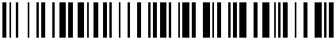
B08GFSMVJ2

INTSUPERMAI 12V DC Linear Actuator 1320LBS
(6000N) Electric Motor Linear Telescopic Rod Linear
Motion Heavy Duty Actuators Controller Stroke
5.9inch(150mm)
021364*1

New

