GUILLOTINE SHEAR
(Item：025107)

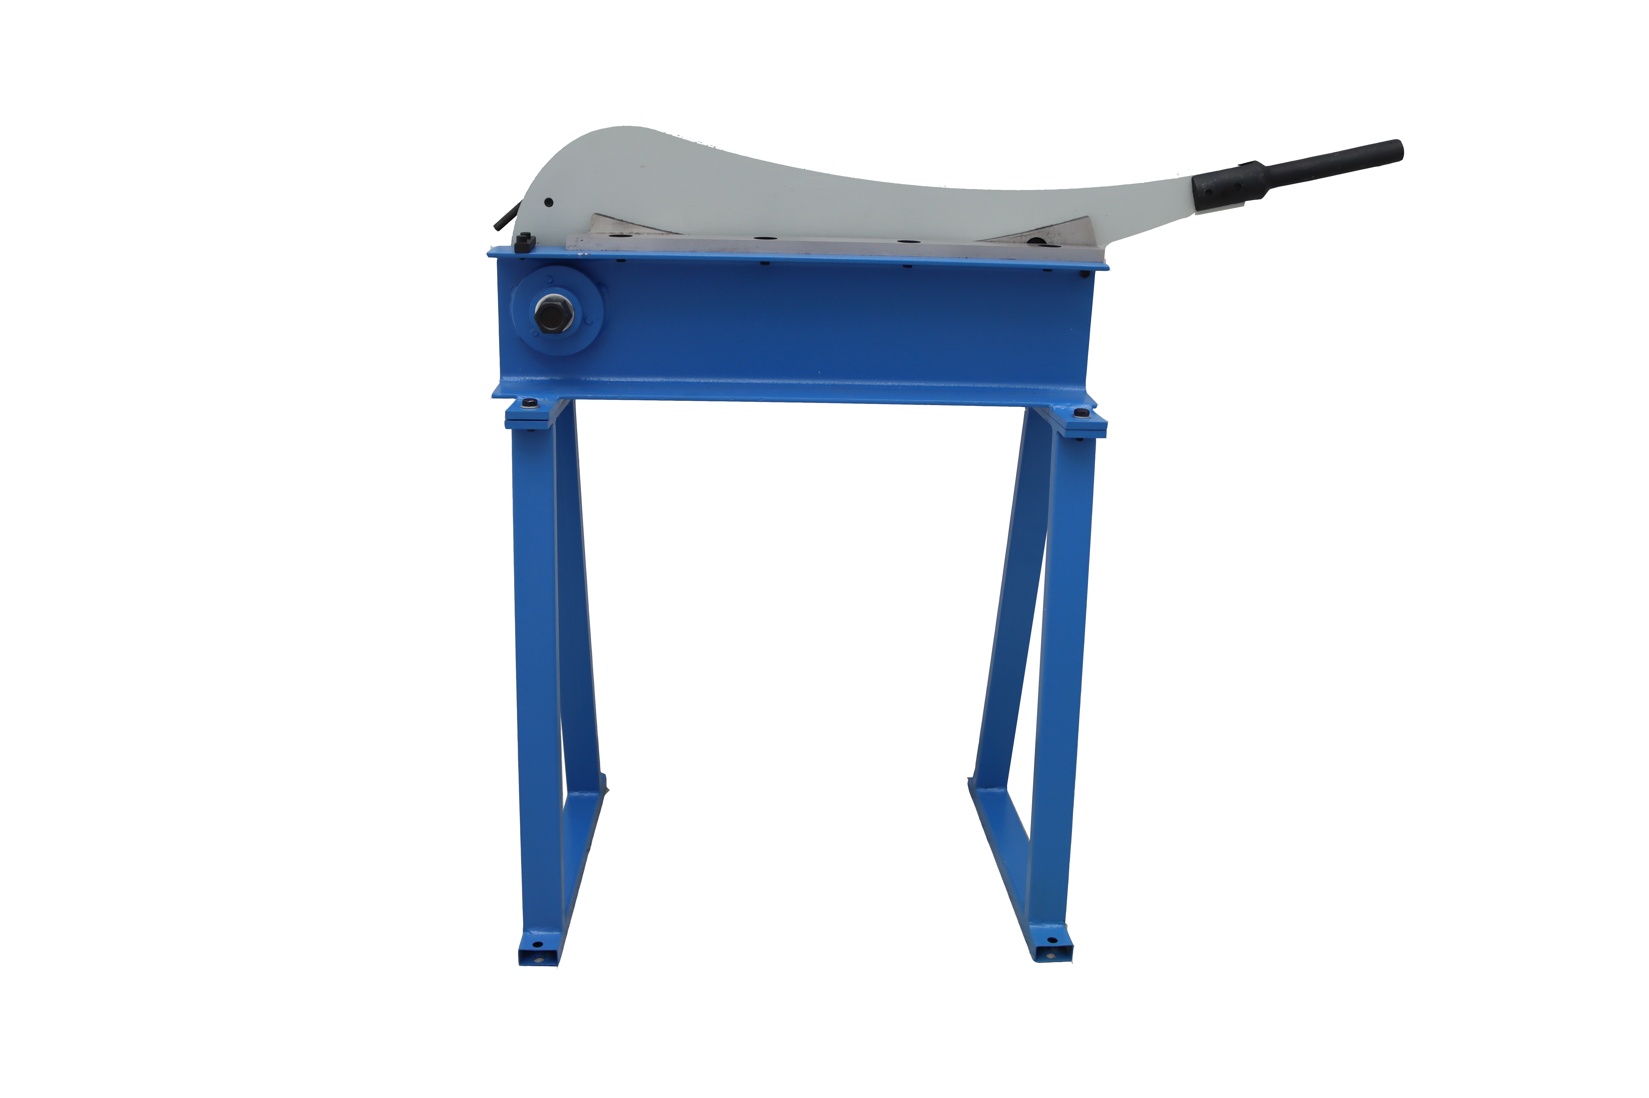

Usage
This is suitable for sheet metal and steel plate
1.Main technical specification
Specification | HS-500
Bed width(mm) | 500
Shearing thickness(mm) | 1.5
2. Installation and caution
2.1 Installation
2.1.1 Please check whether the part of this machine are fully equipped and not damaged according to the parts list or parts figure.
2.1.2 This machine should be mounted on hard ground or specific stand
2.1.3 Please leave plenty room around the machine for your easy operating, in order to avoid injury.
2.1.4 Please remove the anti-rust grease on processing surface and some parts included with kerosene.
2.2 Caution
2.2.1 Please read this manual before operation and make yourself understand its structure and principle completely.
2.2.2 Please don't operate the material width and thickness than table list max range.
2.2.3 When you shear the plate or bar which list in above table, you must be used lengthen handle in order to increase force. (not supplied)
2.2.4 Please don't touch the blade during operation.
3. Lubricate the rotating parts of the machine everyday.
4.Parts list

